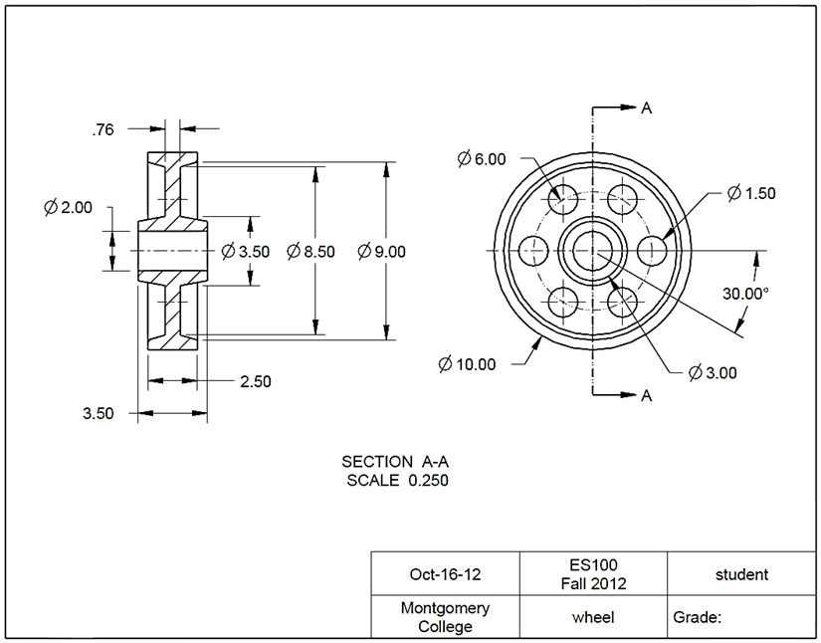**4.7 Symmetrical Features**

Task: Create a wheel using CREO as shown in the figure. The unit is in inches.

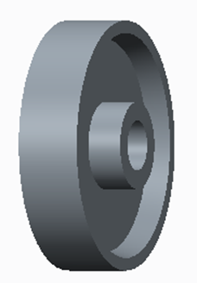

Step 1: Create a new file for the 3D solid model.

From File, click the icon of **New**. In the **New** window, select the **Part** module.

Type *wheel* as the file name. Clear the box of Use default template. Afterwards, click **OK**. In the New File Options window, select inlbs_part_solid. Type wheel under Description and type student under Modeled_by. Click **OK**. This will bring up the design window.

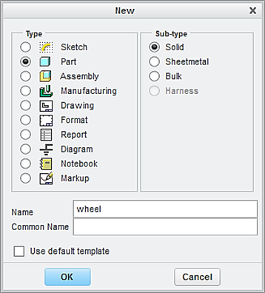

Clear this box

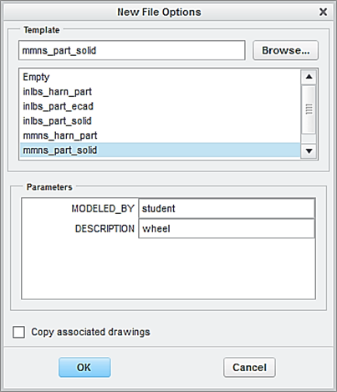

Step 2: Create the first feature, which is a plate.

From the Model tab, click the icon of **Revolve**.

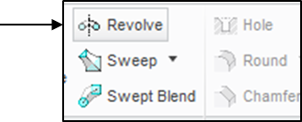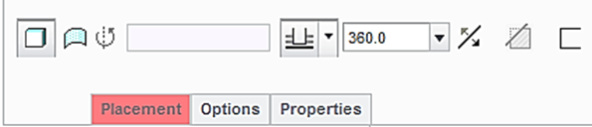

From the Model Tree, select the **FRONT** datum plane as the sketching plane, and click the icon of **Sketch View** to orient the sketching plane parallel to the screen.

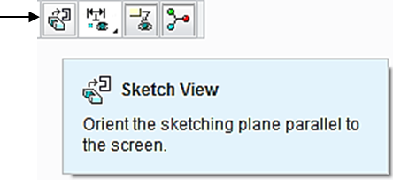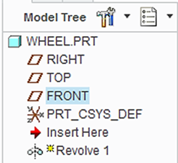

Right click and pick **Axis** **of** **Revolution** from the pop up window, and sketch a horizontal centerline.

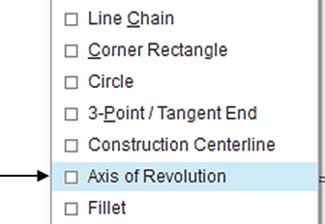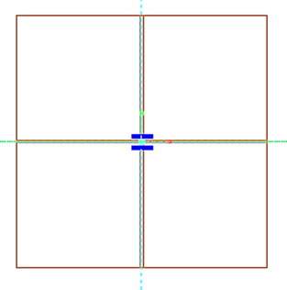

Click the icon of **Line**, and sketch a horizontal line, as shown. Modify the diameter dimension to 10 and the length dimension to 1.25.

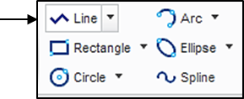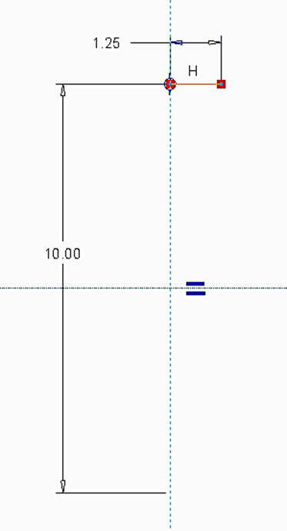

Click the icon of **Line**, and make the following sketch. There are 2 diameter dimensions. Modify them to 2 and 3.5, respectively. Modify the width dimension to 1.75.

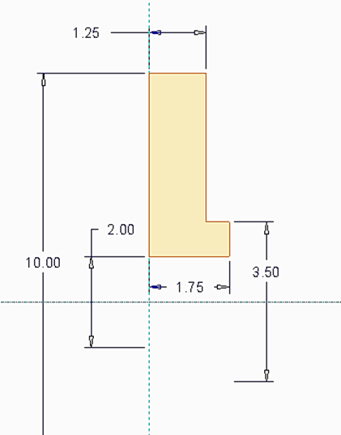

Upon completing this sketch, pick the icon of **OK**. Click the icon of **Apply and Save.**

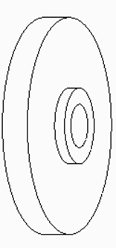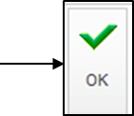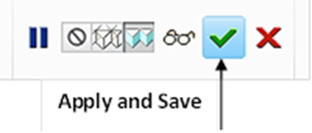

Step 3: Use MIRROR to obtain the feature on the other side of the RIGHT datum plane.

From the Model Tree, highlight Revolve 1. Click the icon of **Mirror**. Pick the **RIGHT** datum plane and click the icon of **Apply and Save**.

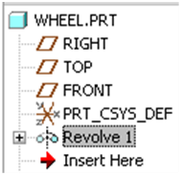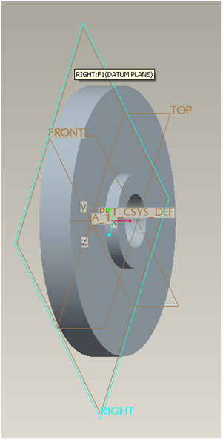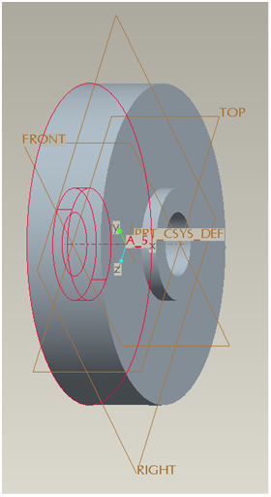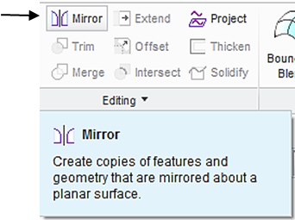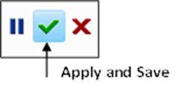

Step 4: Create the second feature, which is a revolved feature with CUT (removal).

Click the icon of **Revolve** displayed on the toolbar. Select **Cut**.

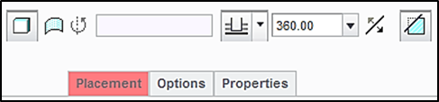

From the Model Tree, select the **Front** datum plane as the sketching plane and click the icon of **Sketch** **View** to orient the sketching plane parallel to the screen.

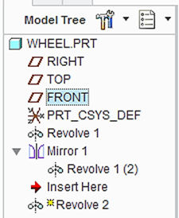

Right click and pick **Axis** **of** **Revolution** from the pop up window, and sketch a horizontal centerline.

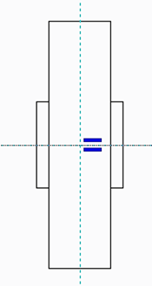

Click the icon of **References**, and add 2 new references, as shown. click **Close** after defining them.

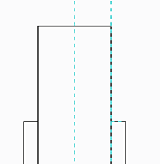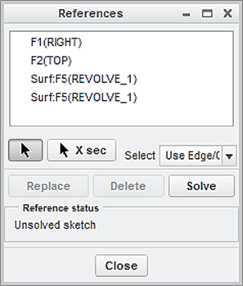

New reference

New reference

Click the icon of **Line**, and prepare the following sketch. The 2 diameter dimensions are 8.5 and 9.0. The width dimension is 0.88.

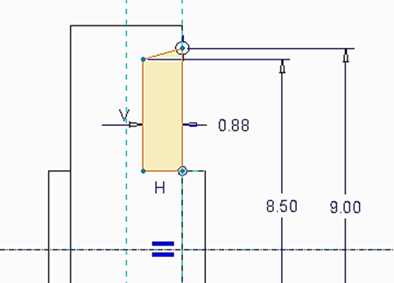

Click the icon of **Centerline** and sketch a vertical centerline.

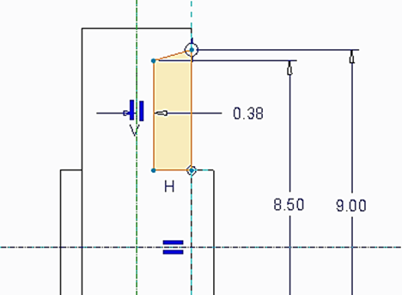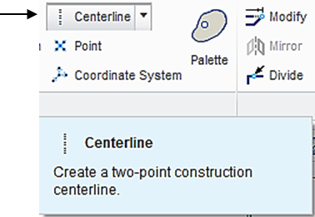

Pick the 4 lines from the sketch while holding down the Ctrl key, click the icon of Mirror. Click the vertical centerline to obtain the identical sketch on the other side.

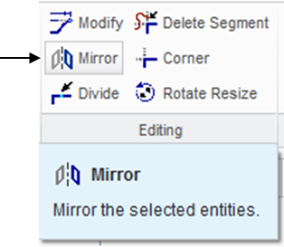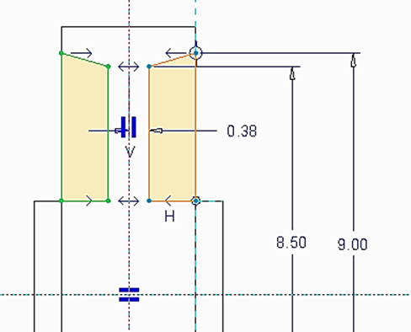

Upon completing this sketch, pick the icon of **OK**. Click the icon of **Apply and Save.**



Click the icon of **Revolve** displayed on the toolbar. Select **Cut**.



From the Model Tree, select the **Front** datum plane as the sketching plane and click the icon of **Sketch** **View** to orient the sketching plane parallel to the screen.

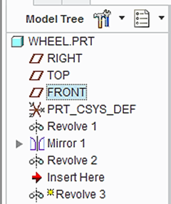

Right click and pick **Axis** **of** **Revolution** from the pop up window, and sketch a horizontal centerline.

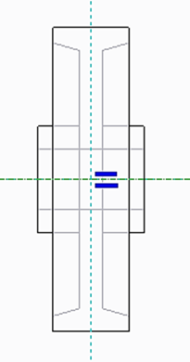

Click the icon of **References**, and add 3 new references, as shown. Click **Close** after defining.

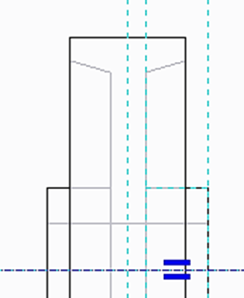

New reference

New references

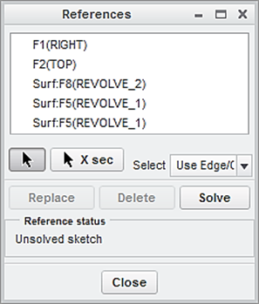

Click the icon of **Line**, and prepare the following sketch. Modify the diameter dimension to 3.0.

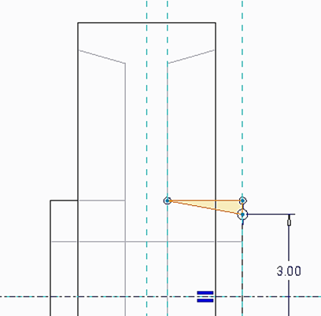

Click the icon of **Centerline** and sketch a vertical centerline.

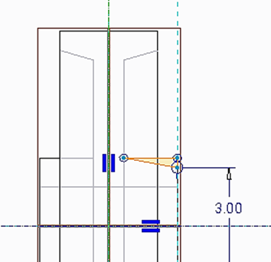

Pick the 3 lines from the sketch while holding down the **Ctrl** key, click the icon of **Mirror**. Click the vertical centerline to obtain the identical sketch on the other side.

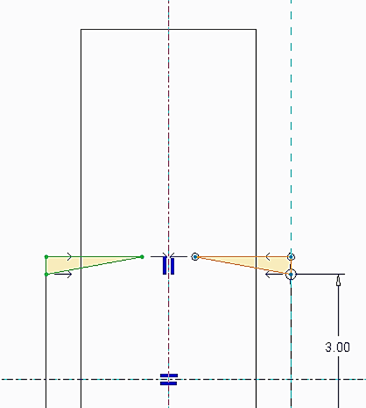

Upon completing this sketch, pick the icon of **OK**. Click the icon of **Apply and Save.**

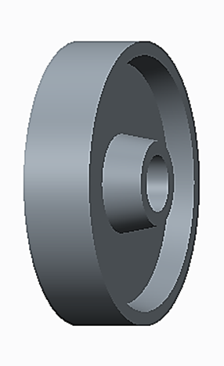

Step 5: Create the through all hole and the diameter is 1.5 inch.

Click the icon of **Extrude**. Select **Cut** and **Thru** **All**.

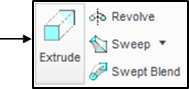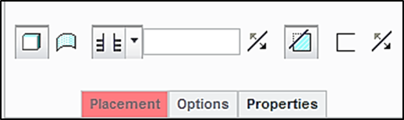

Select the inner flat surface as the sketching plane, and click the icon of Sketch View to orient the sketching plane parallel to the screen.

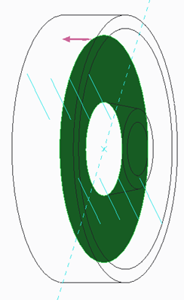

Click the icon of **Centerline**. Sketch a centerline at an angle equal to 30 degrees, as shown.

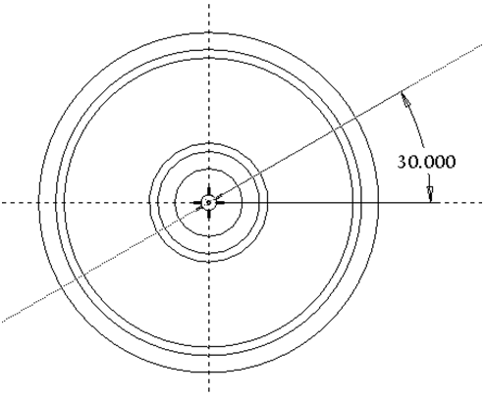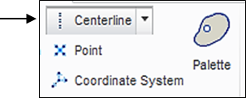

Click the icon of **Construction** Mode and click the icon of **Circle**. Sketch a circle, as shown below. The diameter value is 6 or the radius value is 3.

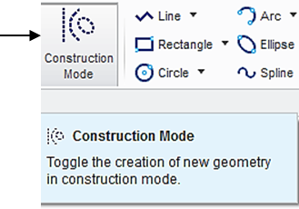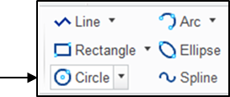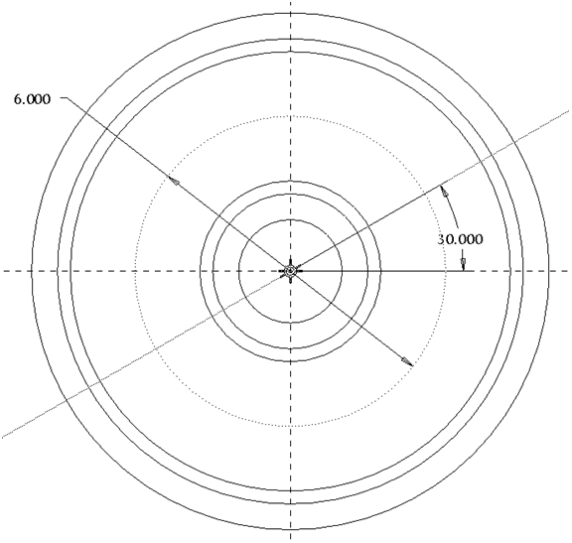

Click the icon of **Circle**. Sketch a circle, as shown below. The diameter value is 1.5.

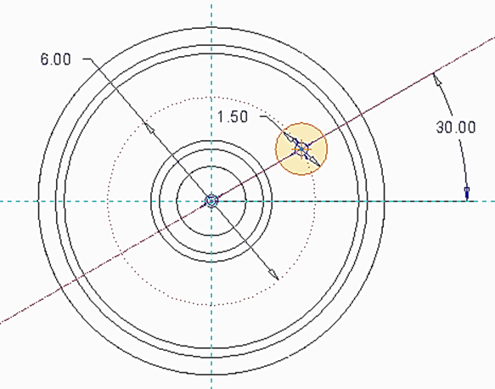

Upon completing this sketch, click the icon of **OK** and click the icon of **Apply** **and Save** to complete the creation of the hole feature.

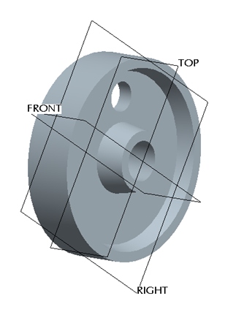

Step 6: Create the other 5 holes through Pattern.

In the Model Tree, highlight Extrude 1. Right-click and hold to pick **Pattern**.

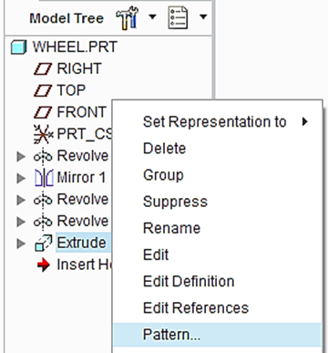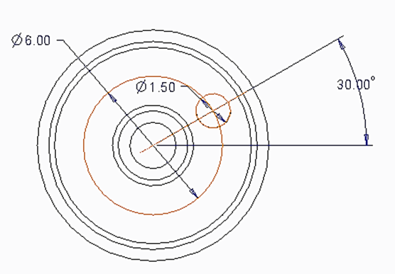

Select Axis as the pattern method. Pick the axis displayed on screen. Specify 6 as the number of holes including the current one and specify 60 as the incremental value in angle. Click the icon of **Apply** **and** **Save** to complete the pattern process.

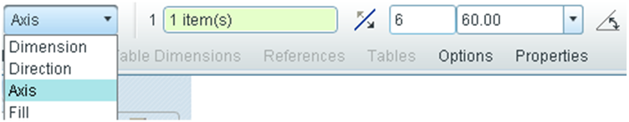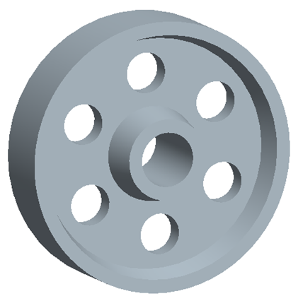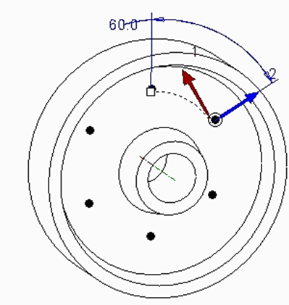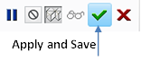

At this time, we have successfully completed the wheel design. Remember to save all work with the 3D solid model. You select **Save** from the main toolbar > **OK**.

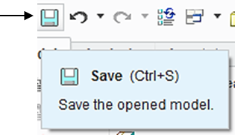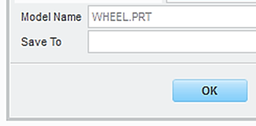

Step 7: Prepare an engineering drawing

To prepare an engineering drawing based on the 3D solid model, we need to create a drawing file. First, we select the icon of **New**, click **Drawing**. Type *wheel* as the name of the file. Clear the box of **Use default template** because we do not want to use the default setting for the drawing work. Afterwards, click **OK**.

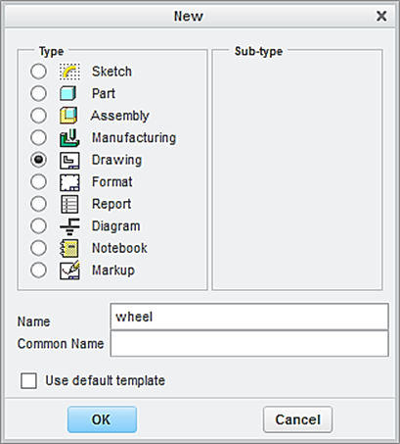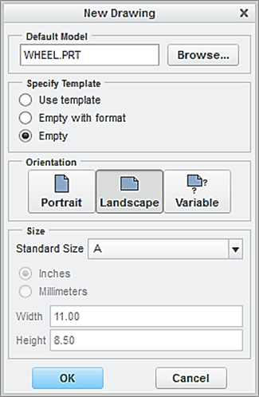

In the window of **New Drawing** shown above, make sure that the file of the 3D solid model called *wheel* is shown. Otherwise, use “**Browse**” to locate it. Select **Empty** under Specify Template, and select the paper size to be **A**. Afterwards, click the button of **OK**.

This brings up the drawing screen. Click the icon of **Layout**. Click the icon of **General.** In the **Select Combined** **State** window, click OK to accept **No Combined State**.

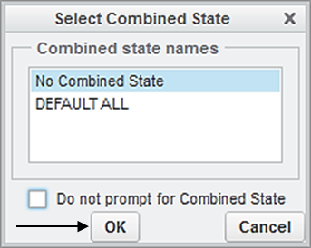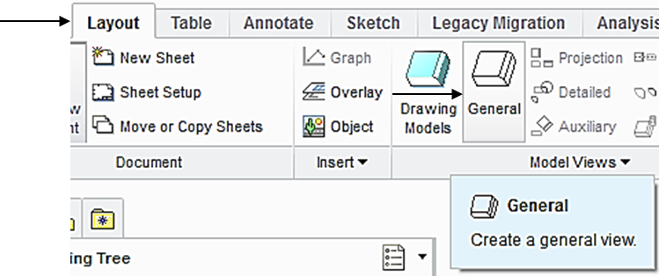

Select a location on the drawing screen as the center point for the **General** **View**. A general view appears on the screen.

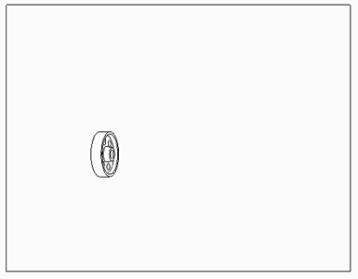

In the pop-up Drawing View window, select **FRONT** > **Apply.** To change the scale, click **Scale** > **Custom scale** > type 0.25 > **Apply** > **Close**, the construction of the Front View is completed.

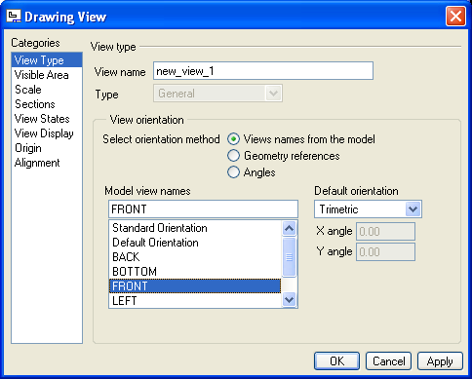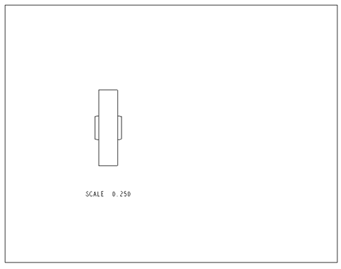

To insert the right side view through, pick the FRONT View just created, right-click and hold, and then select **Insert** **Projection View** > move the cursor to the right side and click the left button of mouse, and the construction of the right side view is completed.

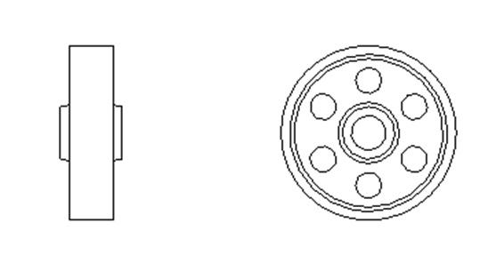

Step 10: Add a section view to the auxiliary view.

First, let us enable the display of datum planes. Click the icon of **Datum Display Filter** and check the box of **Plane** **Display** and **Repaint.**

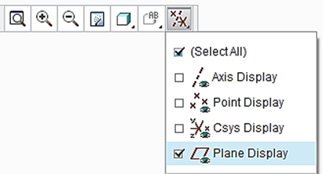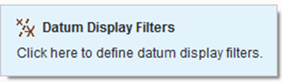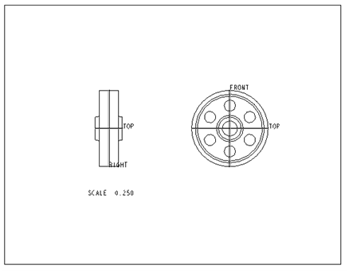

Now activate the front view through a left click of mouse. Afterwards, right click and hold, select **Properties.**

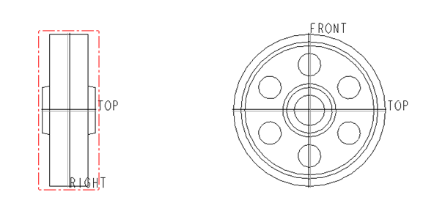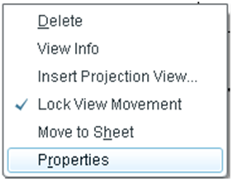

In the Drawing View window, select **Sections** and **2D cross-section.** Click the icon of **Add** (plus sign) to add cross-section. In the pop up window, accept Planarand **Single > Done**.

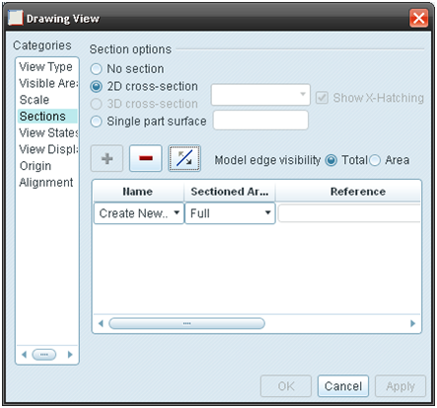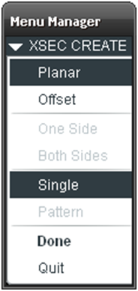

The software system is asking the user to enter a name for cross-section. Type *A* as the name for cross-section and press the **Enter** key. On the screen display, select the **FRONT** datum plane from the right-sided view > click the box of **Apply**, a cross-section is added to the front view.

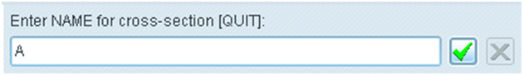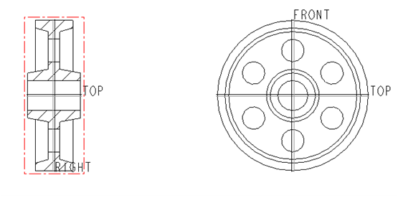

Pick FRONT DATUM PLANE

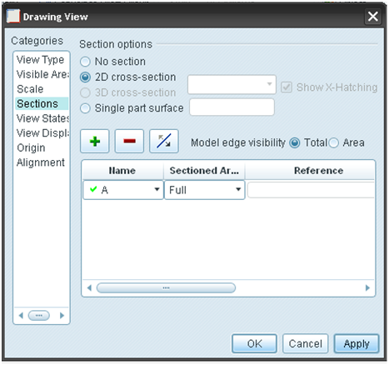

To add an arrow indicating the direction of the cross-section view, activate **Arrow Display** from the **Drawing View** window > click the Top view > **Apply** and two arrows marked as A appear together with SECTION A-A > **Close**.

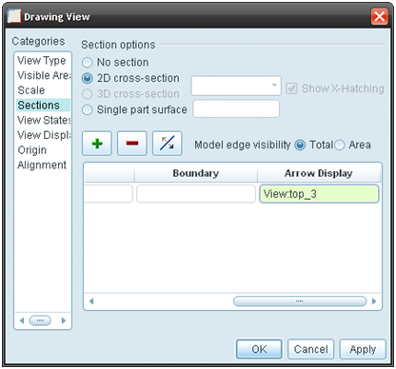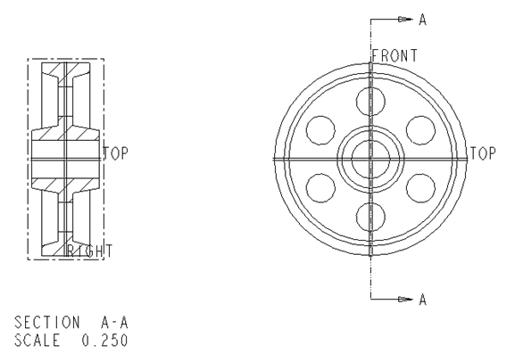

Upon completing the layout, we start adding dimensions. Click the icon of **Annotation**. Select the icon of **Show Model Annotation.**

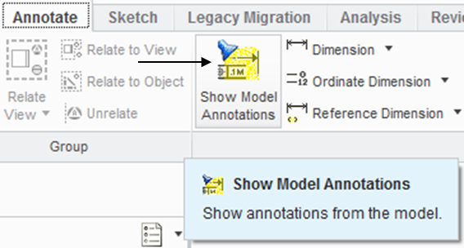

In the pop-up window, select the icon of **Dimensions. In the Show Model Annotation** window, change All to All Driving Dimensions. Click the Front view. Four dimensions are shown. Click Select All and Apply. Repeat this procedure and pick the right-sided view to show the required dimensions.

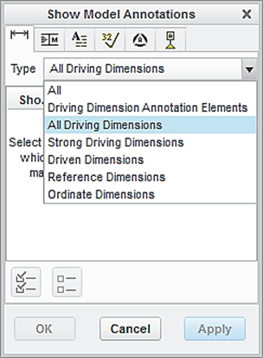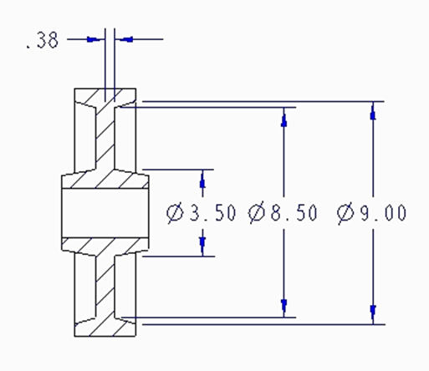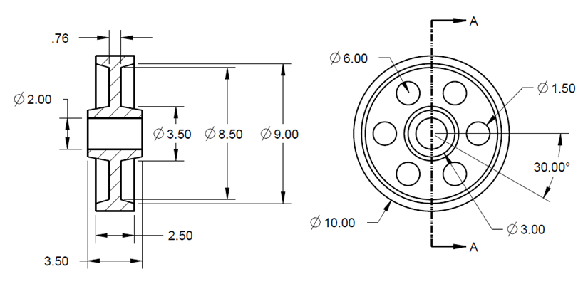

To add centerlines, select the box of centerlines. **In the Show Model Annotation** window, change All to Axes. In the Model Tree, click WHEEL.PRT. All axes are shown on both Front and Right-sided Views.

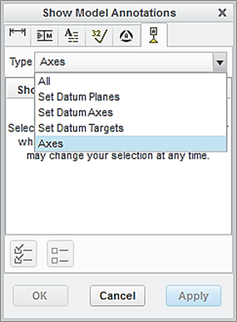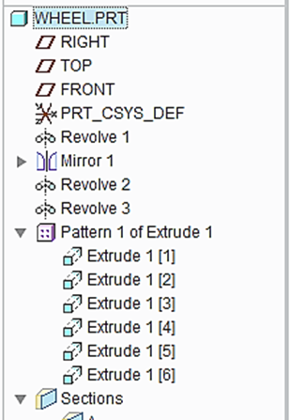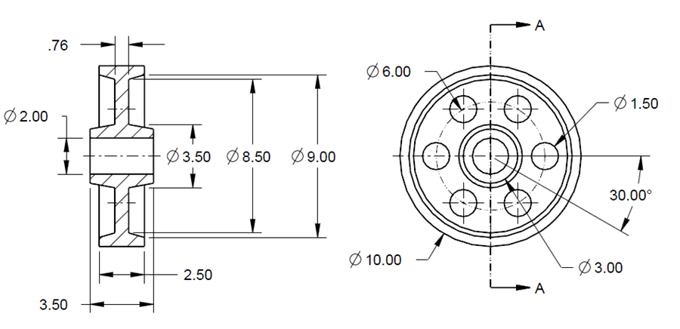

Let us insert the format to the drawing. From the Layout tab, click the icon of Sheet Setup. In the **Page** **Setup** window, use **Browse** to locate the format file, which is *es100*_*fall_2012* > **Open** > select **Show** **Format** > **OK**.

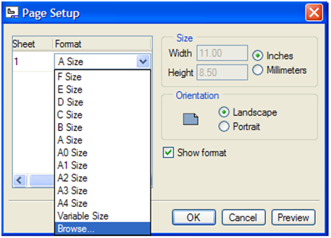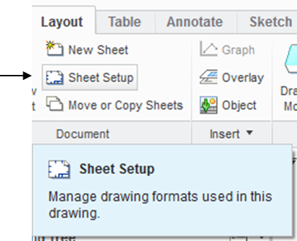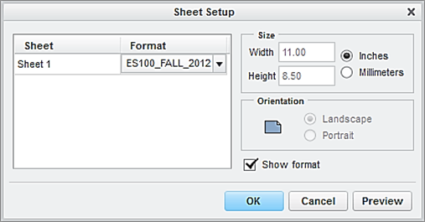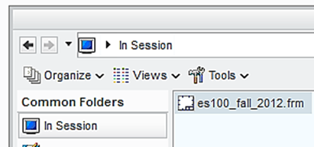

At this time, the user has successfully completed the engineering drawing of the wheel component. Select **Save** from the main toolbar > **OK**.

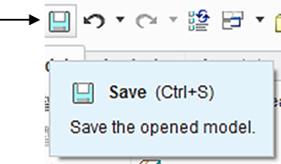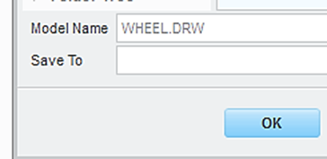

**EXERCISE AND ACTIVITIES**

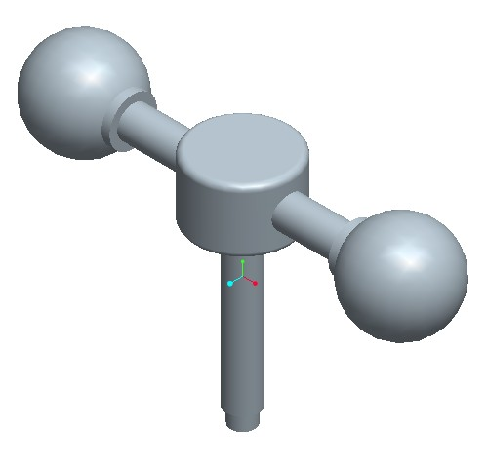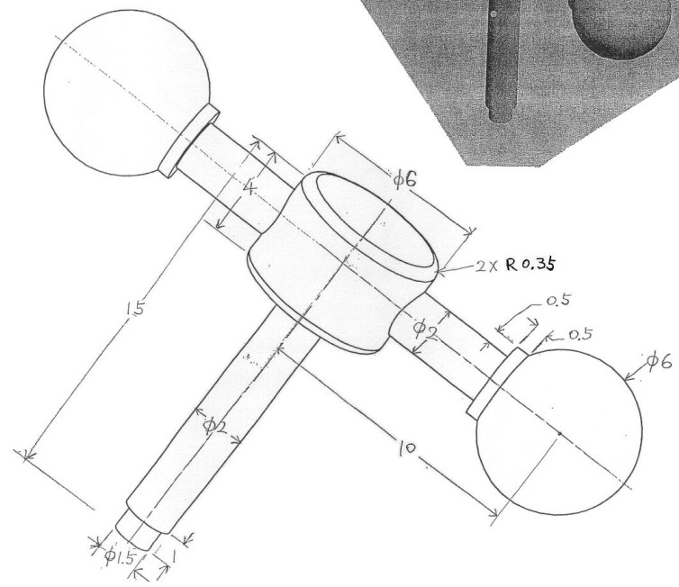1.

2.