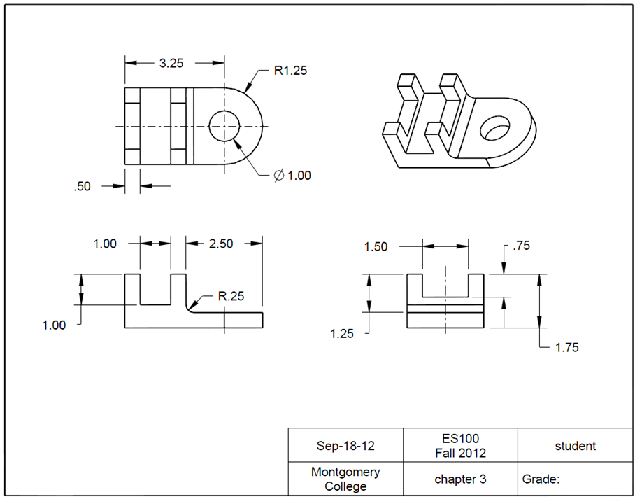**4.3 Model History Tree**

Task: Construct a L-support fixture using CREO. The unit is in inches.

Step 1: Create a new file for the 3D solid model.

Select **File** and click the icon of **New.**

Type *chapter_3* as the file name. Clear the box of Use default template. Afterwards, click **OK**. In the New File Options window, select inbs_part_solid. Type *student in Modeled_by,* and type *chapter 3 in Description.* Click **OK**. This will bring up to the design window.

Click **OK**

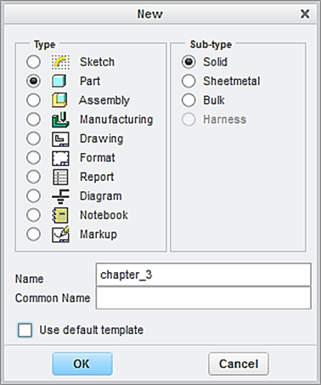

Type *chapter_3 as* the file name

Clear this box

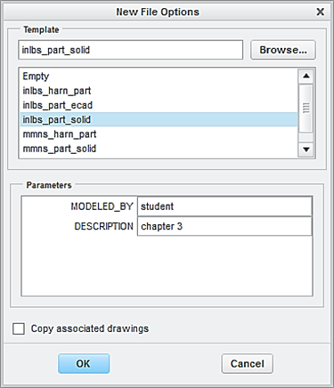

Step 2: Create the first feature, which is a plate. The 3 dimensions are R1.25 x 3.25 x 1.75 inch.

From the Model tab, click the icon of **Extrude**. Specify 1.75 as the height of the block feature.

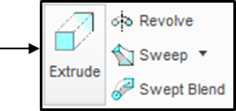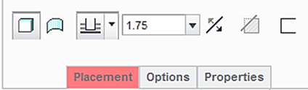

From the Model Tree, select the **TOP** datum plane as the sketching plane and click the icon of **Sketch View** to orient the sketching plane parallel to the screen.

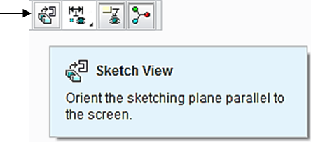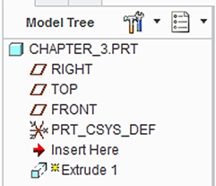

Let us create a 2D sketch. Click the icon of **Circle**, and sketch a circle, as shown below. Do not modify the dimension.

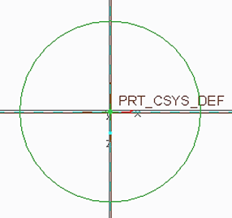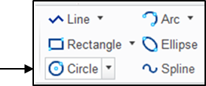

Click the icon of **Delete**. To remove the half circle on the left side, click the half circle on the left side, as shown. Note the diameter dimension is changed to a radius dimension. Modify the value to 1.25.

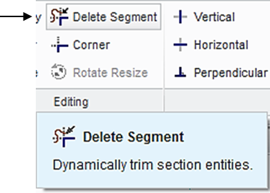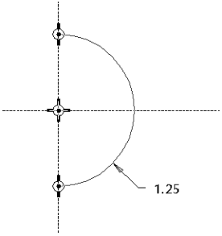

Click the icon of **Line** to sketch 3 lines, as shown. Specify 3.25 as the length value.

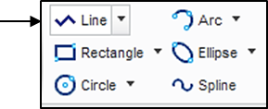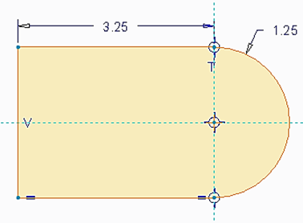

Upon completing this sketch, click the icon of **OK** and click the icon of **Apply** **and Save** to complete the creation of the plate feature.

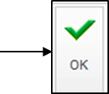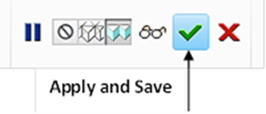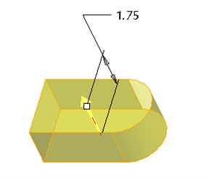

Step 3: Create the second feature, which cuts or removes the material from the created feature.

Click the icon of **Extrude**. Select Cut, and specify Thru All as the depth choice.

CUT

Thru All

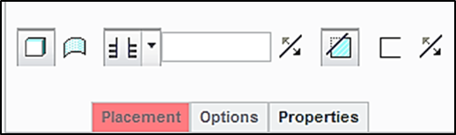

Select the front surface of the plate feature as the sketching plane, and click the icon of **Sketch** **View** to orient the sketching plane parallel to the screen.

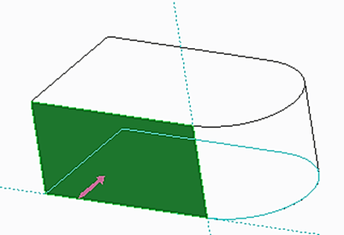

Click **Sketch > References**, and add 3 new references, as shown. Click **Close**.

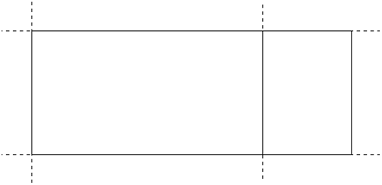

3 New references

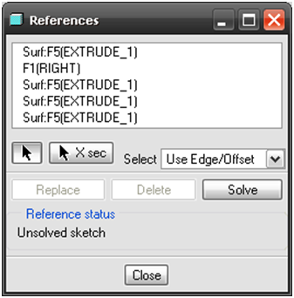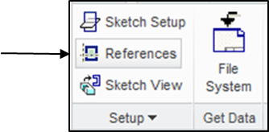

Click the icon of **Rectangle**. Sketch a rectangle, as shown below. The 3 dimensions are 0.5, 1.0 and 1.0, respectively.

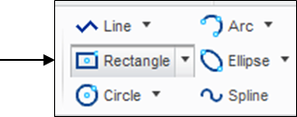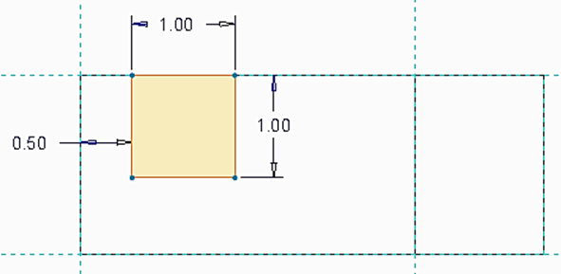

Click the icon of **Rectangle**, again. Sketch another rectangle, as shown below. The 2 dimensions are 2.5 and 1.25, respectively.

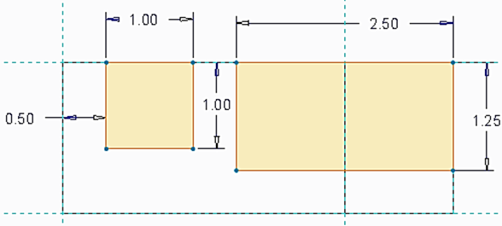

Upon completing this sketch, click the icon of **OK** and click the icon of **Apply** **and Save.**

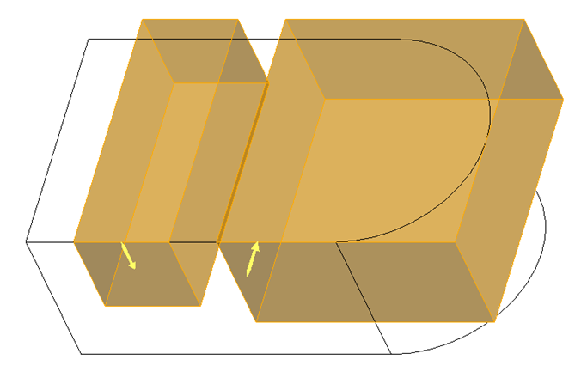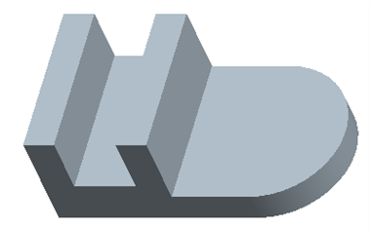

Step 4: Create a through hole and the diameter dimension is 1.0 inch.

Click the icon of **Datum** **Axis**. Pick the cylindrical surface and an axis is created, as shown.

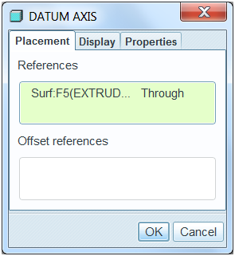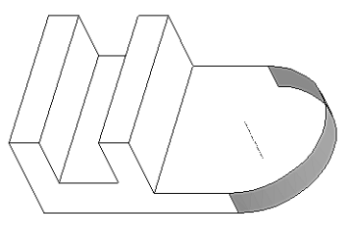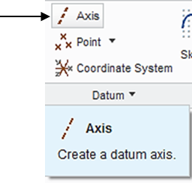

Click the icon of **Hole**. Specify 1.0 as the diameter value and use **Thru** **All** as the depth choice. Activate **Placement.** It should be noted that the created axis is already selected by the system default. While holding down the **Ctrl** key, pick the top surface of the plate, the hole feature is created, as shown.

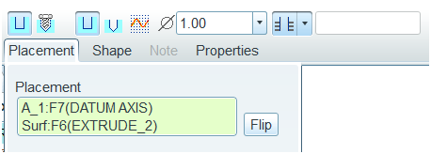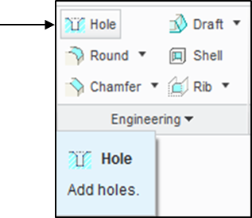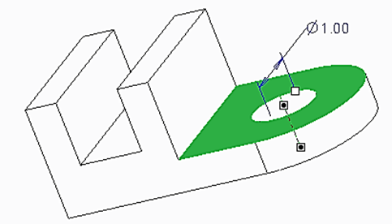

Step 5: Create the required slot feature. The 2 dimensions are 1.5 and 0.75 inch.

Click the icon of **Extrude** displayed on the toolbar. Select Cut and specify **Thru** **All** as the depth choice. Activate **Placement** > **Define.**



Select the surface on the right side of the wall, as shown, as the sketching plane, and click the icon of **Sketch** **View** to orient the sketching plane parallel to the screen.

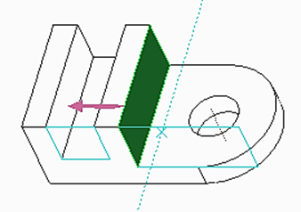

Before sketching the circle, let us click **Sketch > References**, and add 2 new references. Click the **FRONT** datum plane and the surface as shown. After defining these 2 new references, click **Close**.

New references

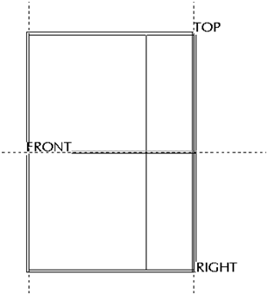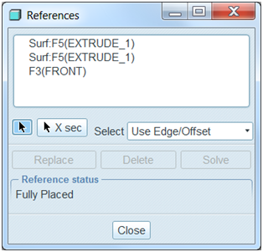

Pick the icon of **Centerline**. Draw a horizontal centerline through the new reference or **FRONT**, as shown.

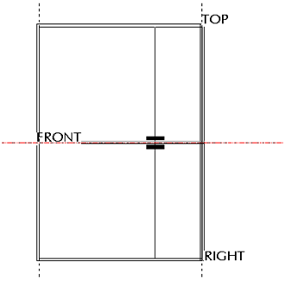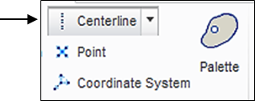

Click the icon of **Rectangle**, again. Sketch a rectangle, as shown below. The 2 dimensions are 1.5 and 0.75, respectively.

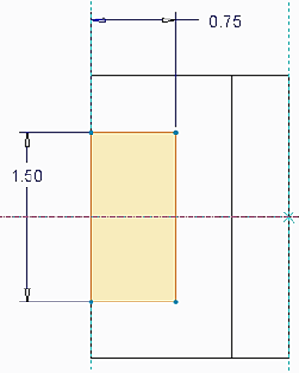

Upon completing this sketch, click the icon of **OK** and click the icon of **Apply** **and Save** to complete the creation of the slot feature.

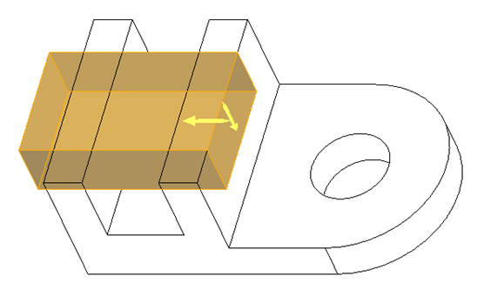

Step 6: Create the round at the corner. The radius value is 0.25 inch.

Click the icon of **Round**. Specify 0.25 as the radius value and select the edge. As shown. Click the icon of **Apply** **and** **Save**.

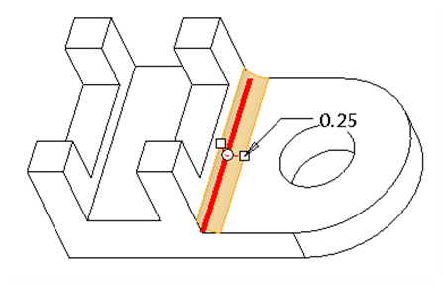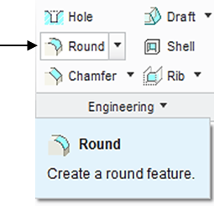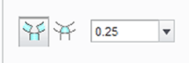

Let us save the file. Click the icon of **Save** > **OK**.

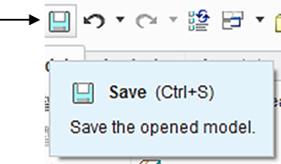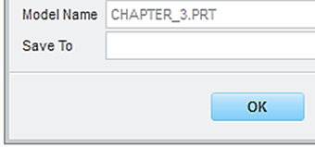

To prepare an engineering drawing, click the icon of **New.**  A **New** window appears, as illustrated below. Type *chapter_3* as the name of the file. Clear the box of **Use default template**. Afterwards, click **OK**.

Select drawing

Clear the default box

Select paper size

Locate the 3D solid model file

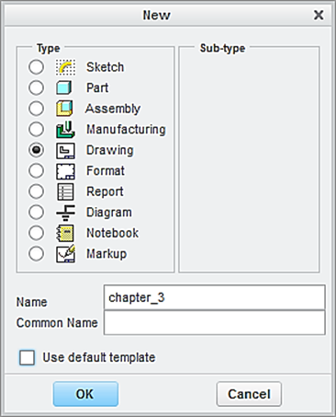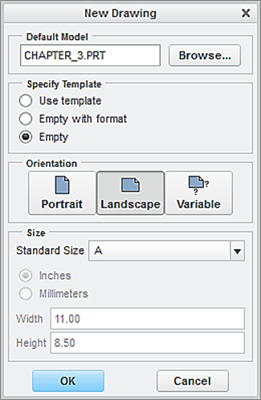

In the window of **New Drawing** shown above, make sure that the file of the 3D solid model called *chapter_3* is shown. Otherwise, use “**Browse**” to locate it. Select **Empty** under Specify Template, and select the paper size to be **A**. Afterwards, click the button of **OK**.

This brings up the drawing screen. Click the icon of **Layout**. Click the icon of **General.** In the **Select Combined** **State** window, click OK to accept **No Combined State**.

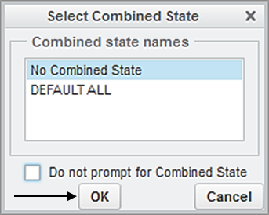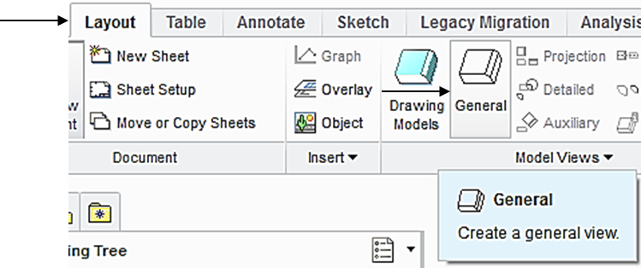

Select a location on the drawing screen as the center point for the **General** **View**. A general view appears on the screen.

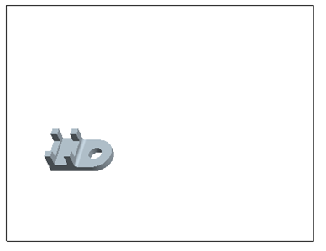

In the pop-up Drawing View window, select **FRONT** > **Apply** > **Close**, the construction of the Front View is completed.

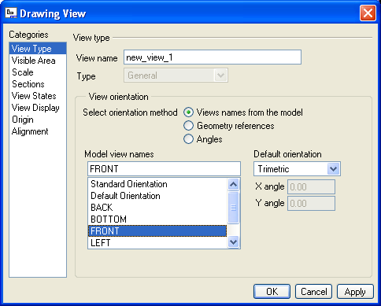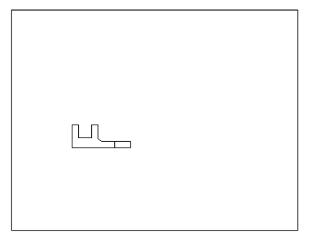

To insert the right side view through, pick the FRONT View just created, right-click and hold, and then select **Insert** **Projection View** > move the cursor to the right side and click the left button of mouse, and the construction of the right side view is completed. Follow the same procedure to create the top view, as shown below.

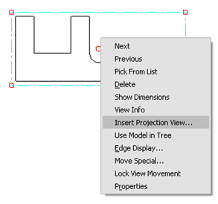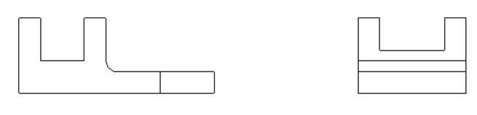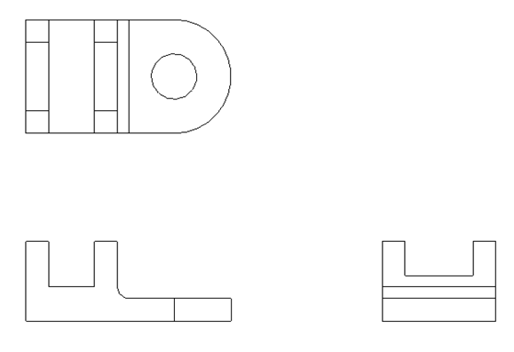

Click the icon of **General.** In the **Select Combined** **State** window, click **OK** to accept **No Combined State**. Select a location on the drawing screen as the center point for the 3D View (click the left button of mouse). A general view appears on the screen. In the pop-up Drawing View window, select **Standard Orientation** > **Apply** > **Close**, the construction of the 3D View is completed.

In the pop-up Drawing View window, select **Standard Orientation** > **Apply** > **Close**, the construction of the 3D View is completed.

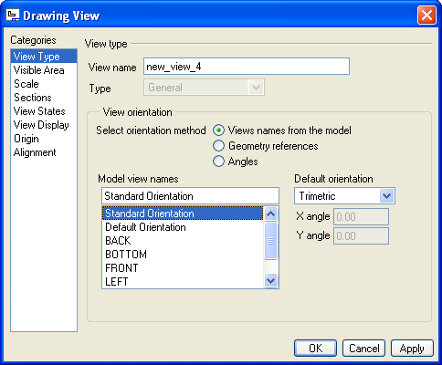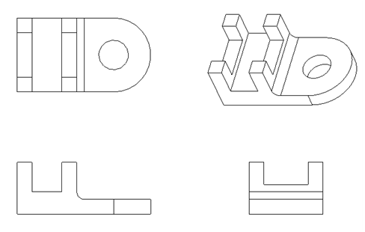

Upon completing the layout, we start adding dimensions. Click the icon of **Annotation**. Select the icon of **Show Model Annotation.**

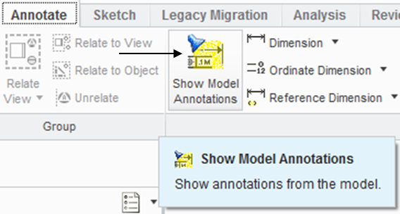

In the pop-up window, select the icon of **Dimensions.** To show the dimension of Extrude 1, click Extrude 1 listed in the model tree. Click Accept and OK. The 3 dimensions of 3.25, 1.75 and R1.25 are shown. Click the box of **Accept** **All** > **OK**.

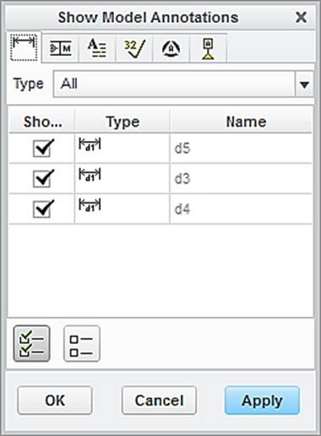

Dimension

Accept all

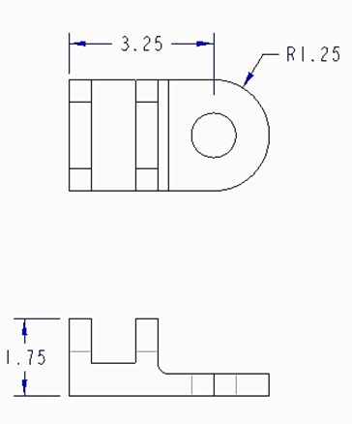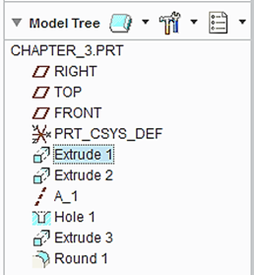

Follow the same procedure to add the dimensions associated with Extrude 2, Extrude 3, and Hole 1 and Round 1.

To add centerlines, select the box of centerlines. Click the hole feature listed in the model tree. All the centerlines are shown. Click **Accept All > OK.**

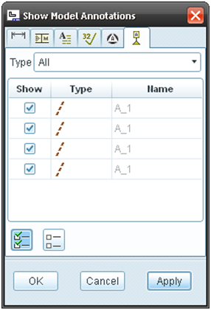

Accept all

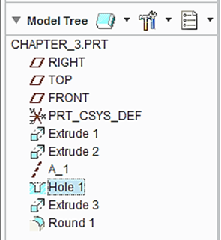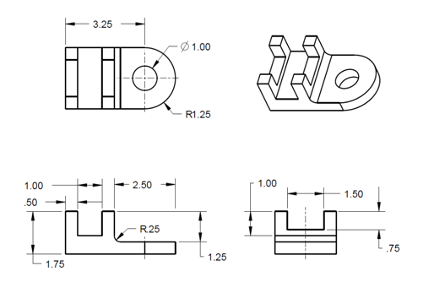

Let us insert the format to the drawing. From the Layout tab, click the icon of Sheet Setup. In the **Page** **Setup** window, use **Browse** to locate the format file, which is *es100*_*fall_2012* > **Open** > select **Show** **format** > **OK.**

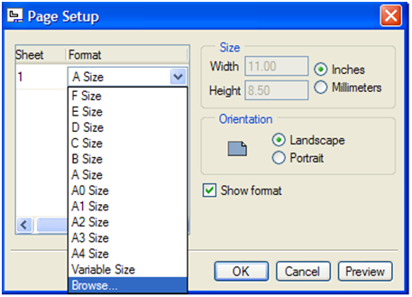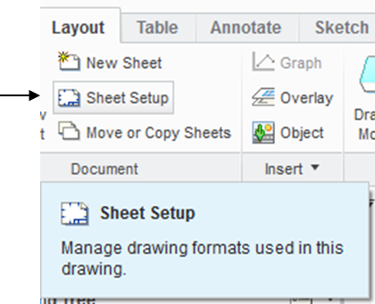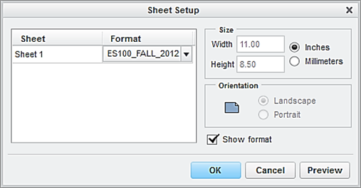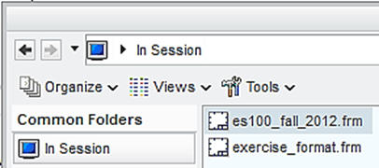

At this time, the user has successfully completed the engineering drawing of the designed part. Select **Save** > **OK**.

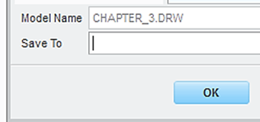

**EXERCISE AND ACTIVITIES**

