Chapter 4 – Introduction to Solid Modeling - CREO

**4.0 Computer Aided Design**

The rapid changes in the field of Computer Aided Design (CAD) have brought exciting advances in the engineering design. Today in the industry, computers are not only used in the design phase but also used for analysis, simulation and manufacturing too. There are many advantages that engineers use CAD specially the 3-D modeling for the design:

* A creative and innovative method of representing a design conceived by design engineers
* Facilitate design modifications and redesign
* Execute long and complex engineering analyses
* Integrated design with other tasks, such as manufacturing
* An effective method of communicating design information

There are a lot of software that can be used for this purpose such as AutoCAD Inventor, SolidWork, CREO and others. Here, we are going to learn some basics for construction of a 3-D part from an idea or engineering drawing using CREO:

**4.1 Parametric Modeling Fundamentals**

Task: Use CREO to create the adjuster shown in the figure. The unit is in inch.

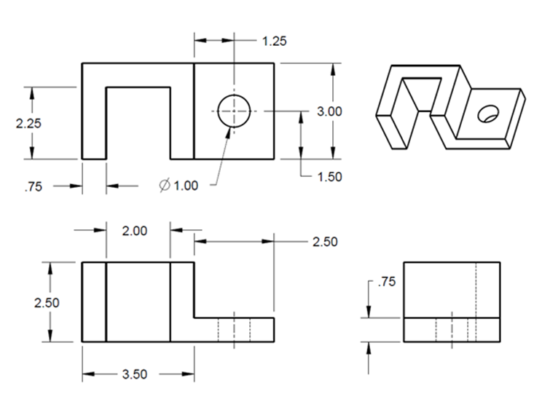

Step 1: Create a new file for the 3D solid model.

Select the icon of **New** from the toolbar. In the **New** window, select the **Part** module. Type *chapter_1* as the file name. Click the box of **OK**. This will bring up the design window.

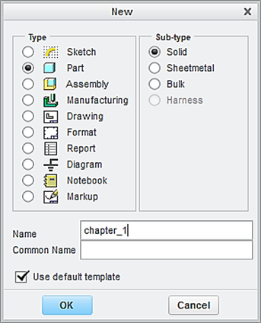

Click the box of **OK**

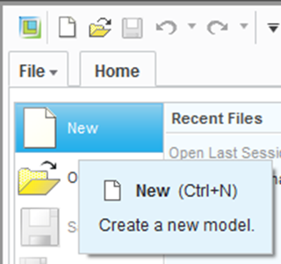

Step 2: Create the first feature, which is a block and the 3 dimensions are 3.5 x 3.0 x 2.5 inches.

From the Model tab, click the icon of **Extrude.** Specify 2.5 as the height of the block feature.

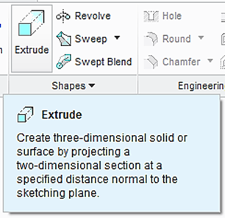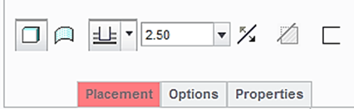

From the Model Tree, select the **TOP** datum plane as the sketching plane. Click the icon of **Sketch** **View** to orient the sketching plane parallel to the screen.

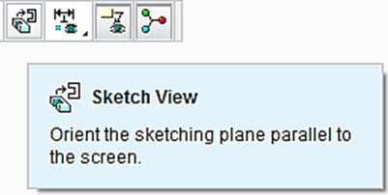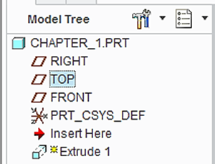

Click the icon of **Centerline** and create a vertical centerline passing through the origin of the coordinate system. Users should make 2 left clicks along the vertical dashed-line, which serves as a reference.

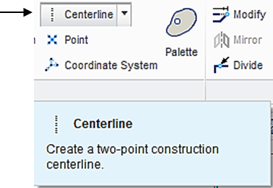

Click the icon of **Rectangle** to sketch a rectangle, which is symmetric about the vertical centerline. How to sketch this rectangle? Start with picking a point on the left side of the horizontal axis, and picking the second point on the other side. Before making the second click, set the rectangle symmetric about the vertical axis. A pair of arrows is displayed, indicating the symmetry, as shown below. To modify the 2 dimensions, click the icon of **Select** or **One by One**. Afterwards, double click the displayed numbers and change the 2 dimensions to 3.5 and 3, respectively.

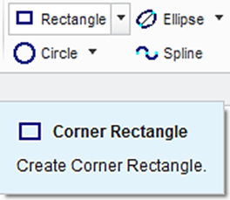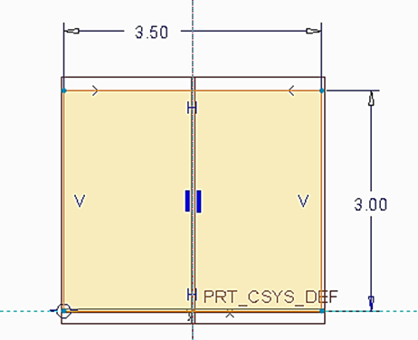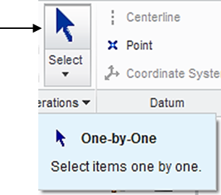

Upon completing this sketch, click the icon of **OK** and click the icon of **Apply** **and Save** to complete the creation of the block feature.

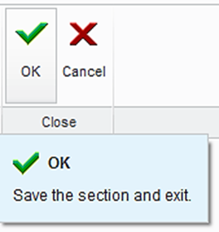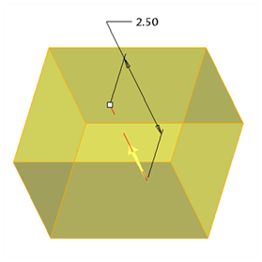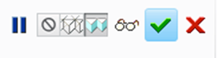

Apply and Save

Step 3: Create the second feature, which is a slot and the 3 dimensions are 2 x 2.25 x 2.5 inch.

Click the icon of **Extrude**. Select **Cut** because we are going to remove the material from the created block. Specify 2.5 as the depth of cut.

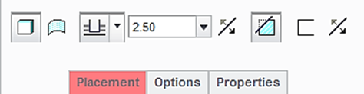

**Cut**

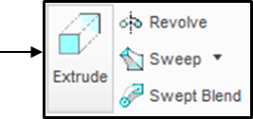

Select the top surface of the block feature as the sketching plane, and click the icon of **Sketch View** to orient the sketching plane parallel to the screen.

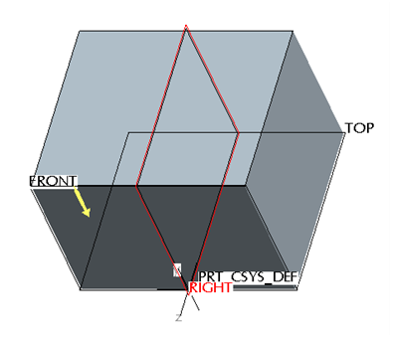

Click the icon of **Centerline**. Sketch a vertical centerline passing through the origin of the coordinate system. To do so, make 2 left clicks on the vertical dashed line, which is a reference.

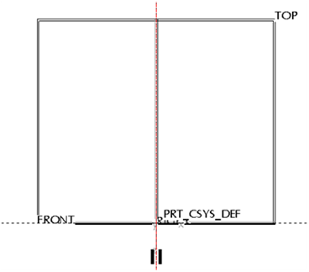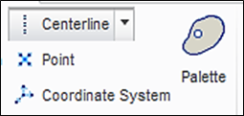

To create a rectangle, click the icon of **Rectangle**, and start the sketch by picking one point on the left side of the horizontal axis, and the second point on the right side. Before making the second click, set the rectangle symmetric about the vertical axis. A pair of arrows is displayed, indicating the symmetry, as shown below. Afterwards, double click the displayed numbers and change the 2 dimensions to 2.25 and 2, respectively.

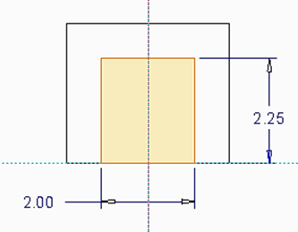

Upon completing this sketch, click the icon of **OK** and click the icon of **Apply** **and Save** to complete the creation of the block cut feature.



Apply and Save

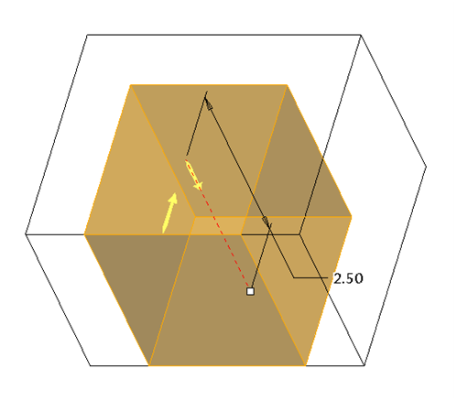

Step 4: Create a plate before creating the required hole feature. The plate size is 2.5 x 0.75 x 3 inch.

Click the icon of **Extrude** displayed on the toolbar. Specify 3 as the depth of extrusion.

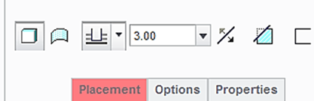

Select the front surface of the block feature as the sketching plane, and click the icon of **Sketch** **View** to orient the sketching plane parallel to the screen.

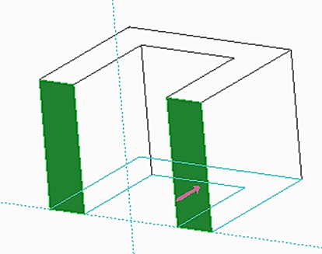

Click the icon of **References**. Click the surface on the right side of the block, as shown. After defining this new reference, click **Close**.

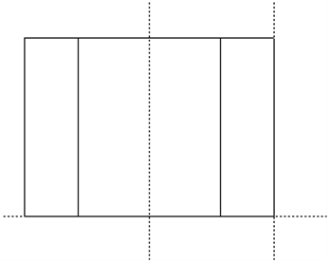

New reference

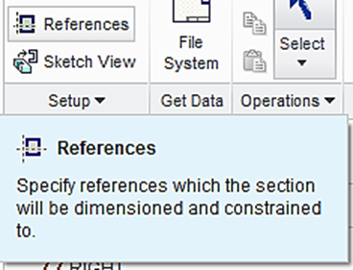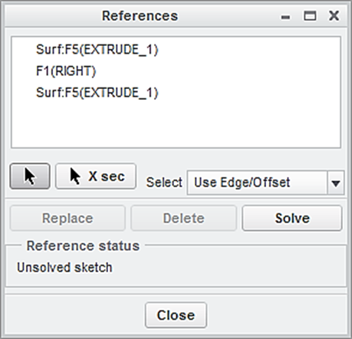

Click the icon of **Rectangle**, and sketch a rectangle as shown below. The 2 size dimensions are 2.5 and 0.75, respectively.

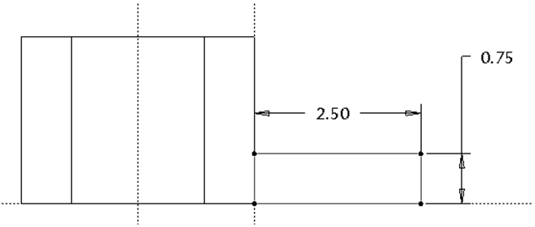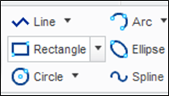

Click the icon of **OK**.**.** Pay attention to the direction of extrusion. Users may click the arrow to reverse the direction of extrusion. Click the icon of **Apply and Save**.

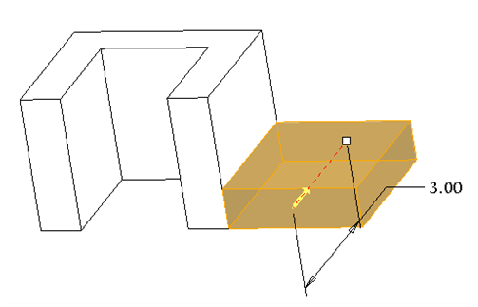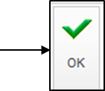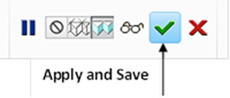

Step 5: Create the hole feature. The diameter is 1 inch and the 2 position dimensions are 1.5 and 1.25.

Click the icon of **Hole** displayed on the toolbar. Specify 1 as the diameter value and use **Thru All** as the depth choice (a through hole). Specify Thru All, as shown below.

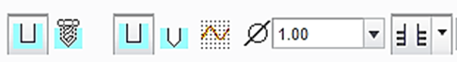

Type 1 as the diameter dimension

Select Thru All

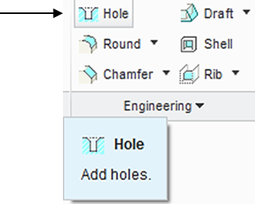

Click **Placement**, click or activate the box under **Placement**, and select the top surface of the plate as the primary surface, and select **Linear**.

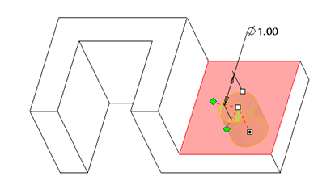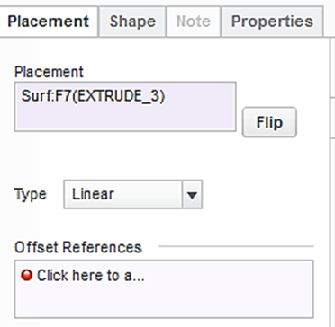

To define the center location of the hole, click or activate the box under **Offset References**, and select the front surface of the block and the surface on the left side of the block while holding down the **Ctrl** key. Specify the values of offsets to be 1.5 and 1.25, respectively.

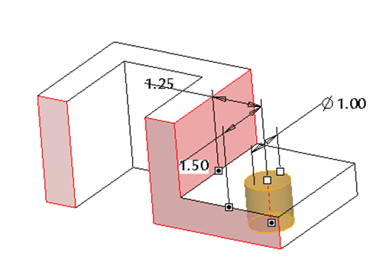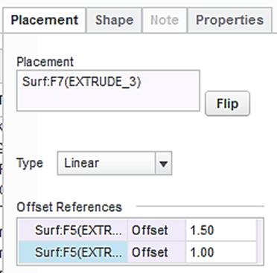

Click the icon of **Apply and Save** to complete the creation of the hole feature, as shown below:

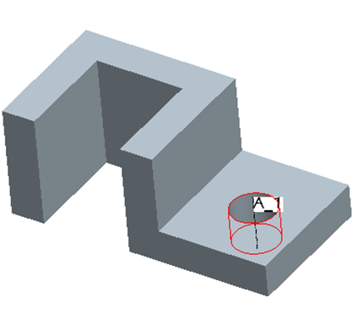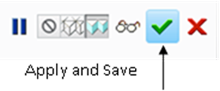

You have successfully completed the design of an object with a block feature, a slot feature, and a hole feature. Remember to save all of your work with the 3D solid model. Click **Save** from the main toolbar > **OK**.

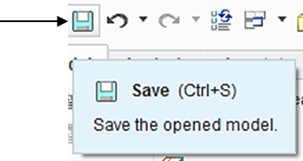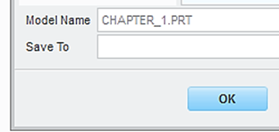

To prepare an engineering drawing based on the 3D solid model, we need to create a drawing file. First, we click the icon of **New**, or “Create a new model”.

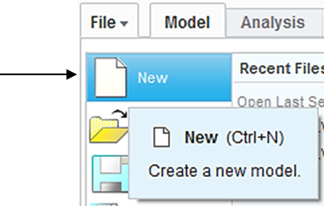

A **New** window appears, as illustrated below. This is the same step we used to open a new file when creating the 3D solid model of *chapter*_*1*. However, this time, “**Drawing**” mode, instead of “**Part**” mode, should be selected. Type *chapter*_*1* as the name of the file.. Clear the box of **Use default template** because we do not want to use the default setting for the drawing work. Afterwards, click **OK**. In the window of **New Drawing**, make sure that the file of the 3D solid model called *chapter*_*1* is shown. Otherwise, use “**Browse**” to locate it. Select **Empty** under Specify Template, and select the paper size to be **A**. Afterwards, click **OK**.

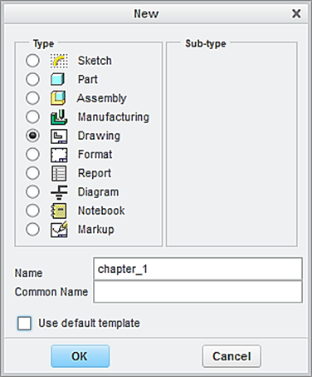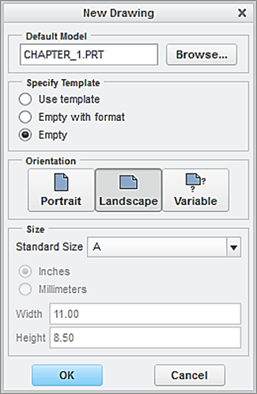

This brings up the drawing screen. Click the icon of **Layout**. Click the icon of **General.** In the **Select Combined** **State** window, click OK to accept **No Combined State**.

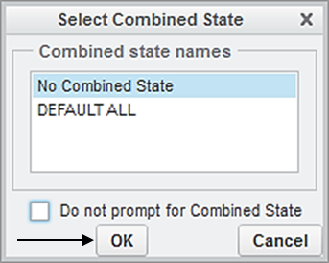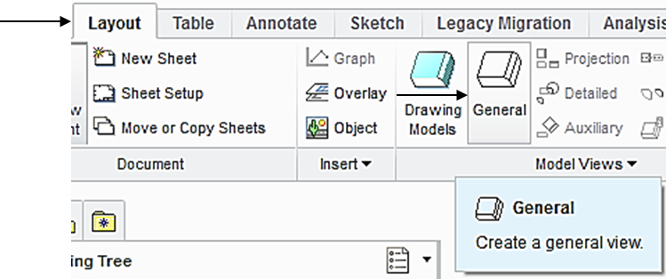

Select a location on the drawing screen as the center point for the **General** **View**. A general view appears on the screen.

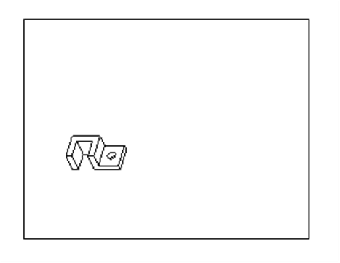

In the pop-up Drawing View window, select **FRONT** > **Apply** > **Close**, the construction of the **Front View** is completed.

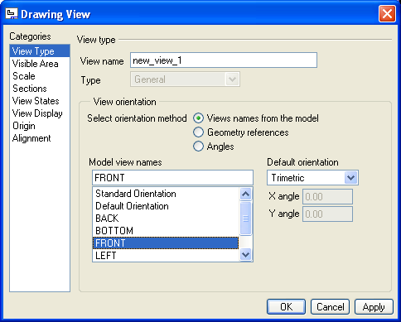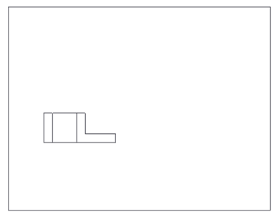

To insert the right side view, pick the **FRONT** View just created so that the Front View is activated, click the icon of Projection and make a left click at the right side of the Front View.

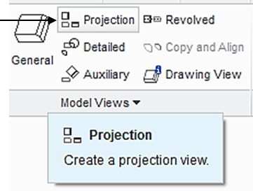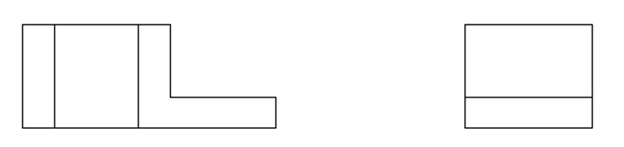

An alternative method to create a projection on the right side is to click the Front View for activation. Afterwards, make a right-click and hold, and then select **Insert** **Projection View** > move the cursor to the right side and click the left button. The construction of the right side view is completed.

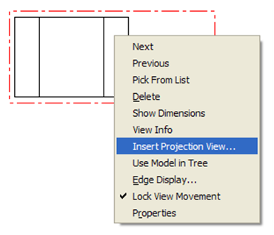

Follow the same procedure to create the top view, as shown below.

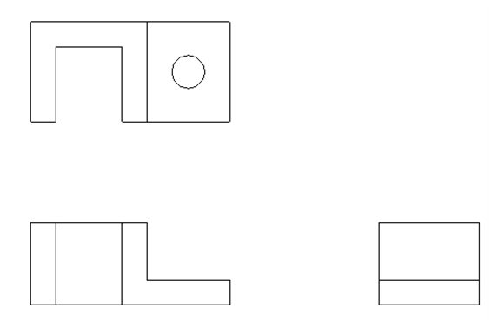

Click the icon of **General.** In the **Select Combined** **State** window, click **OK** to accept **No Combined State**. Select a location on the drawing screen as the center point for the 3D View (click the left button of mouse). A general view appears on the screen. In the pop-up Drawing View window, select **Standard Orientation** > **Apply** > **Close**, the construction of the 3D View is completed.

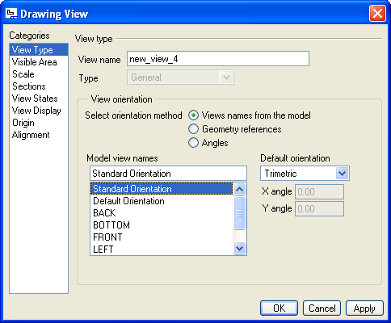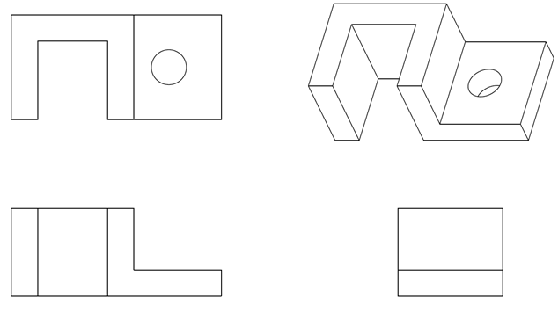

Sometimes, users may notice that the names of the datum planes, such as FRONT, RIGHT and TOP, appear on the drawing. The name of coordinate system, such as PRT_CSYS_DEF, also appears. To clean the drawing screen, click the icon of Datun Display Filter.

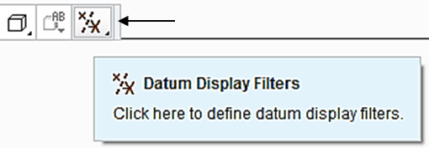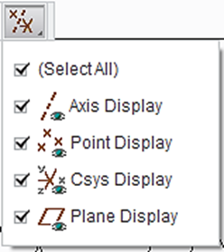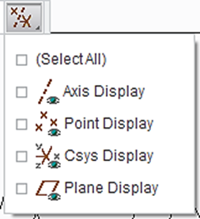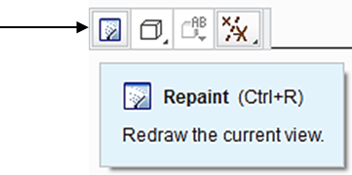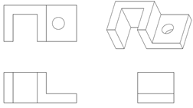

Upon completing the layout, we start adding dimensions. Click the icon of **Annotation**. Select the icon of **Show Model Annotation.**

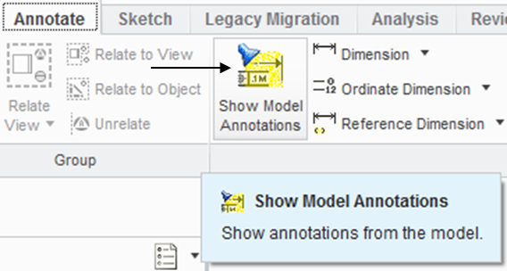

In the pop-up window, select the icon of **Dimensions.** To show the dimension of Extrude 1, click Extrude 1 listed in the model tree. Click Accept and OK. The 3 dimensions of 2.5, 3.5 and 3.0 are shown. Click the box of **Accept** **All** > **OK**.

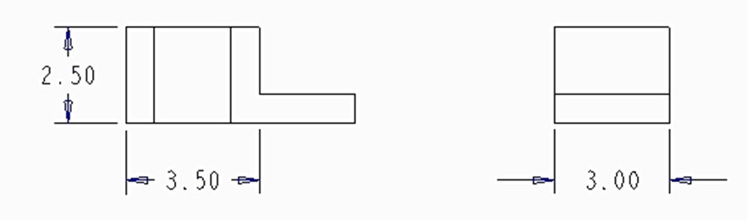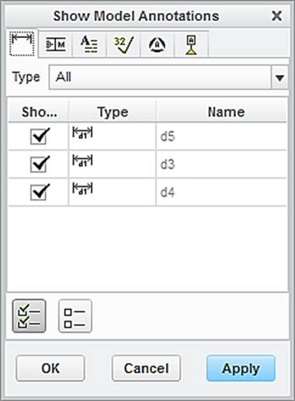

Dimension

Accept all

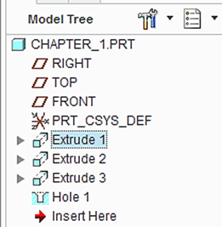

To show the dimension of Extrude 2, click Extrude 2 listed in the model tree. Click Accept and OK. The 3 dimensions of 2.25, 2.0 and 2.5 are shown. Click the dimension 2.25 and dimension 2.0 and do not click dimension 2.5 because there is 2.5 on display. Click the box of **Apply** > **OK**.

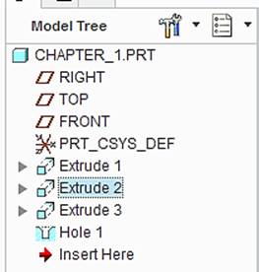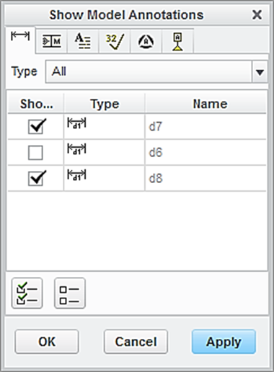

**Dimensions**

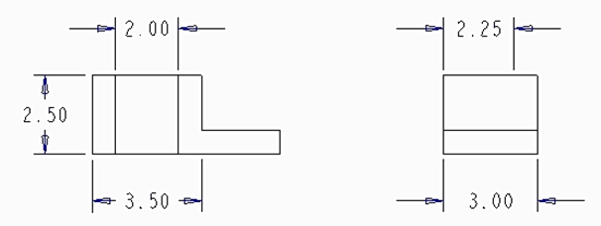

Accept all

Users may use the left button of mouse to pick up a dimension and draw it for moving to an appropriate location. For example, the dimension of 3.5 is repositioned.

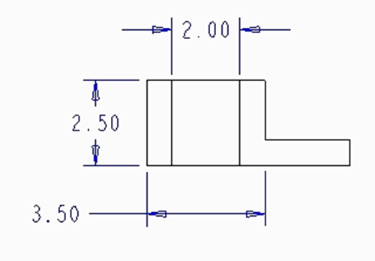

To show the dimensions, for example of Extrude 3, an alternative way is to click the icon of **Dimension** - **New** **References** > **On** **Entity** > Pick the relevant lines using the left clicks on the mouse > click the middle button of the mouse to position the dimension at an appropriate location.

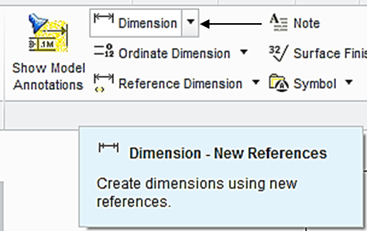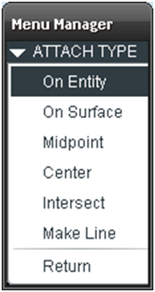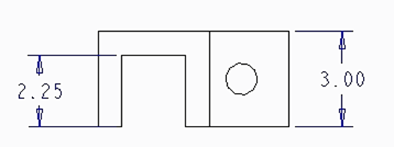

Left click this line

Left click this line

Click the middle button to place the dimensioni

Click the middle button to place the dimensioni

Now let us add centerlines to the drawing. In the pop-up window, select the box of centerlines. Click the hole feature listed in the model tree. All the centerlines are shown. Click **Accept All > OK.**

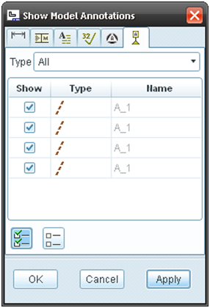

Accept all

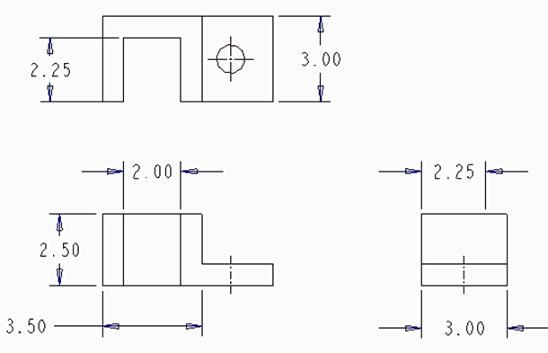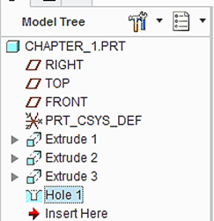

Users may add the required dimensions on your own. Users may also move some of the dimensions displayed on the Front View to the Right-Sided View. First, pick the dimension > right click and hold, select **Move Item to View**. Afterwards, pick the Right-Sided View.



At this time, the user has successfully completed the engineering drawing of the designed object with a block feature, a slot feature and a hole feature. Select **Save** > **OK**.

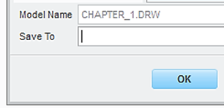

**EXERCISE AND ACTIVITIES**

