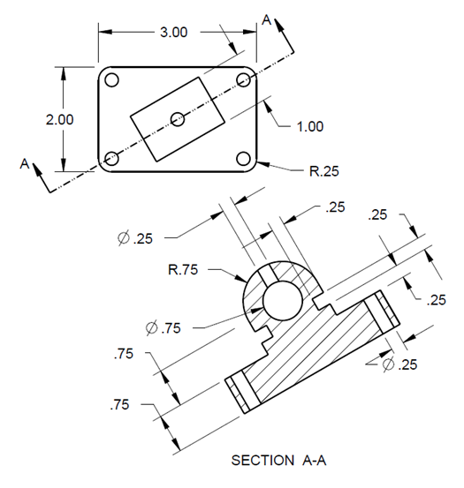**4.6 Datum Features**

Task: Create a Rod-guide using CREO as shown in the figure. The unit is in inches.

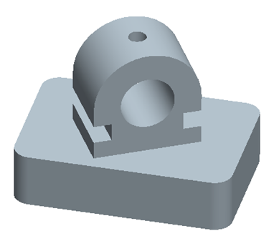

Step 1: Create a new file for the 3D solid model.

From File, select the icon of **New.** In the **New** window, click **Part**.

Type *rod_guide* as the file name. Clear the box of Use default template. Afterwards, click **OK**. In the New File Options window, select inlbs_part_solid. Type *student* under Modeled_by, and type *rod* *guide* under Description. Click **OK**. This will bring up the design window.

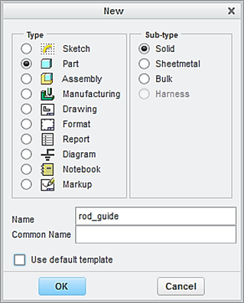

Clear this box

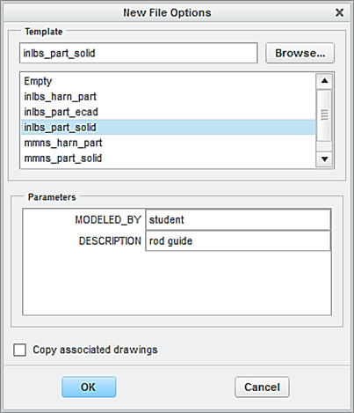

Step 2: Create the first feature, which is a plate.

Click the icon of **Extrude** displayed on the toolbar. Specify o.75 as the height of the plate feature. Activate **Placement** > **Define.**

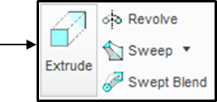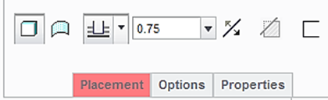

Select the **TOP** datum plane as sketching plane and click the icon of **Sketch** **View** to orient the sketching plane parallel to the screen.

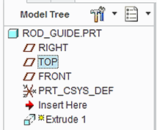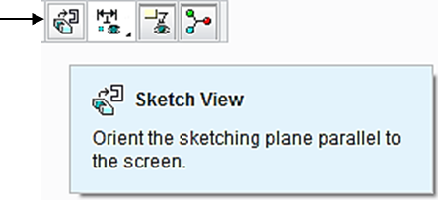

Click the icon of Center Rectangle and sketch a rectangle symmetric about the origin. Click the icon of One by One. Modify the 2 dimensions to 3 and 2, respectively.

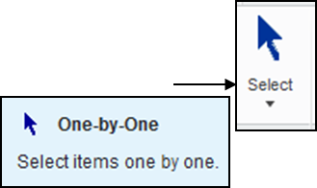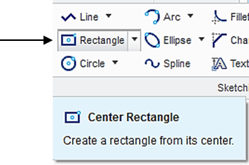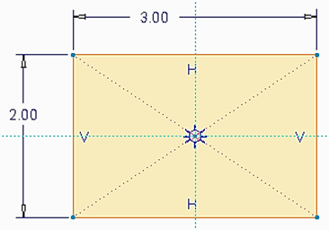

Upon completing this sketch, click the icon of **OK** and click the icon of **Apply** **and Save** to complete the creation of the plate feature.

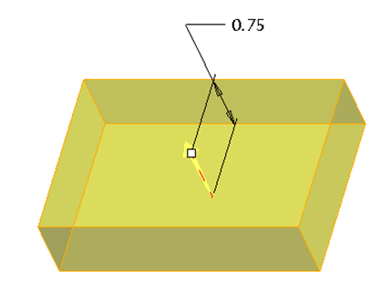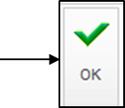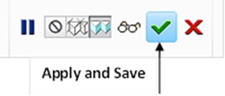

Step 3: Create the second feature, which is a round feature.

Click the icon of **Round**. Specify 0.25 as the radius value. Pick the 4 edges at the 4corners.Click the icon of **Apply and Save**.

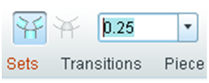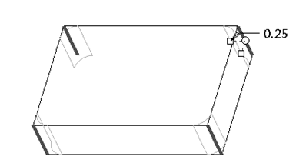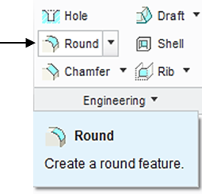

Step 4: Create the datum plane at an angle equal to 30 degrees with respect to the **FRONT** datum plane.

Click the icon of **Datum Axis**. While holding down the **Ctrl** key, pick the **FRONT** and **RIGHT** datum planes. Click **OK**.

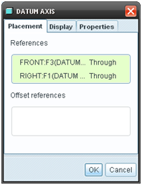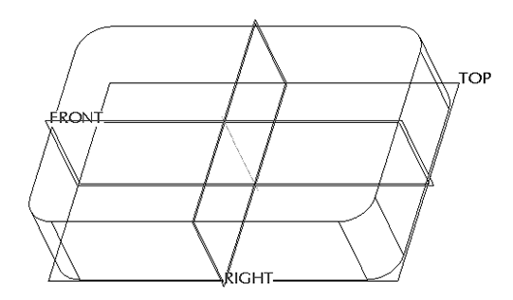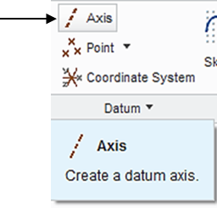

Click the icon of **Datum Plane**. Pick the created axis and the **FRONT** datum plane while holding down the **Ctrl** key. Type 30 and click **OK**.

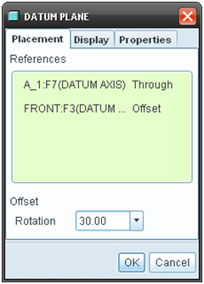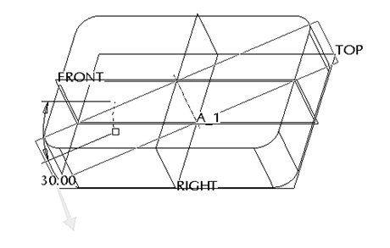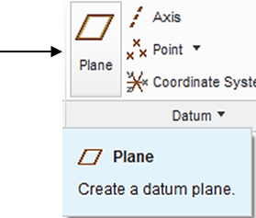

Step 5: Create the third feature, which is a plate.

Click the icon of **Extrude**. Select Symmetry and specify 1.0 as the extrusion value on both sides of the sketching plane.

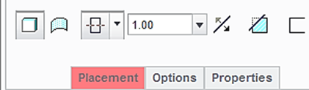

Symmetry



From the Model Tree, select the **DTM1** datum plane as the sketching plane, and click the icon of Sketch View to orient the sketching plane parallel to the screen.

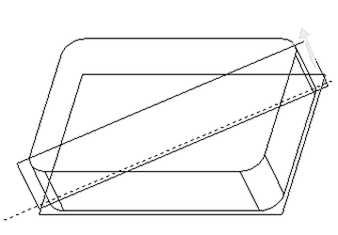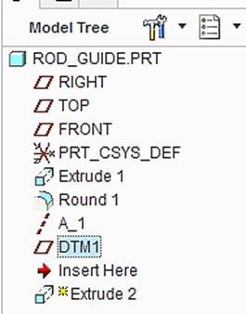

Click the icon of **References**, and add 2 new references. Click the surface on the top of the plate, as shown. Pick the vertical axis, as shown. click **Close**.

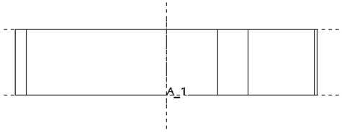

New references

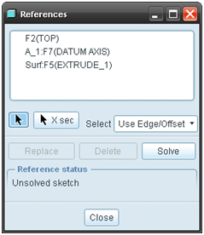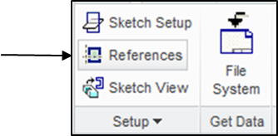

Click the icon of Centerline. Sketch a vertical centerline, as shown.

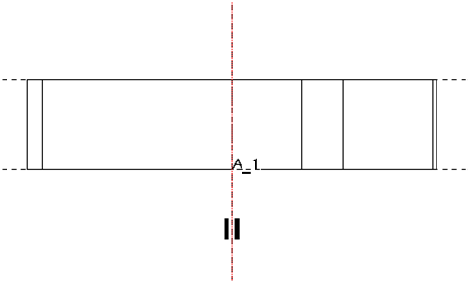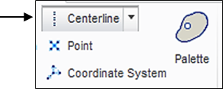

Click the icon of **Circle**. Sketch a circle, as shown below. Modify the position dimension to 0.75.

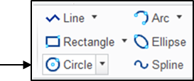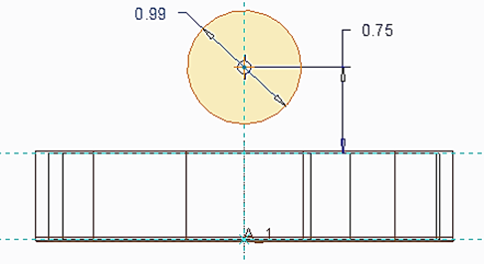

Click the icon of **Centerline**. Draw the horizontal centerline through the center, as shown.

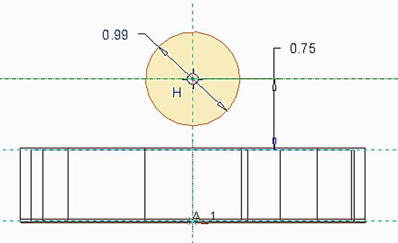

Click the icon of **Delete**. Remove the half circle on the lower side, as shown. A radius dimension is shown. Modify the radius value to 0.75.

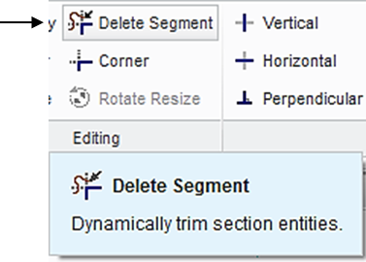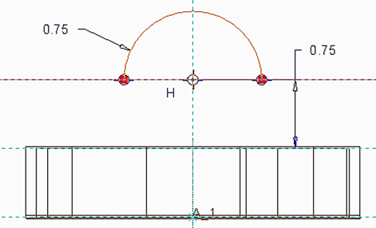

Click the icon of **Line** to sketch 3 lines, which connect the 2 ends of the half circle to form a closed sketch, as shown.

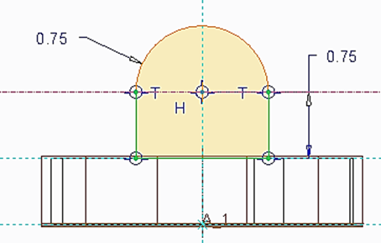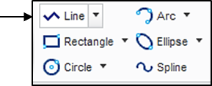

Click the icon of **Circle**. Sketch a circle, as shown below. The diameter value is 0.75.

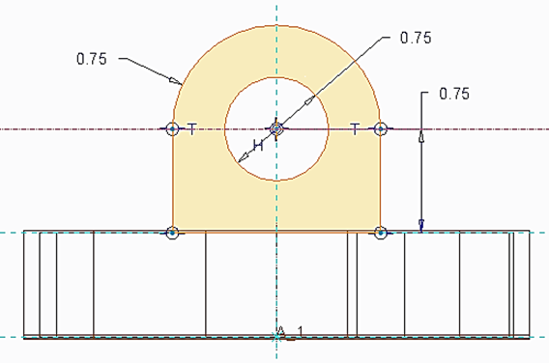

Upon completing this sketch, click the icon of **OK** and click the icon of **Apply** **and Save** to complete the creation of the half cylinder feature.

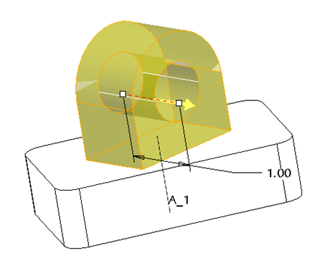

Step 6: Create the third feature, which cuts or removes the material from the created feature.

Click the icon of **Extrude**. Select **Cut**, and specify **Thru All** as the depth choice.

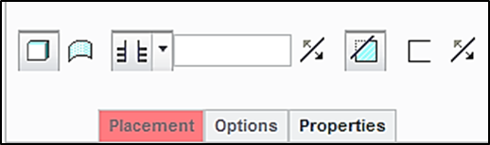

Select the front surface of the angle plate as the sketch plane, and accept the **TOP** datum plane as the default reference to orient the sketch plane, as illustrated below:

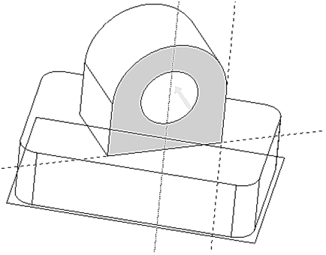

lick **References**, and add 3 new references. Click the surface on the right side of the plate, as shown. Pick the vertical axis, and the top surface of the plate, as shown. click **Close**.

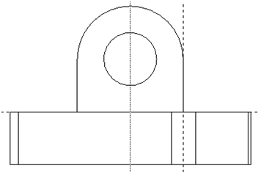

New references

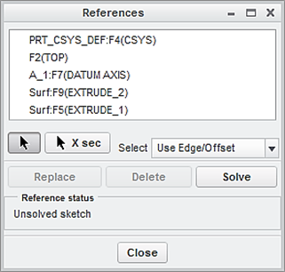

Click the icon of Centerline. Sketch a vertical centerline, as shown.

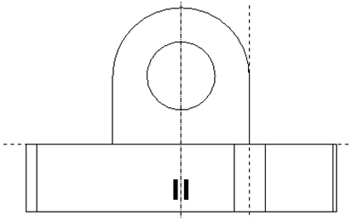

Click the icon of **Rectangle**. Sketch a rectangle, all the 3 dimensions are equal to 0.25, as shown.

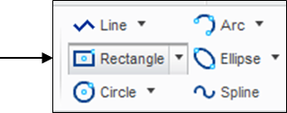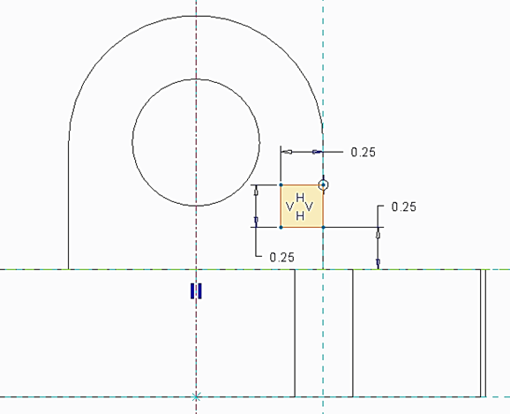

Pick this rectangle and click the icon of **Mirror**. Afterwards, click the vertical centerline to obtain the rectangle sketch on the left side, as shown.

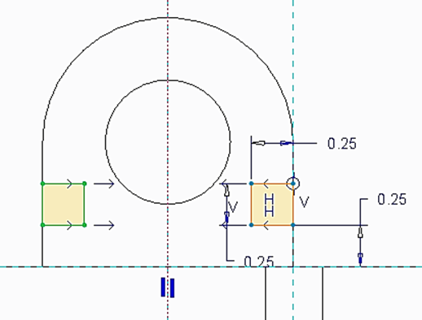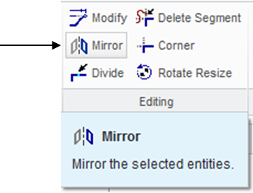

Upon completing this sketch, click the icon of **Done** and click the icon of **Apply** **and Save** to complete the creation of the cut feature.

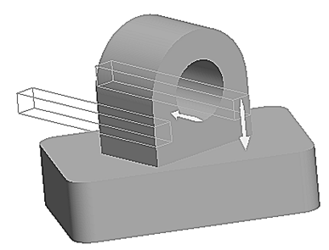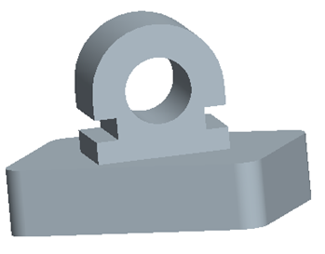

Step 7: Create a through hole and the diameter dimension is 0.25 inch.

Click the icon of **Hole** displayed on the toolbar. Specify 0.25 as the diameter value and use **Up** **to** **Next** as the depth choice. Activate **Placement** > pick the axis and, while holding down the **Ctrl** key, pick the upper half cylindrical surface. Click the icon of **Apply** **and** **Save**.

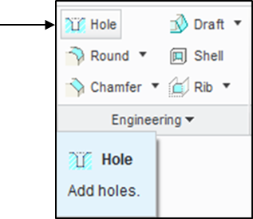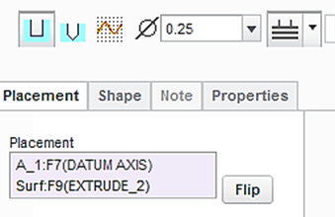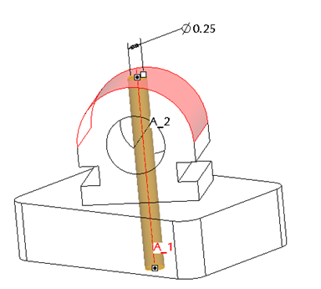

Step 8: Create 4 holes on the base plate. The diameter dimension is 0.25 inch.

Let us first create an axis at the corner, as shown. Click the icon of **Datum Axis**. Pick the round surface at the corner > **OK**. An axis is created.

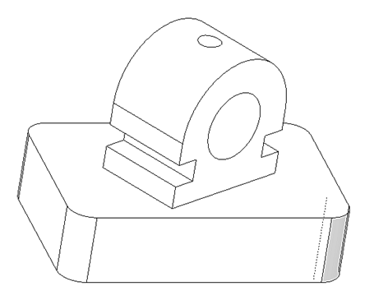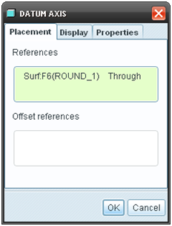

Click the icon of **Hole** displayed on the toolbar. Specify 0.25 as the diameter value and use **Thru All** as the depth choice. Activate **Placement** > pick the axis and, while holding down the **Ctrl** key, pick the top surface of the plate. Click the icon of **Apply** **and** **Save**.

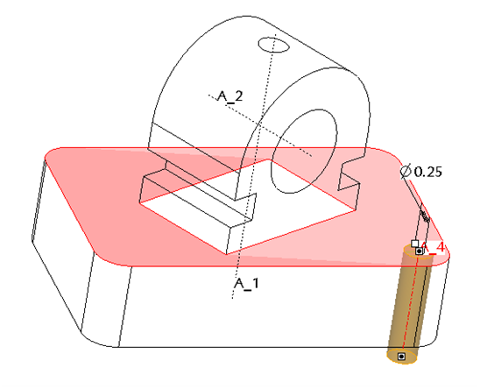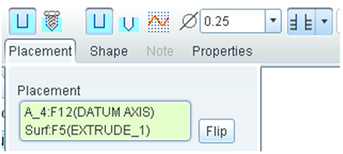

Now let us use MIRROR to create the other 3 holes. In the model tree, highlight Hole 2. Click the icon of **Mirror** **Tool**. Pick the RIGHT datum plane and click the icon of **Apply and Save**. A hole feature is created through **MIRROR**, as shown.

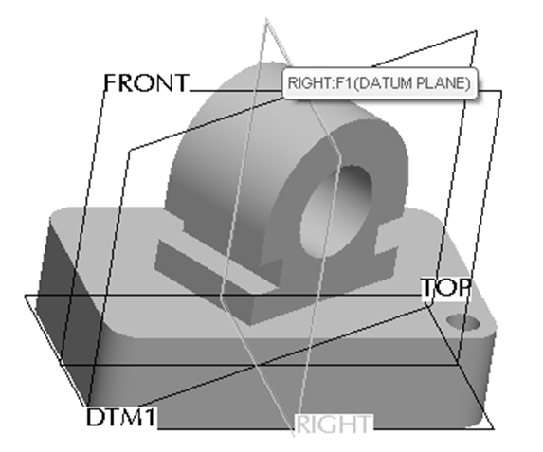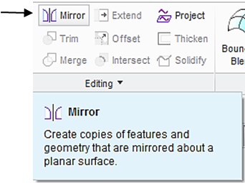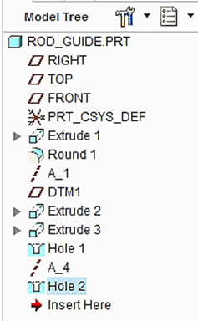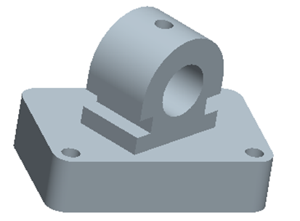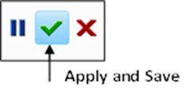

Repeat this process two more times (use FRONT and RIGHT, respective) to obtain the other 2 holes, as shown.

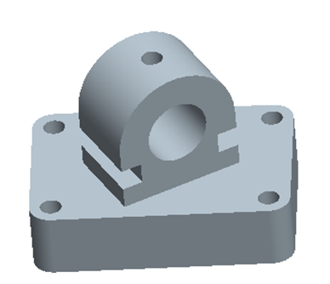

At this time, we have successfully completed the angle feature design. Remember to save all work with the 3D solid model. You select **Save** from the main toolbar > **OK**.

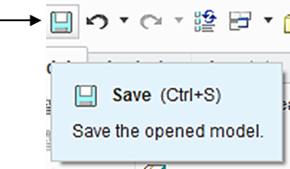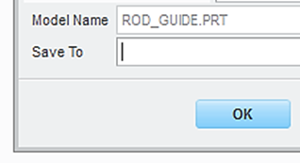

Step 9: Prepare an engineering drawing

To prepare an engineering drawing based on the 3D solid model, we need to create a drawing file. First, we select the icon of **New.** Select **Drawing**. Type rod_guide as the file name. Clear the box of **Use default template** because we do not want to use the default setting for the drawing work. Afterwards, click **OK**.

Select drawing

Clear the default box

Select paper size

Locate the 3D solid model file

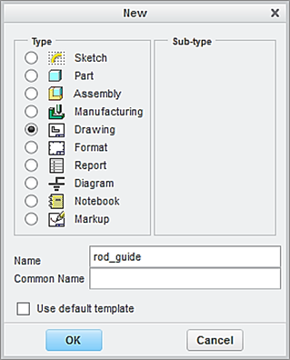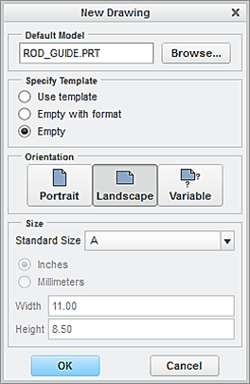

In the window of **New Drawing** shown above, make sure that the file of the 3D solid model called *rod_guide* is shown. Otherwise, use “**Browse**” to locate it. Select **Empty** under Specify Template, and select the paper size to be **A**. Afterwards, click the button of **OK**.

This brings up the drawing screen. Click the icon of **Layout**. Click the icon of **General.** In the **Select Combined** **State** window, click OK to accept **No Combined State**.

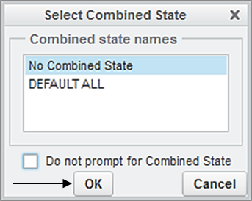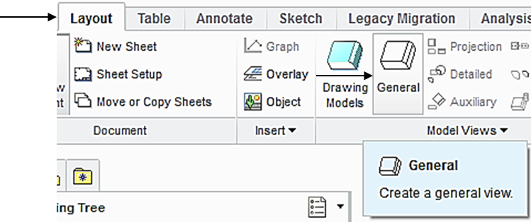

Select a location on the drawing screen as the center point for the **General** **View**. A general view appears on the screen.

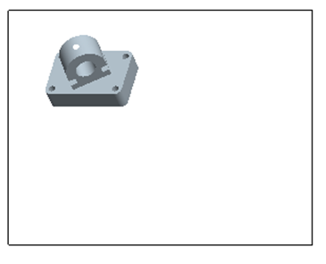

In the pop-up Drawing View window, select **TOP** > **Apply.** To change the scale, click **Scale** > **Custom scale** > type 0.75 > **Apply** > **Close**, the construction of the Front View is completed.

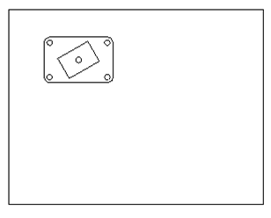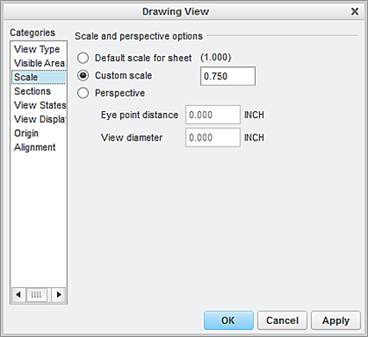

To insert an auxiliary view, click the icon of **Auxiliary** from the Layout tab. From the **TOP** projection, left-click the edge of the inclined rectangle, and move the cursor to the right side, as shown > left-click to position the auxiliary view. Note that the auxiliary view is aligned to the inclined rectangle in the TOP projection view.

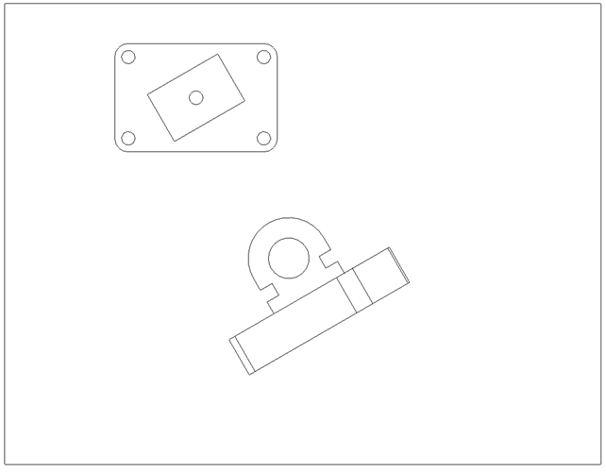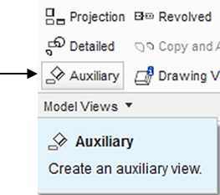

Step 10: Add a section view to the auxiliary view.

First, let us enable the display of datum planes. Click the icon of **Datum Display Filter** and check the box of **Plane** **Display** and **Repaint.**

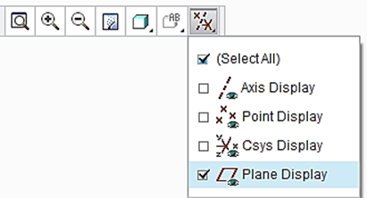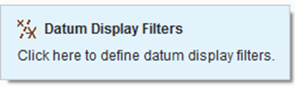

Now activate the auxiliary view by left clicking the mouse. Afterwards, right click and hold, select **Properties.**

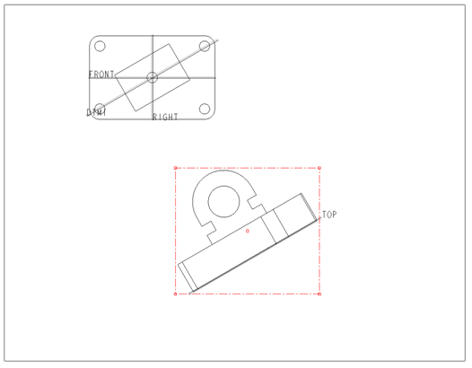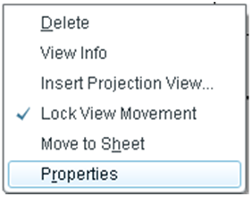

In the Drawing View window, select **Sections** and **2D cross-section.** Click the icon of **Add** (plus sign) to add cross-section. In the pop up window, accept **Planar** and **Single > Done**.

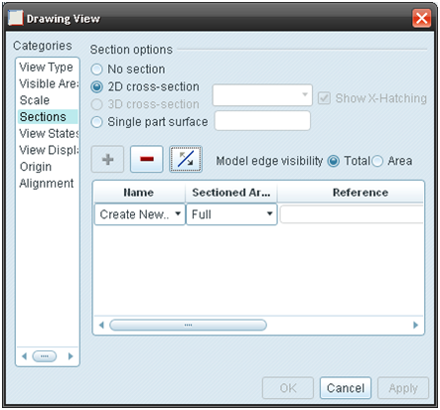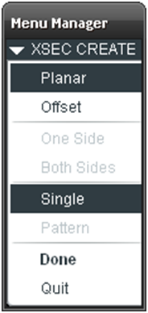

The software system is asking the user to enter a name for cross-section. Type *A* as the name for cross-section and press the **Enter** key. On the screen display, select the **DTM1** datum plane from the Top View > click the box of **Apply**, a cross-section is added to the auxiliary view.

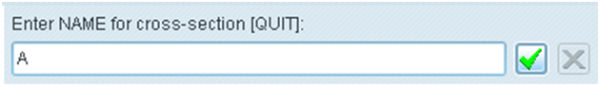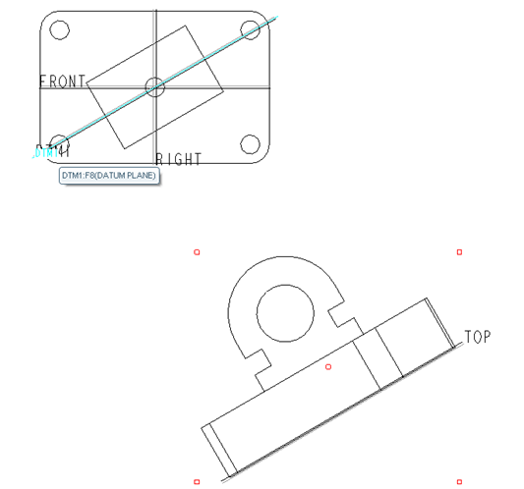

Pick DTM1 DATUM PLANE

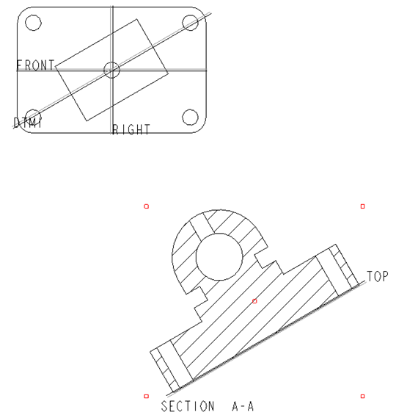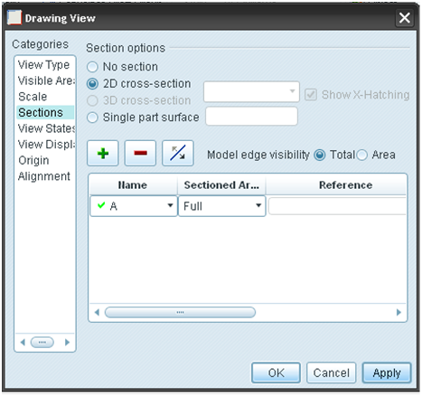

To add an arrow indicating the direction of the cross-section view, activate **Arrow Display** from the **Drawing View** window > click the Top view > **Apply** and two arrows marked as A appear together with SECTION A-A > **Close**.

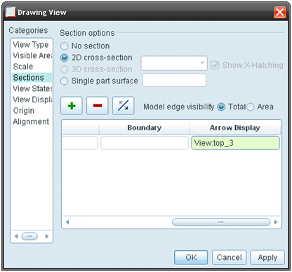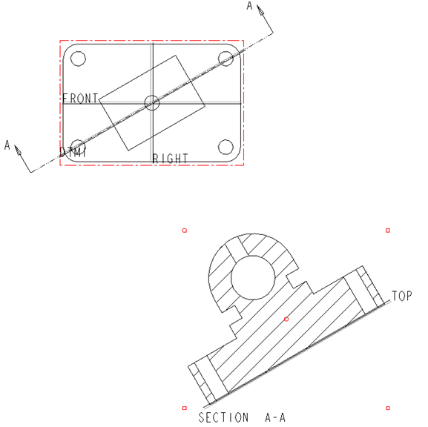

Upon completing the layout, we start adding dimensions. Click the icon of **Annotation**. Select the icon of **Show Model Annotation.**

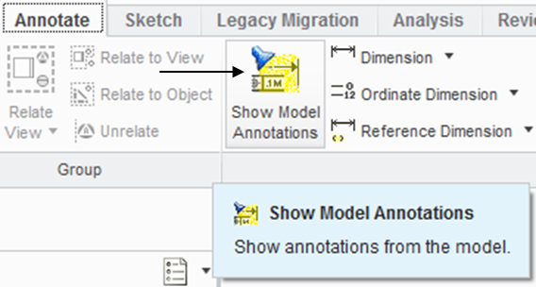

In the pop-up window, select the icon of **Dimensions.** To show the dimension of Extrude 1, click Extrude 1 listed in the model tree. Click Accept and OK. The dimensions associated with Extrude 1 are shown. Click the box of **Accept** **All** > **OK**. Follow the same procedure to add the dimensions associated with Round 1, Extrude 2, Extrude 3, Hole 1 and Hole 2.

Dimension

Accept all

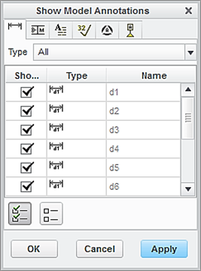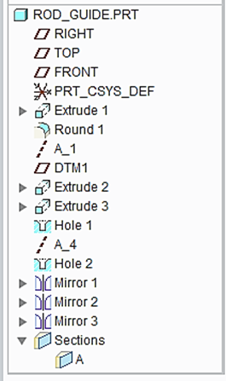

To add centerlines, select the box of centerlines. Click the hole features listed in the model tree. All the centerlines are shown. Click **Accept All > OK.**

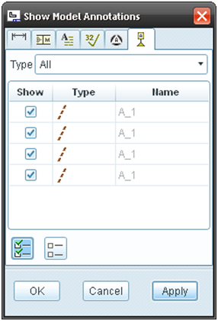

Accept all

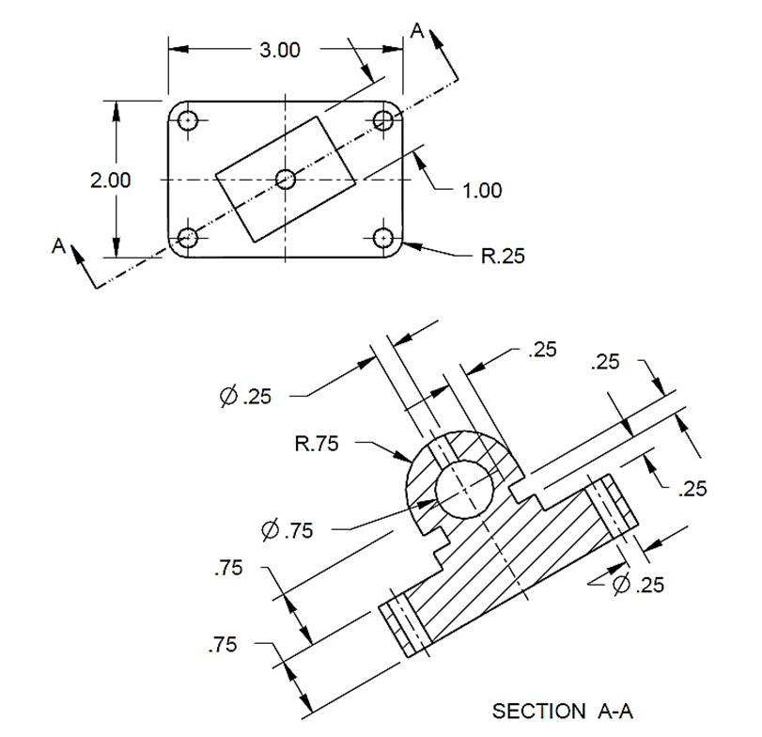

Let us insert the format to the drawing. From the Layout tab, click the icon of Sheet Setup. In the **Page** **Setup** window, use **Browse** to locate the format file, which is *es100*_*fall_2012* > **Open** > select **Show** **format** > **OK.**

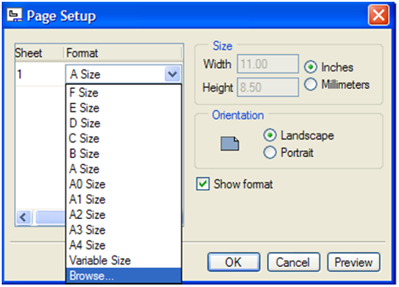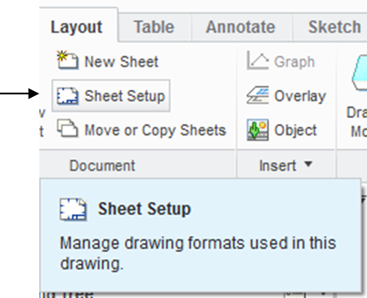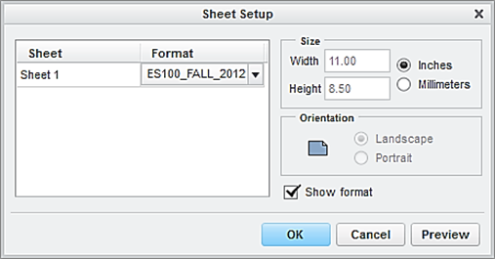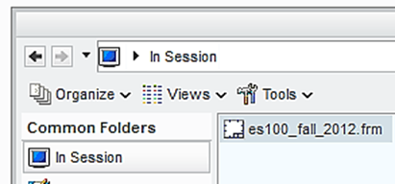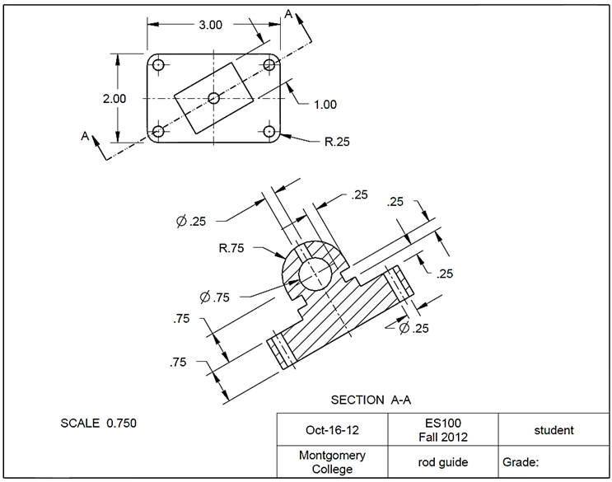

At this time, the user has successfully completed the engineering drawing of the designed part. Select **Save** from the main toolbar > **OK**.

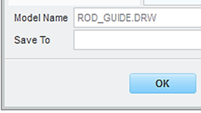

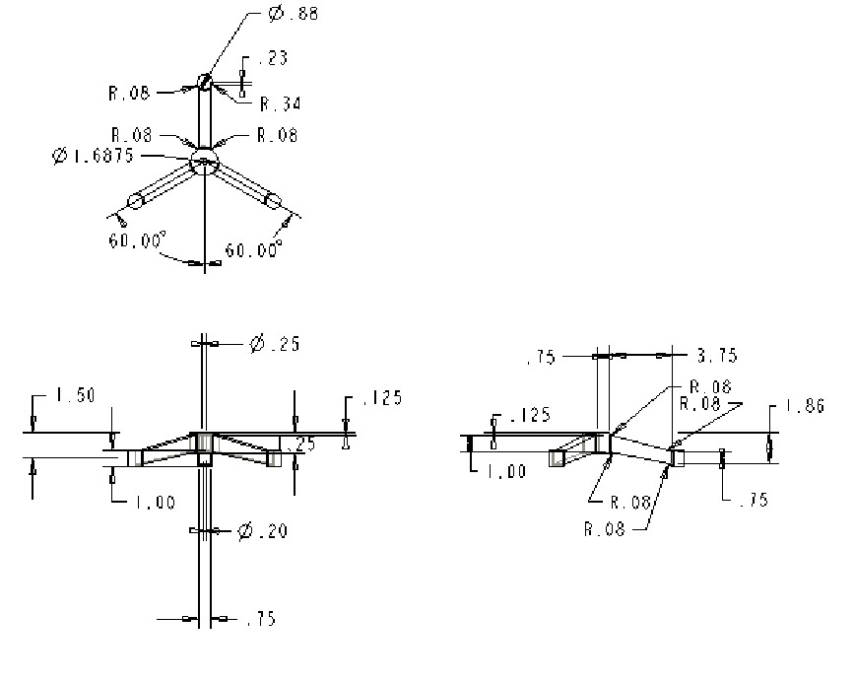**EXERCISE AND ACTIVITIES**

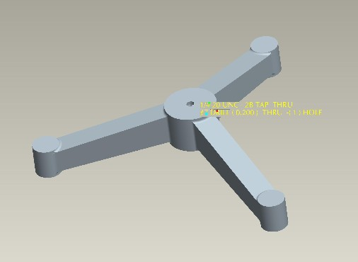1.

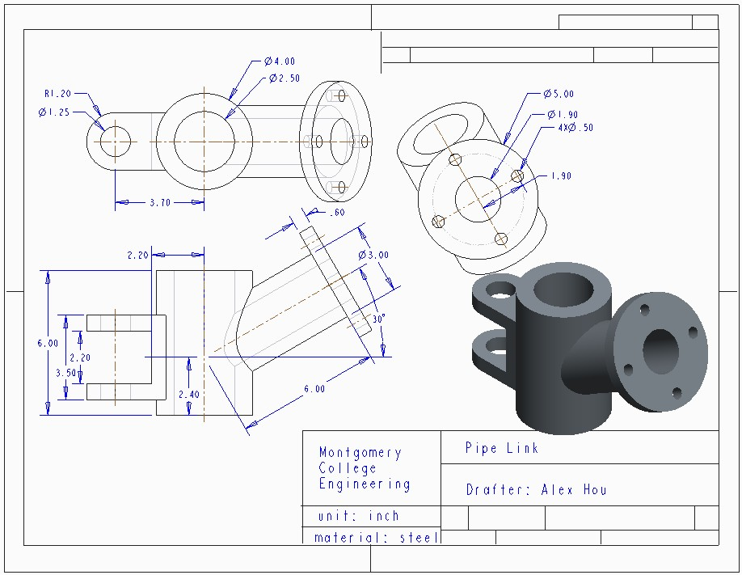2.