**4.2 Constructive Solid Geometry Concepts**

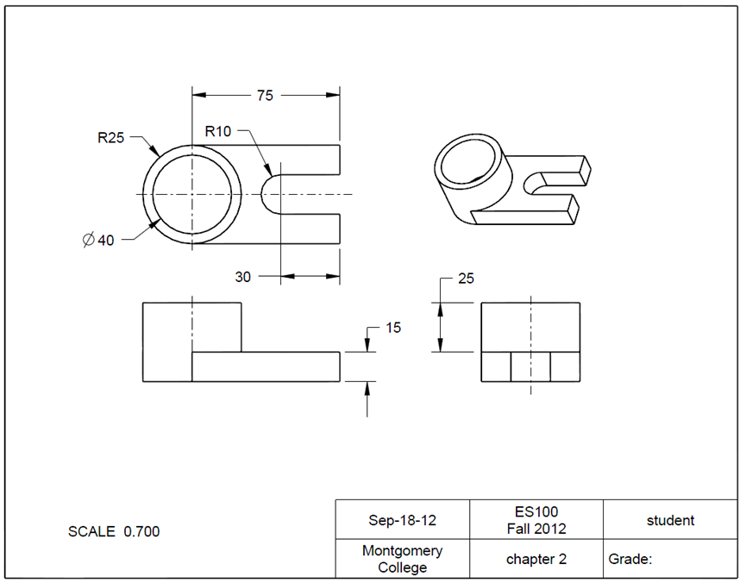Task: Use CREO to create a locator as shown in the figure. The unit is in millimeters.

Step 1: Create a new file for the 3D solid model.

Select **File** and click the icon of **New** from File. Type *chapter_2* as the file name. Clear the box of Use default template. Afterwards, click **OK**. In the **New** **File** Options window, select mmns_part_solid. Type *student* as Modeled_by and type *chapter* *2* as **Description**. Click **OK**. This will bring up the design window.

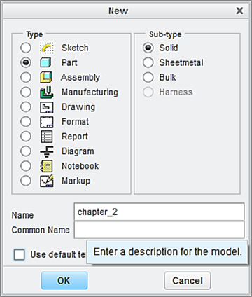

Type *chapter_2 as*  the file name

Clear this box

Click **OK**

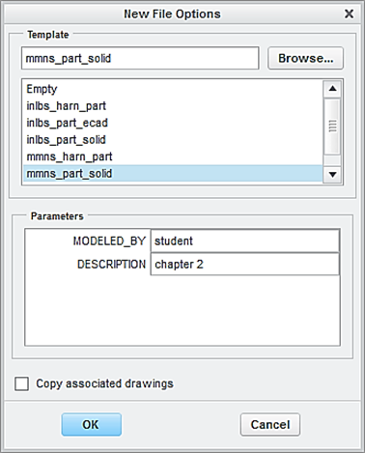

Step 2: Create the first feature, which is a plate. The 3 dimensions are R25 x 75 x 15 mm.

From the Model tab, click the icon of **Extrude**. Specify 15 as the height of the block feature.

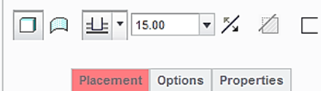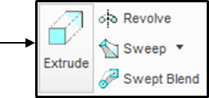

From the Model Tree, select the **TOP** datum plane as the sketching plane, and click the icon of **Sketch View** to orient the sketching plane parallel to the screen.

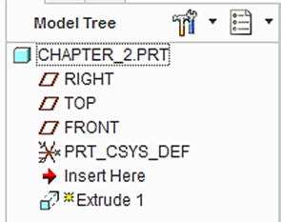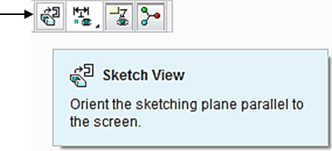

Let us create a 2D sketch. Click the icon of **Circle**, and sketch a circle, as shown below. Do not modify the dimension.

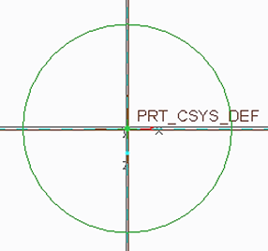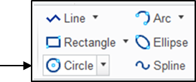

Click the icon of **Delete**. To remove the half circle on the right side, click the half circle on the right side, as shown. Note the diameter dimension is changed to a radius dimension. Modify the value to 25.

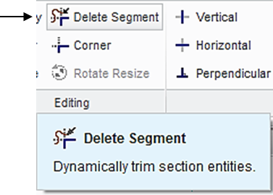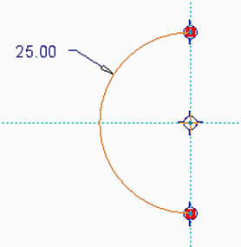

Click the icon of **Line** to sketch 3 lines, as shown. Specify 75 as the length value.

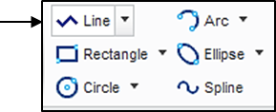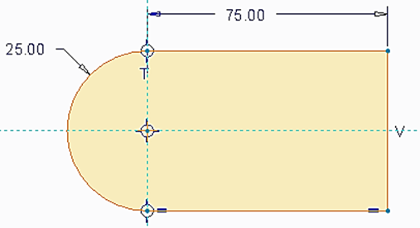

Upon completing this sketch, click the icon of OK and click the icon of **Apply** **and Save** to complete the creation of the plate feature.

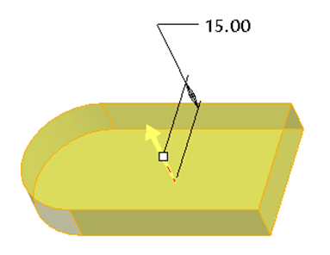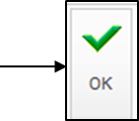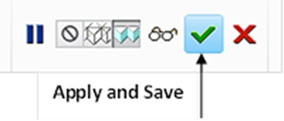

Step 3: Create the second feature, which is a cylinder and the 2 dimensions are Ø50 and 25 mm.

Click the icon of **Extrude.** Specify 25 as the height of the cylinder.

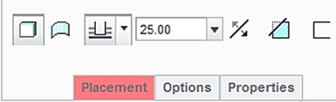

Select the top surface of the plate feature as the sketching plane, and click the icon of **Sketch** **View** to orient the sketching plane parallel to the screen.

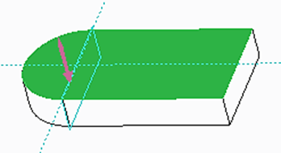

Before sketching the circle, let us click the icon of **References**, and add a new reference. Pick the half circle on the left side of the plate, as shown. After defining this new reference, click **Close**.

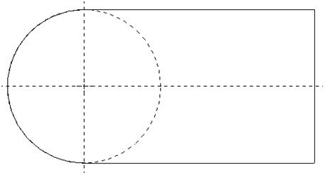

New reference

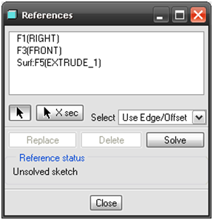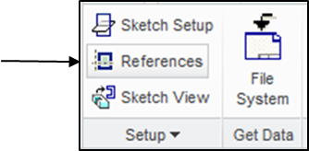

Click the icon of **Circle**. Sketch a circle, as shown below. There is no need to specify the diameter value because the sketched circle matches the half circle, as shown.

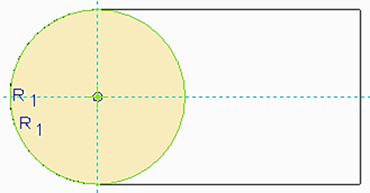

Upon completing this sketch, click the icon of **OK** and click the icon of **Apply** **and Save** to complete the creation of the cylindrical feature.

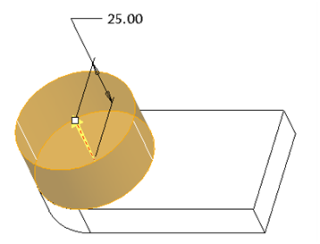

Step 4: Create a through hole and the diameter dimension is 40 mm.

Click the icon of **Hole** displayed on the toolbar. Specify 40 as the diameter value and use **Thru** **All** as the depth choice. Activate **Placement** > pick the axis and, while holding down the **Ctrl** key, pick the top surface of the cylinder. Click the icon of **Apply** **and** **Save**.

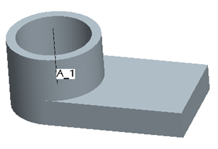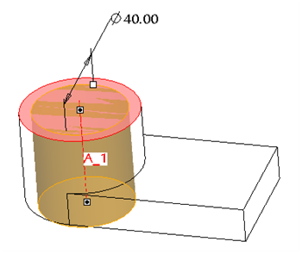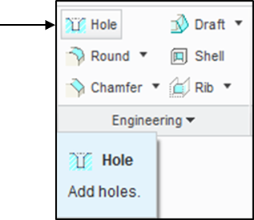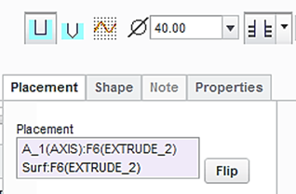

Step 5: Create the required slot feature. The 2 dimensions are R10 and 30 mm.

Click the icon of **Extrude** displayed on the toolbar. Select **Cut** and specify **Thru** **All** as the depth choice.

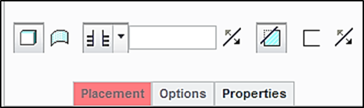

Select the top surface of the plate feature as the sketching plane, and click the icon of **Sketch** **View** to orient the sketching plane parallel to the screen.

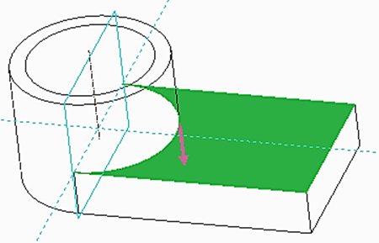

Before sketching the circle, let us click the icon of **References**, and add a new reference. Pick the line on the left side. After defining this new reference, click **Close**.

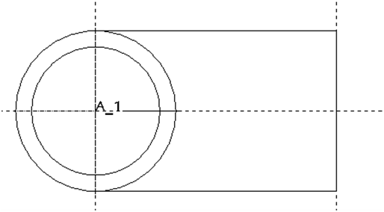

New reference

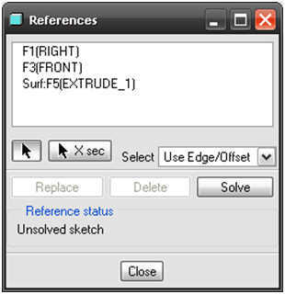

Click the icon of **Circle**, and sketch a circle, as shown below.

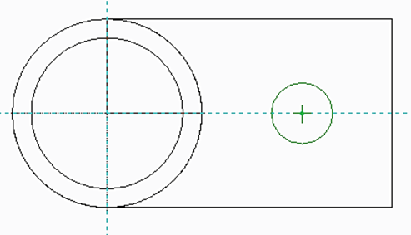

Pick the icon of **Centerline**. Draw a vertical centerline through the center of the circle, as shown.

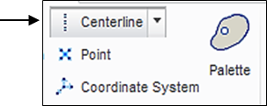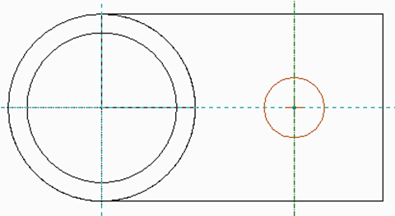

Click the icon of **Delete**. To remove the half circle on the right side, click the half circle on the right side, as shown. Note the diameter dimension is changed to a radius dimension. Modify the value to 10. Also modify the distance value to 30.

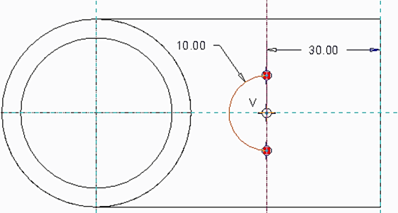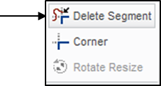

Click the icon of **Line** to sketch 3 lines, as shown.

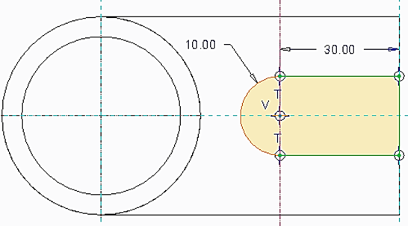

Upon completing this sketch, click the icon of **OK** and click the icon of **Apply** **and Save** to complete the creation of the cut feature.

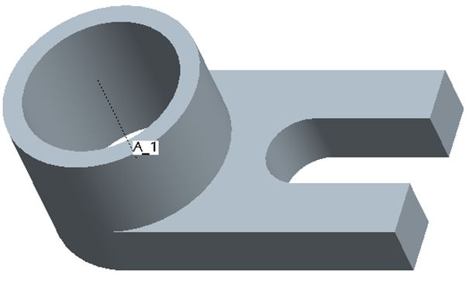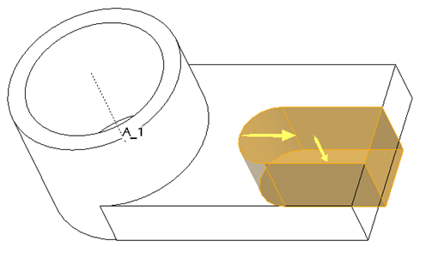

At this time, we have successfully completed the design. Remember to save all work with the 3D solid model. Click **Save** > **OK**.

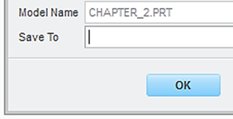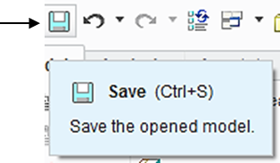

To prepare an engineering drawing based on the 3D solid model, we need to create a drawing file. First, we select the icon of **New**. Select **Drawing** and type chapter_2 as the name of the file. Clear the box of **Use default template** because we do not want to use the default setting for the drawing work. Afterwards, click **OK**.

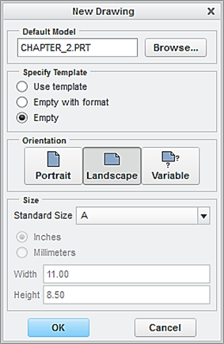

Select the drawing module

Clear the default box

Select paper size

Locate the 3D soild model file

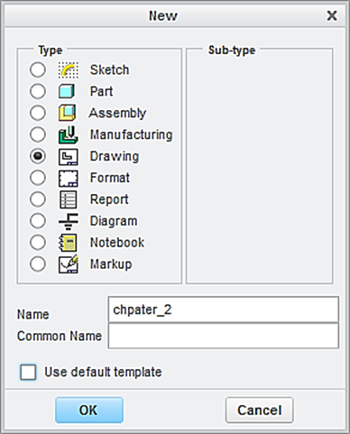

In the window of **New Drawing** shown above, make sure that the file of the 3D solid model called *chapter_2* is shown. Otherwise, use “**Browse**” to locate it. Select **Empty** under Specify Template, and select the paper size to be **A**. Afterwards, click the button **OK**.

This brings up the drawing screen. Click the icon of **Layout**. Click the icon of **General.** In the **Select Combined** **State** window, click OK to accept **No Combined State**.

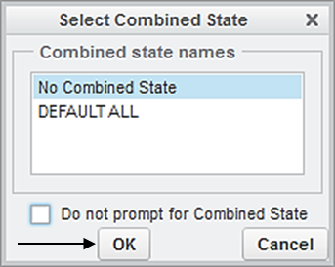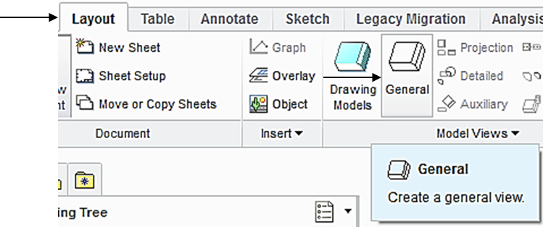

Select a location on the drawing screen as the center point for the **General** **View**. A general view appears on the screen.

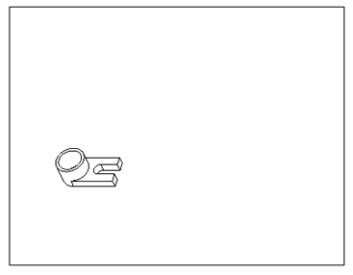

In the pop-up Drawing View window, select **FRONT** > **Apply** > **Close**, the construction of the Front View is completed.

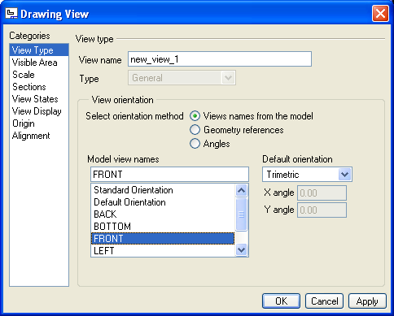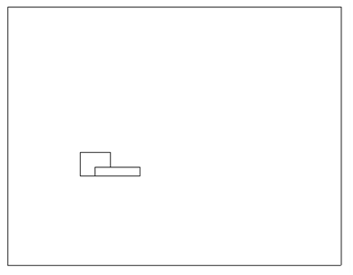

To insert the right side view, pick the **FRONT** View just created so that the Front View is activated, click the icon of **Projection** and make a left click at the right side of the Front View.

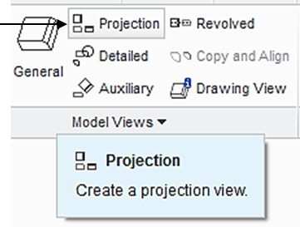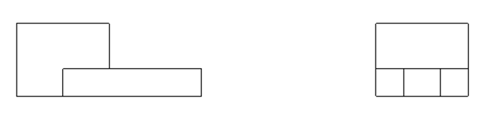

To insert the right side view we use an alternative method. Pick the **FRONT** View created, right-click and hold, and then select **Insert** **Projection View** > move the cursor to a position above the Front view. Click the left button of mouse, and the construction of the Top view is completed.

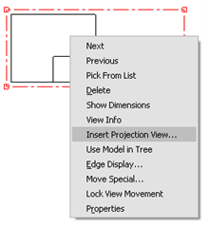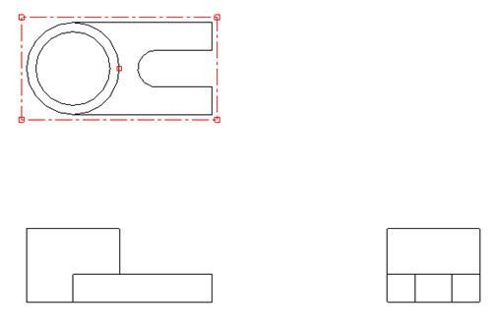

Click the icon of **General.** In the **Select Combined** **State** window, click **OK** to accept **No Combined State**. Select a location on the drawing screen as the center point for the 3D View (click the left button of mouse). A general view appears on the screen. In the pop-up Drawing View window, select **Standard Orientation** > **Apply** > **Close**, the construction of the 3D View is completed.

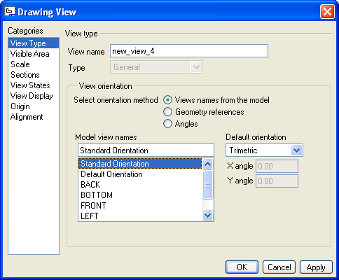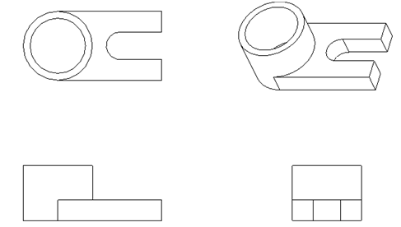

Upon completing the layout, we can start adding dimensions. Click the icon of **Annotation**. Select the icon of **Show Model Annotation.**

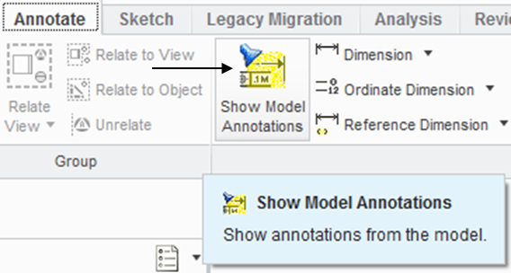

In the pop-up window, select the icon of **Dimensions.** To show the dimension of Extrude 1, click Extrude 1 listed in the model tree. Click Accept and OK. The 3 dimensions of 25, 75 and 15 are shown. Click the box of **Accept** **All** > **OK**.

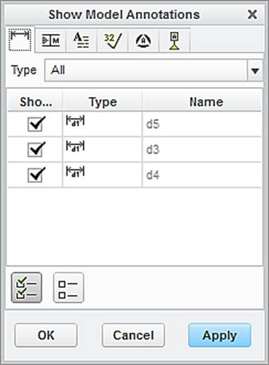

Dimension

Accept all

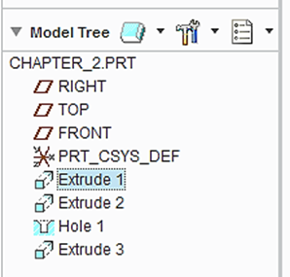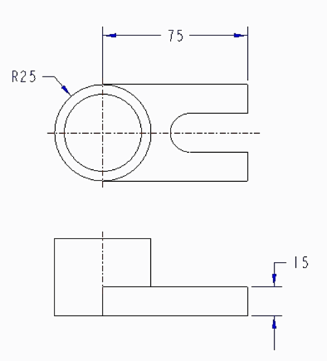

Follow the same procedure to add the dimensions associated with Extrude 2 , Extrude 3 and Hole 1.

To add centerlines, select the box of centerlines. Click the hole feature listed in the model tree. All the centerlines are shown. Click **Accept All > OK.**

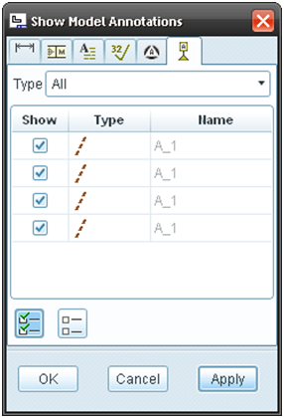

Accept all

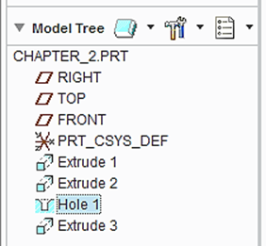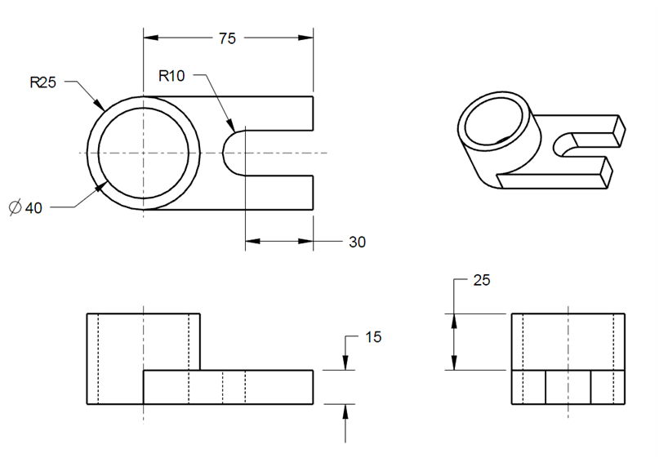

Let us insert the format to the drawing. From the Layout tab, click the icon of Sheet Setup. In the **Page** **Setup** window, use **Browse** to locate the format file, which is *es100*_*fall_2012* > **Open** > select **Show** **format** > **OK.**

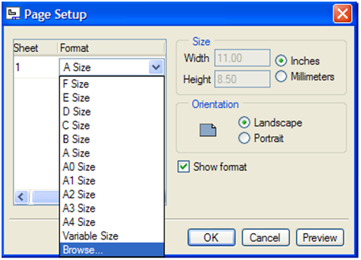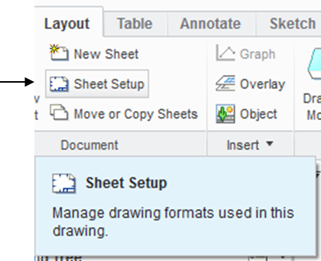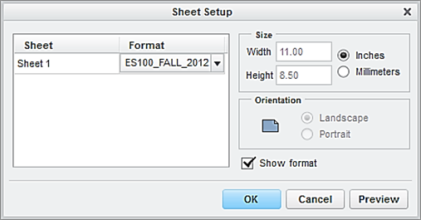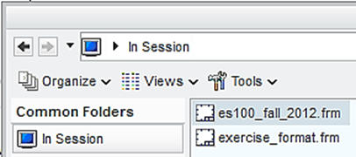

At this time, the user has successfully completed the engineering drawing of the designed part. Select **Save** > **OK**.

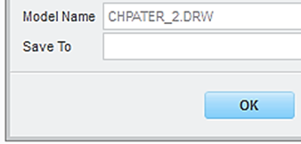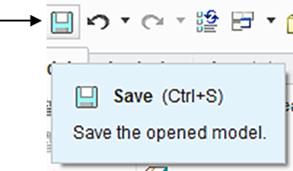

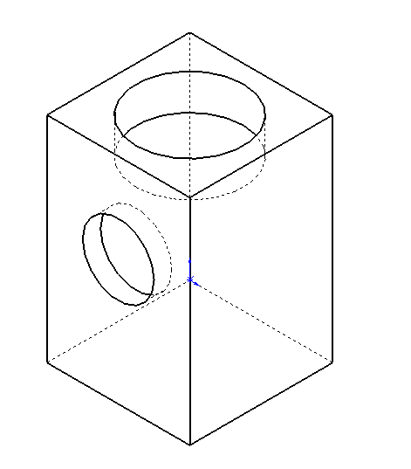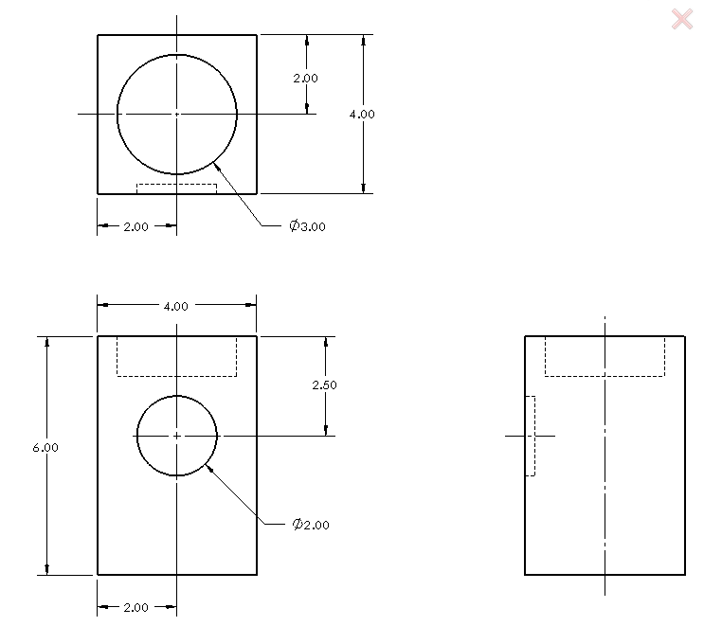**EXERCISE ANDACTIVITIES**