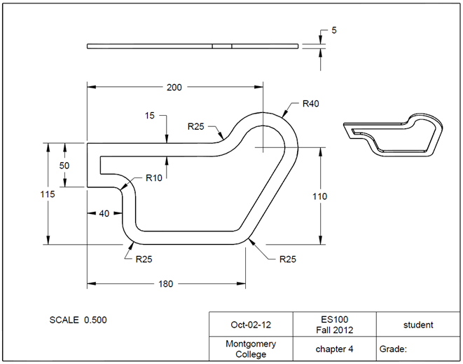**4.4 Geometric Constraints**

Task: Create a gasket using CREO as shown in the figure. The unit is in millimeters.

Step 1: Create a new file for the 3D solid model.

From File, click New, and select Part.

Type *chapter_4* as the file name. Clear the box of Use default template. Afterwards, click OK. In the New File Options window, select mmns_part_solid. Type student under Modeled_by, and type chapter 4 under Description. Click OK. This will bring up the design window.

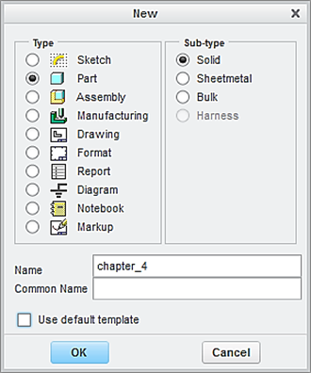

Type *chapter_4 as* the file name

Clear this box

Click **OK**

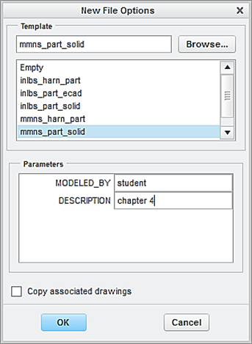

Step 2: Create the first feature, which is a plate.

Click the icon of Extruder. Specify 5 as the depth value of extrusion.

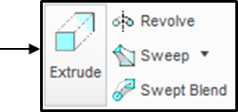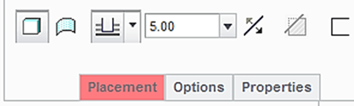

From the Model Tree, Select FRONT as the sketching plane. Click the icon of Sketch View to orient the sketching plane parallel to the screen.

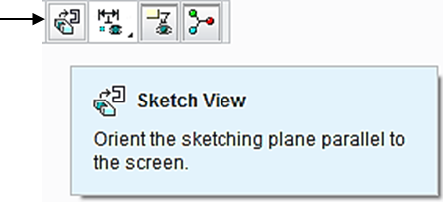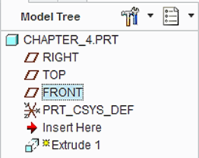

Click the icon of Create a geometry point. Make a left click on the horizontal axis. Specify 180 as the distance with respect to the origin.

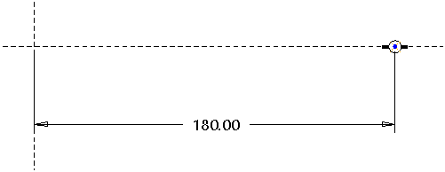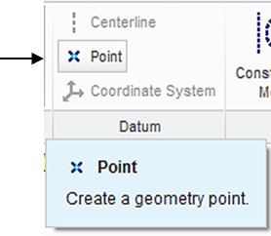

Click the icon of Create a geometry point. Make a left click to create the second point. The two dimensions are 200 and 110, respectively.

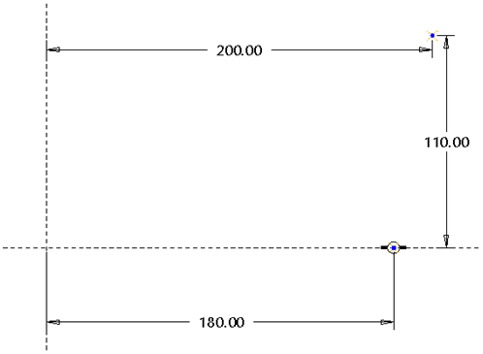

Click the icon of Circle, and sketch a circle. Specify 80 as the diameter value.

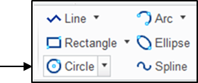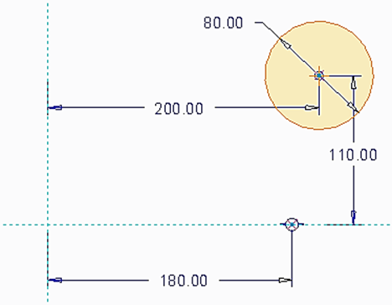

Click the icon of Line. Sketch a horizontal line. Specify 115 as the distance with respect to the horizontal axis, as shown.

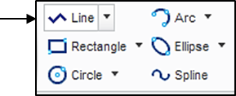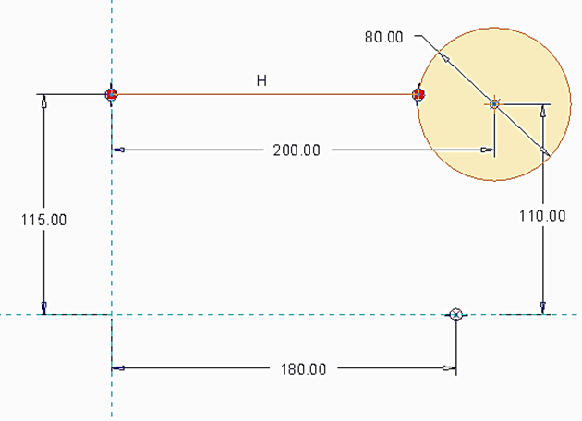

Click the icon of Circular to create a circular fillet. Specify 25 as the radius value, as shown.

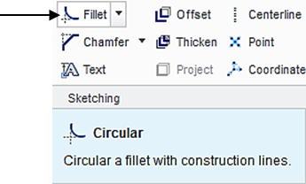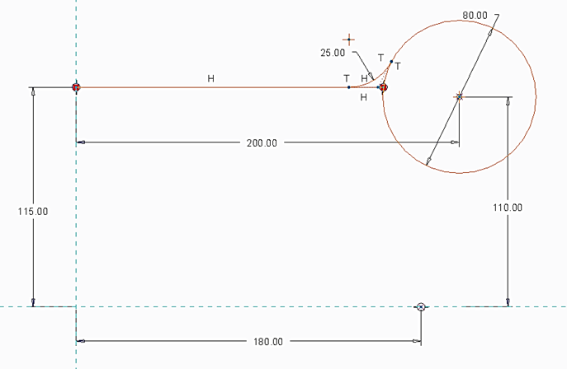

Click the icon of Line. Sketch a line, starting from the first created point and tangential to the sketched circle, as shown.

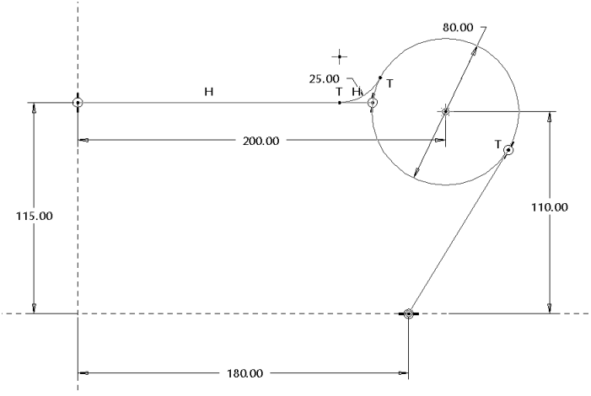

Click the icon of Delete to remove the segments from the sketched circle and the sketched horizontal line, as shown.

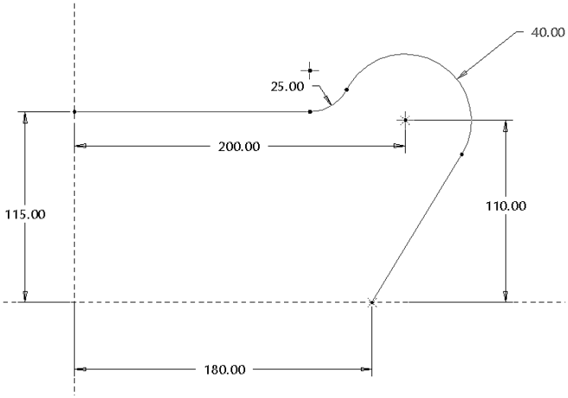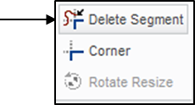

Click the icon of Line. Sketch 4 lines and add 2 dimensions of 50 and 40, as shown below.

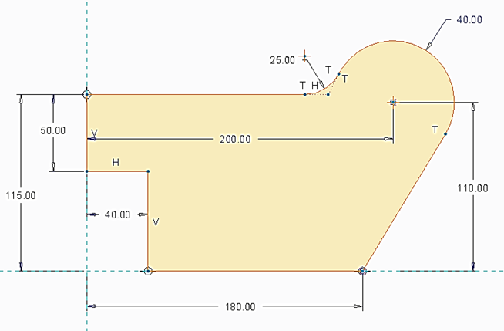

Click the icon of Circular to create 3 circular fillets. Specify 10, 25 and 25 as the radius values, respectively.

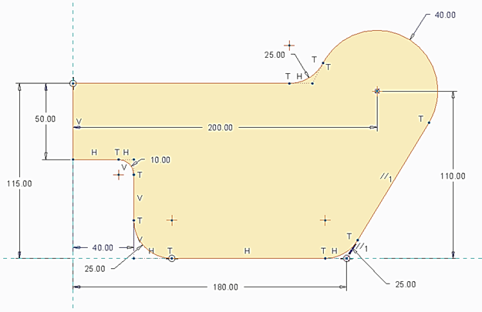

Upon completing this sketch, click the icon of OK and click the icon of Apply and Save to complete the creation of the plate feature.

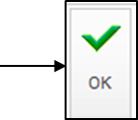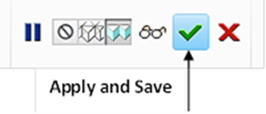

Step 2: Create the second feature, which is a cut feature.

Click the icon of Extrude. Select Cut and use Thru All as the depth choice.

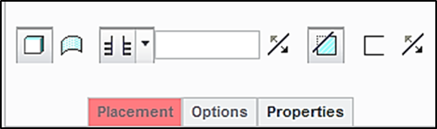

Select the front surface of the plate feature as the sketching plane, and click the icon of Sketch View to orient the sketching plane parallel to the screen.

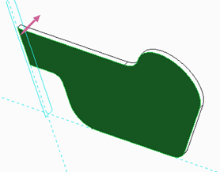

Click the icon of Offset. Click Loop and click the sketched curve. The system automatically selects the entire curve. Specify -15 as the offset value.

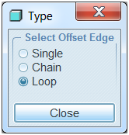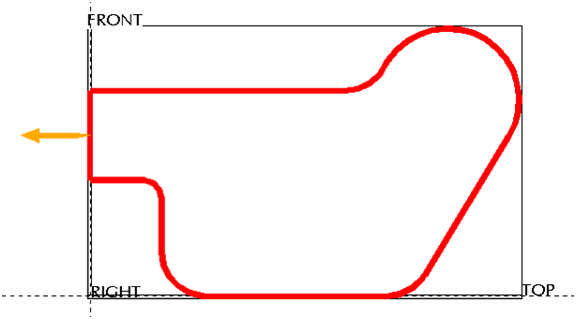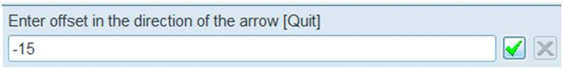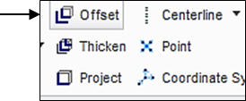

A new curve is created along the profile with a distance equal to 15, as shown below. Click the icon of OK. Click the icon of Apply and Save to complete the creation of the cut feature.

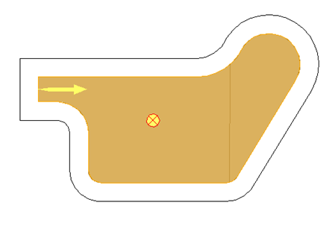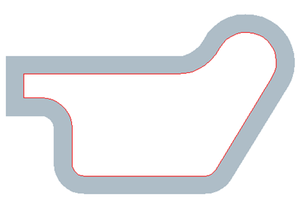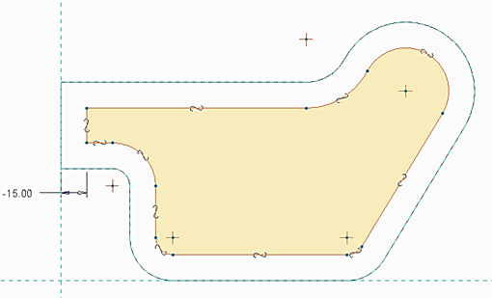

At this time, we have successfully completed the feature design. Remember to save all work with the 3D solid model. You select Save from the main toolbar > OK.

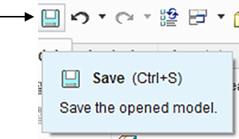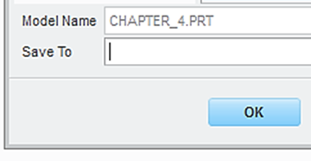

Step 3: Create an engineering drawing.

To prepare an engineering drawing based on the 3D solid model, we need to create a drawing file. First, we select the icon of New. Click Drawing. Type *chapter*_*4* as the name of the file. Clear the box of Use default template > OK.

Select Drawing

Clear the default box

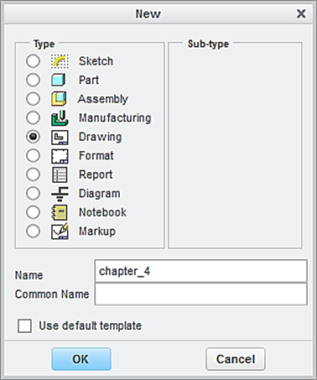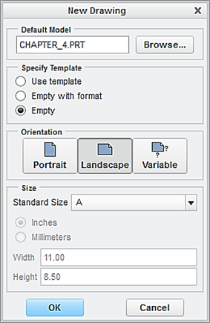

In the window of New Drawing shown above, make sure that the file of the 3D solid model called *Chapter_4* is shown. Otherwise, use “Browse” to locate it. Select Empty under Specify Template, and select the paper size to be A. Afterwards, click the button of OK.

This brings up the drawing screen. Click the icon of Layout. Click the icon of General. In the Select Combined State window, click OK to accept No Combined State.

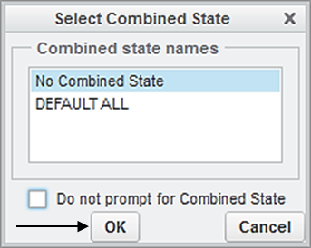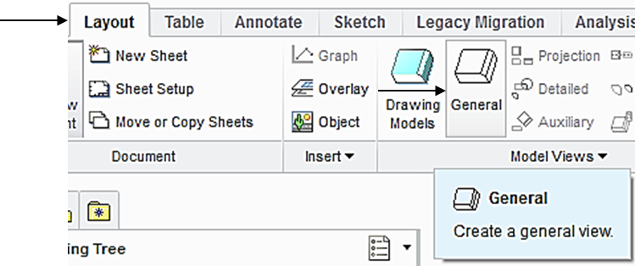

Select a location on the drawing screen as the center point for the General View. A general view appears on the screen.

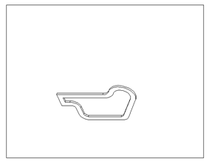

In the pop-up Drawing View window, select FRONT > Apply. To change the scale, click Scale > Custom scale > type 0.5 > Apply > Close, the construction of the Front View is completed.

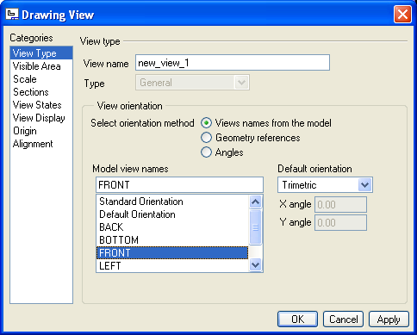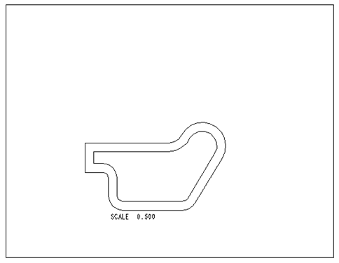

To insert the top view through, pick the FRONT View just created, right-click and hold, and then select Insert Projection View > move the cursor to a location above the front view, and click the left button of mouse, and the construction of the top view is completed.

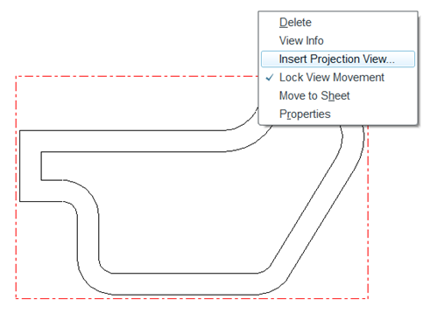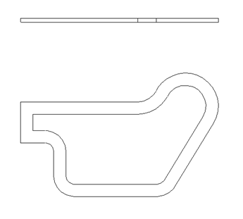

Click the icon of General. In the Select Combined State window, click OK to accept No Combined State. Select a location on the drawing screen as the center point for the 3D View (click the left button of mouse). A general view appears on the screen. In the pop-up Drawing View window, select Standard Orientation > Apply > Close, the construction of the 3D View is completed.

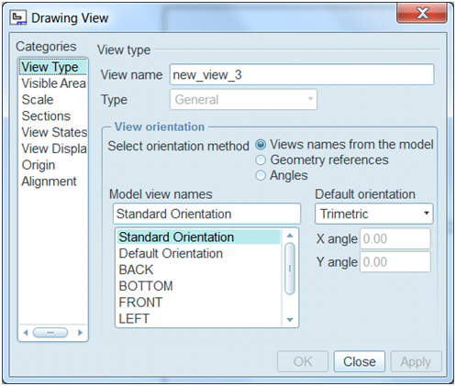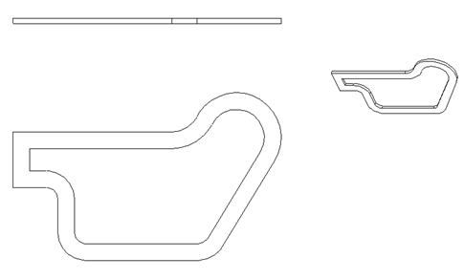

Upon completing the layout, we start adding dimensions. Click the icon of **Annotation**. Select the icon of **Show Model Annotation.**

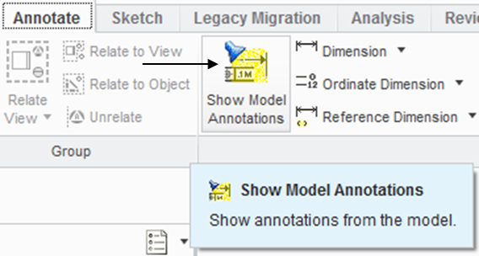

In the pop-up window, select the icon of Dimensions. To show the dimension of Extrude 1, click Extrude 1 listed in the model tree. Click Accept and OK. The dimensions associated with Extrude 1 are shown. Click the box of Accept All > OK. Follow the same procedure to add the dimension of 15 associated with Extrude 2.

Dimension

Accept all

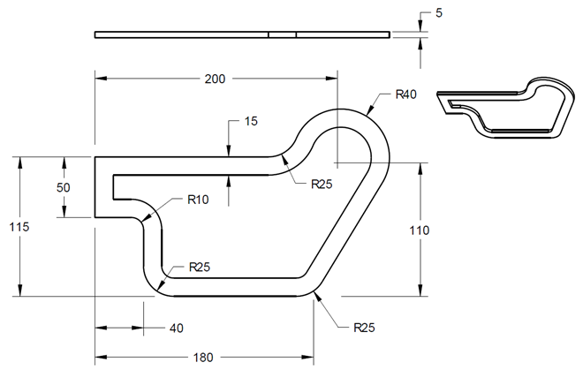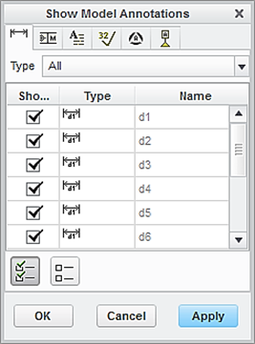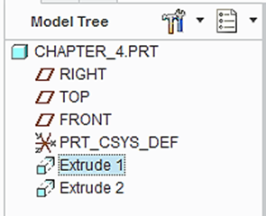

Let us insert the format to the drawing. From the Layout tab, click the icon of Sheet Setup. In the **Page** **Setup** window, use **Browse** to locate the format file, which is *es100*_*fall_2012* > **Open** > select **Show** **format** > **OK.**

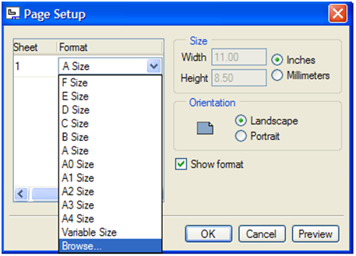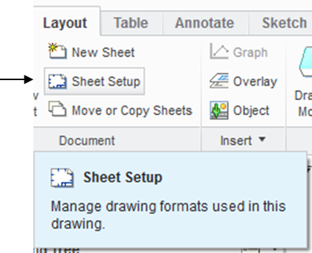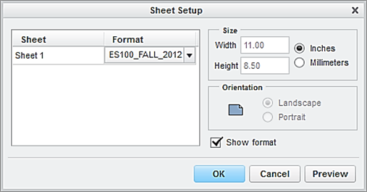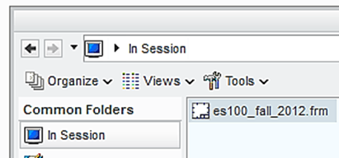

At this time, the user has successfully completed the engineering drawing of the designed part. Select Save > OK.

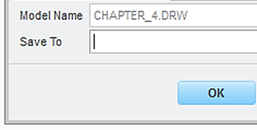

EXERCISE AND ACTIVITIES

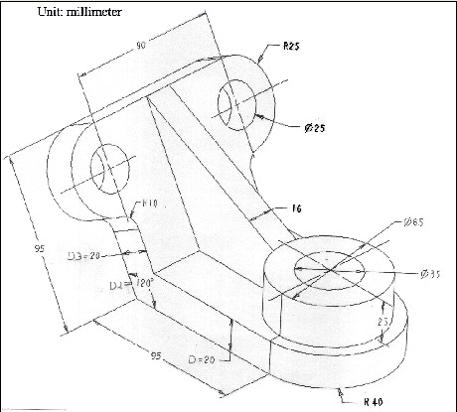1.

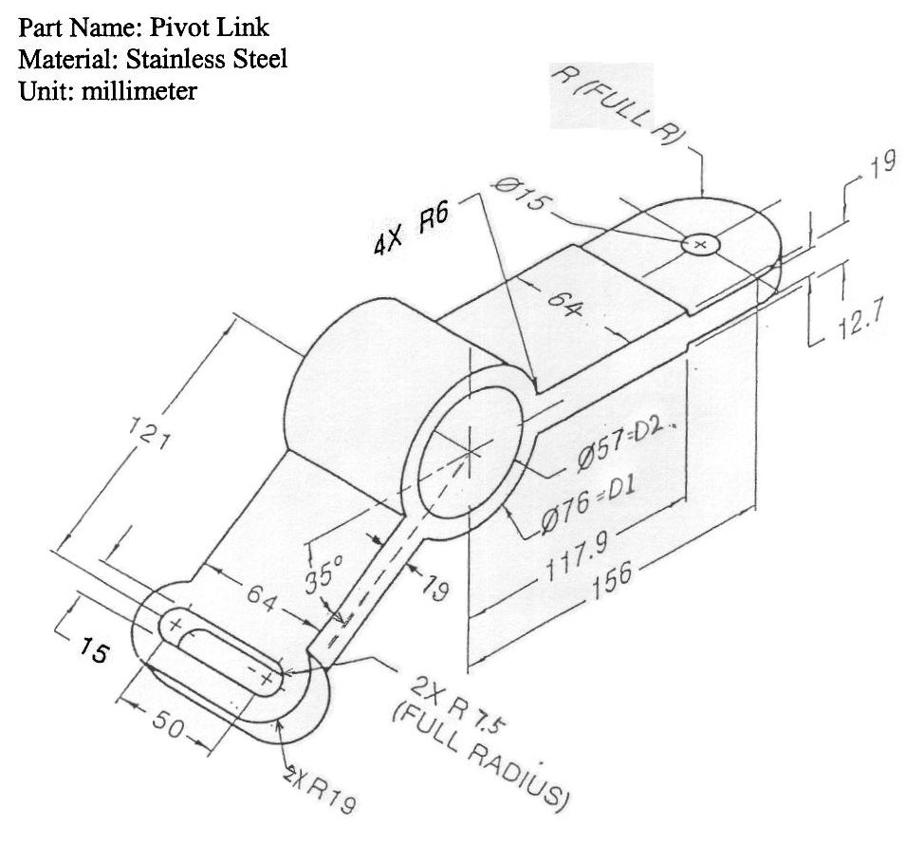2.