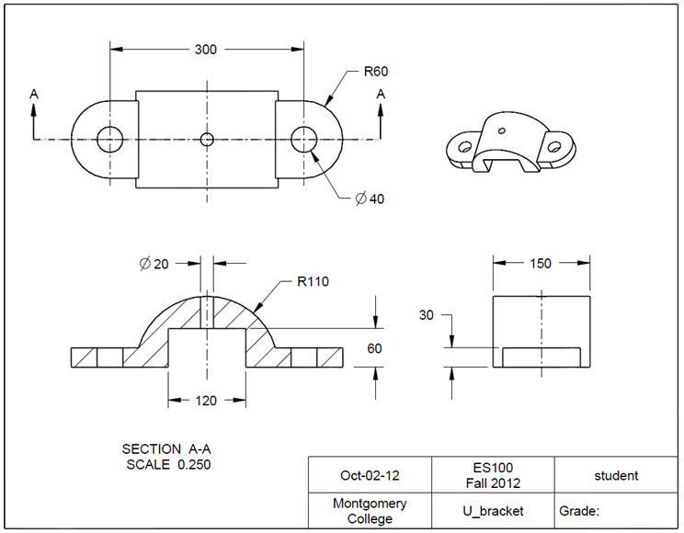**4.5 Parent/Child Relationship**

Task: Create a U-bracker using CREO as shown in the figure. The unit is in millimeters.

Step 1: Create a new file for the 3D solid model.

From **File**, click the icon of **New**. In the **New** window, select **Part**.

Type *U_bracket* as the file name. Clear the box of Use default template. Afterwards, click **OK**. In the New File Options window, select mmns_part_solid. Type student under Modeled_by, and U Cover under Description. Click **OK**. This will bring up the design window.

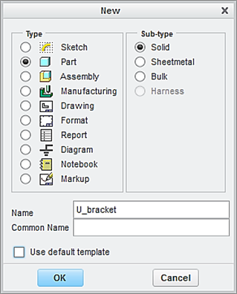

Type *U_bracket as* the file name

Click **OK**

Clear this box

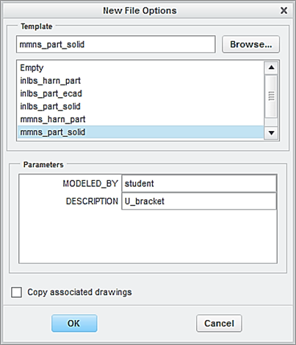

Step 2: Create the first feature, which is a plate.

From the Model tab, click the icon of **Extrude**. Specify 30 as the height of the plate feature.

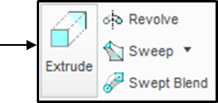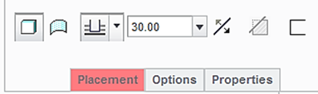

Select the **TOP** datum plane as the sketching plane, and click the icon of Sketch View to orient the sketching plane parallel to the screen.

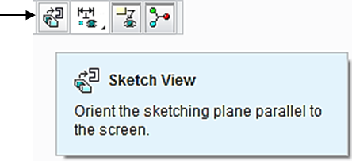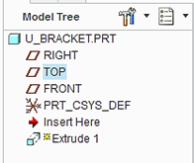

Click the icon of **Centerline** and sketch a vertical centerline passing through the origin of the coordinate system, as shown.

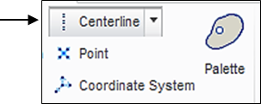

Create another vertical centerline, which is to the right of the sketched centerline. Click the icon of **One** **by** **One**. Modify the distance dimension, which is 150, as shown below.

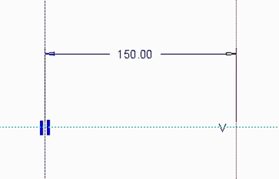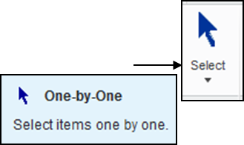

Click the icon of Circle and sketch a circle, as shown below.

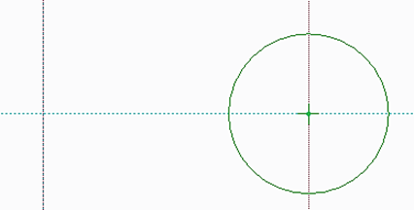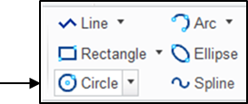

Click the icon of **Delete**. To remove the half circle on the left side, click the half circle on the left side, as shown. Note the diameter dimension is changed to a radius dimension. Modify the dimension to 60.

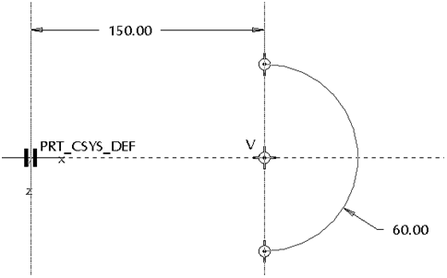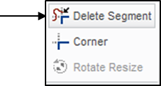

Click the icon of **Circle**, and sketch a circle. Change the diameter value to 40, as shown below.

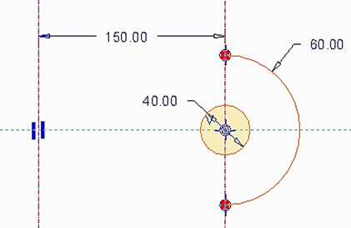

Pick both the sketched circle and arc while holding down the **Ctrl** key, click the icon of **Mirror**. Click the vertical centerline. The sketched circle and are created on the left side of the vertical centerline.

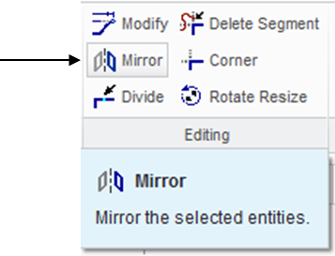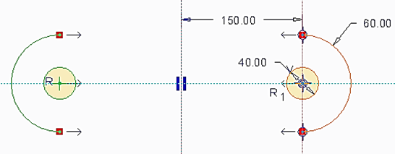

Click the icon of **Line** to sketch 2 lines connecting the original geometry and the mirrored geometry, as shown.

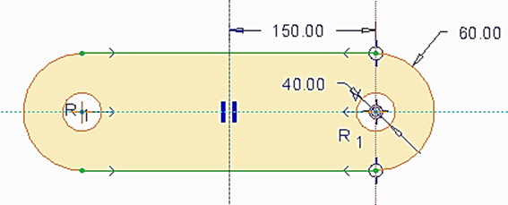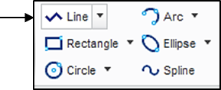

Upon completing this sketch, click the icon of **OK** and click the icon of **Apply** **and Save** to complete the creation of the plate feature.

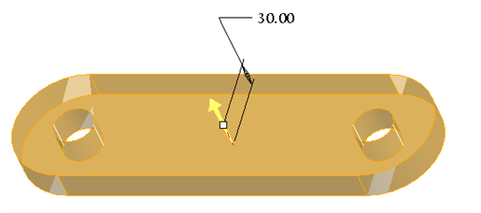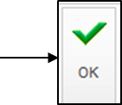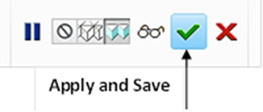

Step 3: Create the second feature, which is a half cylinder.

Click the icon of **Extrude**. Select Symmetry and specify 150 as the depth value.

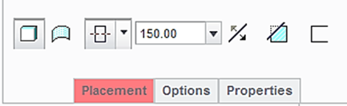

Symmetry



Select the **FRONT** datum plane as the sketching plane, and click the icon of **Sketch** **View** to orient the sketching plane parallel to the screen.

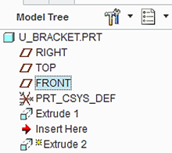

Click the icon of **Circle**. Sketch a circle, as shown below.

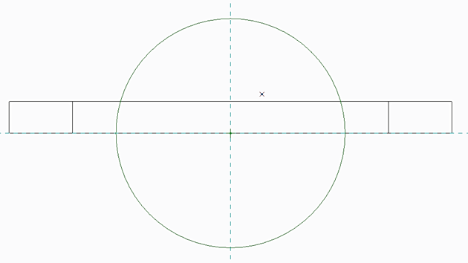

Click the icon of **Delete**. Remove the half circle on the lower side, as shown. Note the diameter dimension is changed to a radius dimension. Modify the dimension to 110.

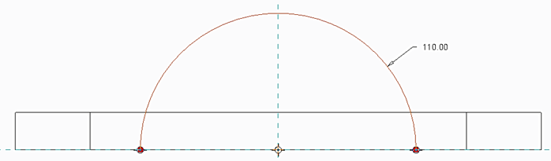

Click the icon of **Line** to sketch a line, which connect the 2 ends of the half circle to form a closed sketch, as shown.

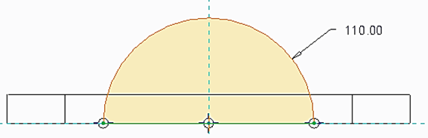

Upon completing this sketch, click the icon of **Done** and click the icon of **Apply** **and Save** to complete the creation of the half cylinder feature.

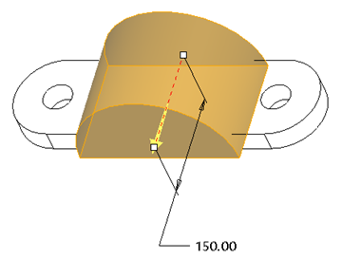

Step 4: Create the third feature, which cuts or removes the material from the created feature.

Click the icon of **Extrude**. Select Cut, and specify **Thru All** as the depth choice.

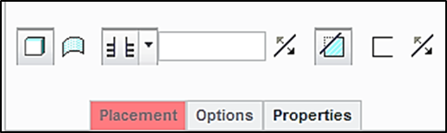

Select the front surface of the half cylindrical feature as the sketch plane, and click the icon of **Sketch** **View** to orient the sketching plane parallel to the screen.

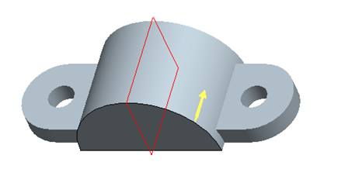

Pick the icon of **Centerline**. Sketch a vertical centerline, as shown.

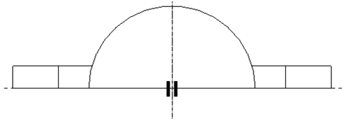

Click the icon of **Rectangle**. Sketch a rectangle, which is symmetric about the vertical centerline, as shown below. The 2 dimensions are 120 and 60, respectively.

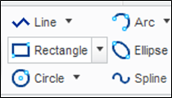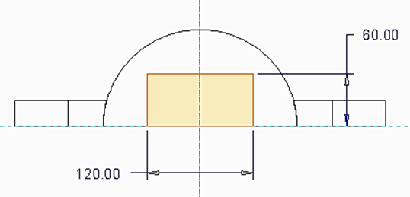

Upon completing this sketch, click the icon of **OK** and click the icon of **Apply** **and Save** to complete the creation of the cut feature.

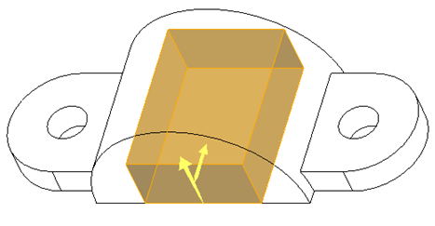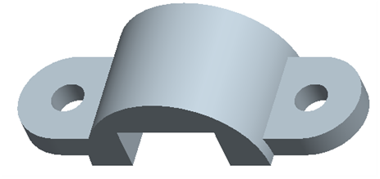

Step 5: Create a through hole and the diameter dimension is 20 mm.

Click the icon of **Hole** displayed on the toolbar. Specify 20 as the diameter value and use **Thru** **All** as the depth choice. Activate **Placement** > pick the flat surface from the cut feature as the Placement. Click Offset Reference. While holding down the **Ctrl** key, pick **FRONT** and **RIGHT** and select Align for both. Click the icon of **Apply** **and** **Save**.

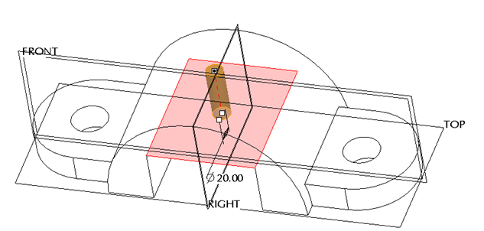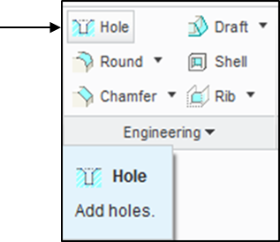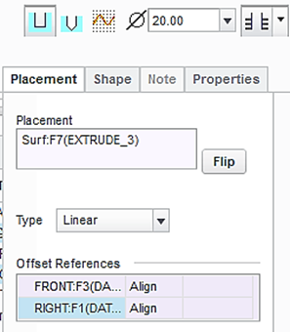

At this time, we have successfully completed the U_bracket design. Remember to save all work with the 3D solid model. You select **Save** from the main toolbar > **OK**.

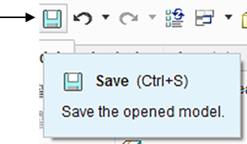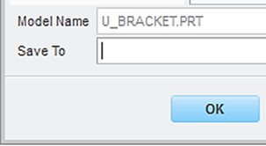

Step 6: Prepare an engineering drawing

To prepare an engineering drawing based on the 3D solid model, we need to create a drawing file. First, we select the icon of **New**. In the **New** window, click **Drawing.** Type *U_bracket* as the name of the file. Clear the box of **Use default template** because we do not want to use the default setting for the drawing work. Afterwards, click **OK**.

Select Drawing

Clear the default box

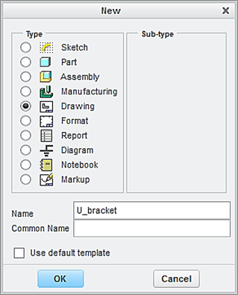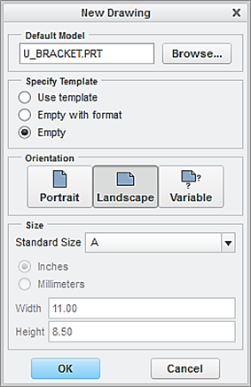

In the window of **New Drawing** shown above, make sure that the file of the 3D solid model called *U_BRACKET* is shown. Otherwise, use “**Browse**” to locate it. Select **Empty** under Specify Template, and select the paper size to be **A**. Afterwards, click the button of **OK**.

This brings up the drawing screen. Click the icon of **Layout**. Click the icon of **General.** In the **Select Combined** **State** window, click OK to accept **No Combined State**.

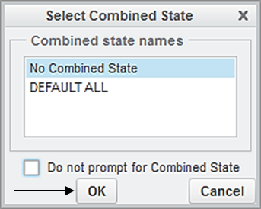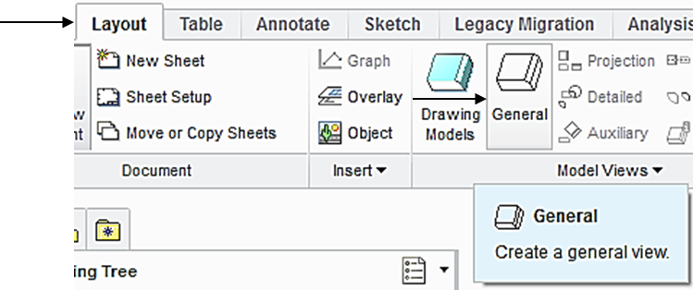

Select a location on the drawing screen as the center point for the **General** **View**. A general view appears on the screen.

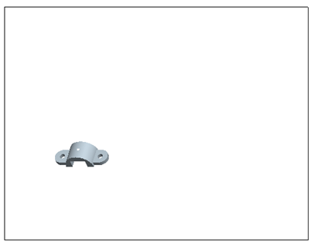

In the pop-up Drawing View window, select **FRONT** > **Apply.** To change the scale, click **Scale** > **Custom scale** > type 0.25 > **Apply** > **Close**, the construction of the Front View is completed.

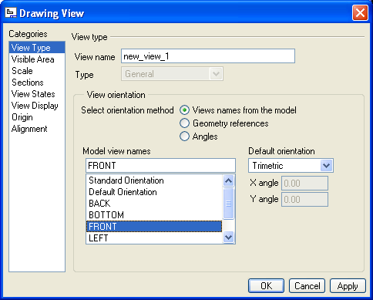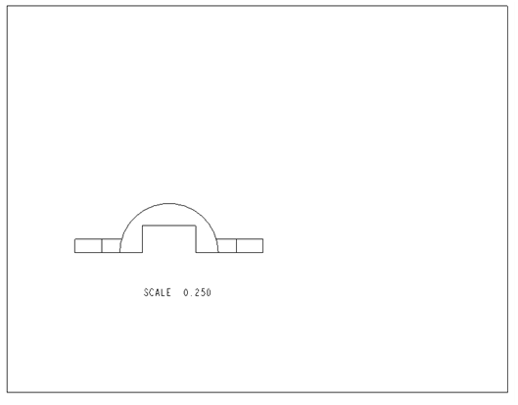

To insert the right side view through, pick the FRONT View just created, right-click and hold, and then select **Insert** **Projection View** > move the cursor to the right side and click the left button of mouse, and the construction of the right side view is completed. Follow the same procedure to create the top view, as shown below.

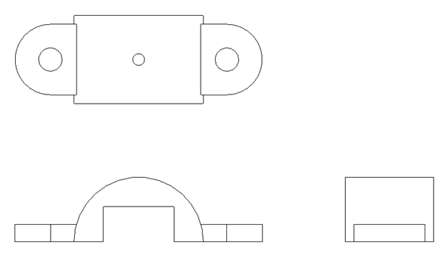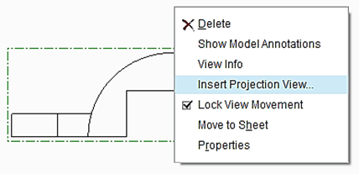

Click the icon of **General.** In the **Select Combined** **State** window, click **OK** to accept **No Combined State**. Select a location on the drawing screen as the center point for the 3D View (click the left button of mouse). A general view appears on the screen. In the pop-up Drawing View window, select **Standard Orientation** > **Apply** > **Close**, the construction of the 3D View is completed.

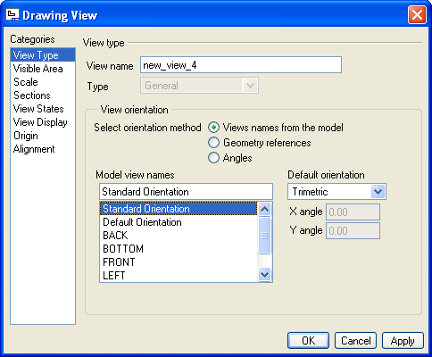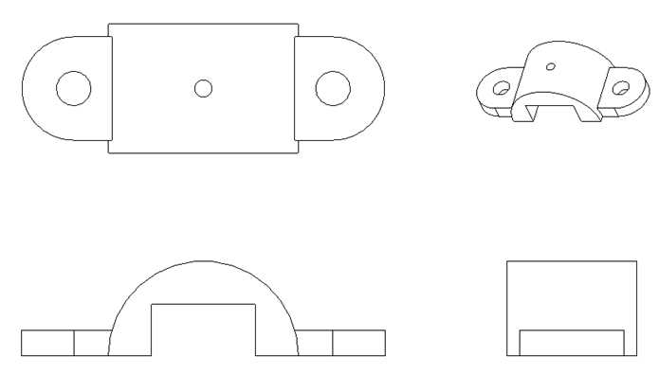

Upon completing the layout, we start adding dimensions. Click the icon of **Annotation**. Select the icon of **Show Model Annotation.**

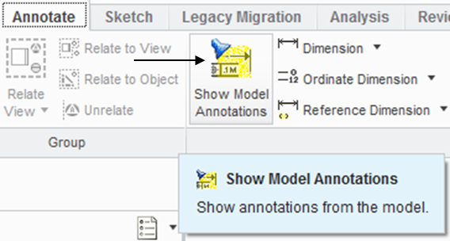

In the pop-up window, select the icon of **Dimensions.** To show the dimension of Extrude 1, click Extrude 1 listed in the model tree. Click Accept and OK. The dimensions associated with Extrude 1 are shown. Click the box of **Accept** **All** > **OK**. Follow the same procedure to add the dimensions associated with Extrude 2, Extrude 3 and Hole.

Dimension

Accept all

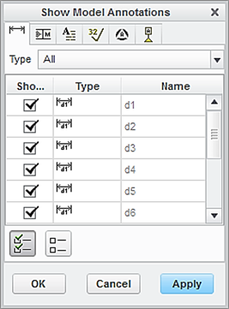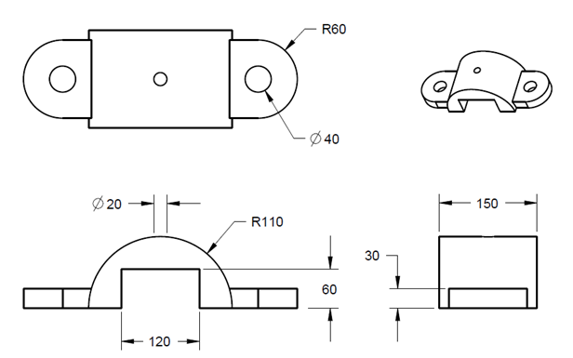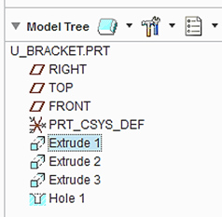

To add centerlines, select the box of centerlines. Click the hole feature listed in the model tree. All the centerlines are shown. Click **Accept All > OK.**

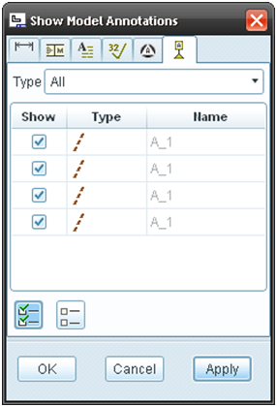

Accept all

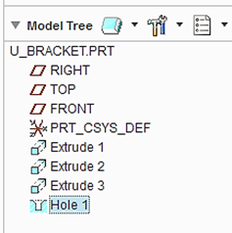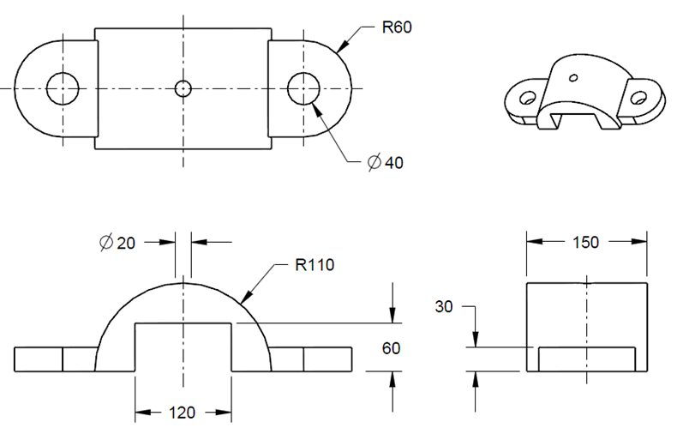

How do you add the dimension defining the distance between the two centers of the 2 circles? Click **Dimension-New** **References** from the top menu. In the pop up window, select **Center**. While holding down the **Ctrl** key, pick the 2 circles.

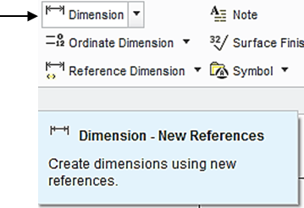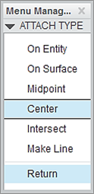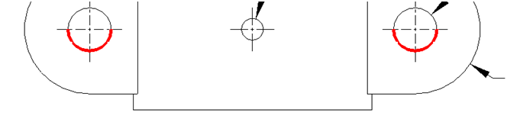

Pick these 2 circles

Click the middle button of mouse to place the dimension > choose **Horizontal** > **OK**.

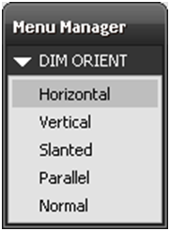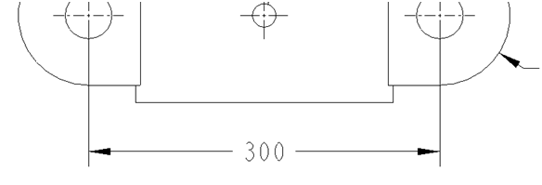

Users may use the icon of **Pick** to move the dimensions to appropriate locations, thus completing the preparation of an engineering drawing.

Let us insert the format to the drawing. From the Layout tab, click the icon of Sheet Setup. In the **Page** **Setup** window, use **Browse** to locate the format file, which is *es100*_*fall_2012* > **Open** > select **Show** **format** > **OK.**

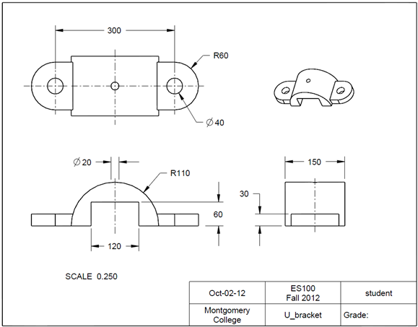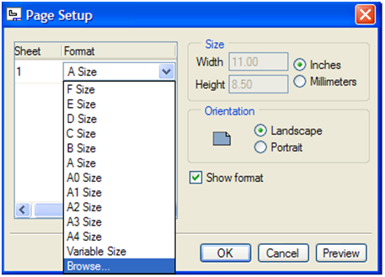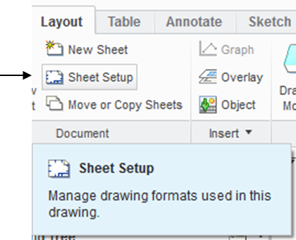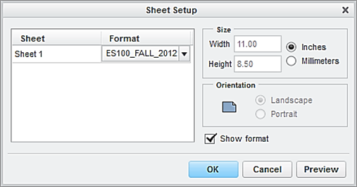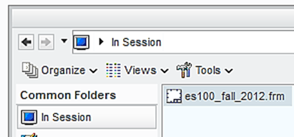

At this time the user has successfully completed the engineering drawing of the designed part. Select **Save** from the main toolbar > **OK**.

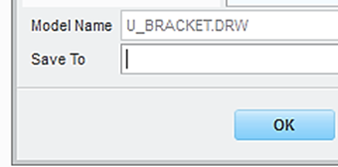

Step 7: Add a section view to the front projection.

Note that the 3 hole features are invisible in the **FRONT** view. In order to have a visible version of the hole features, we add a section view. To do so, let us modify the FRONT view to a full section view.

First, let us enable the display of datum planes. Click the icon of **Datum Display Filter** and check the box of Plane Display and **Repaint.**

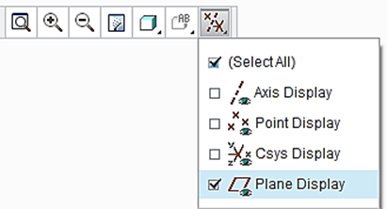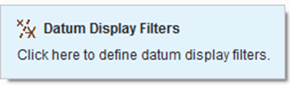

Now click the **FRONT** view through a left click of mouse. Afterwards, right click and hold, select **Properties.**

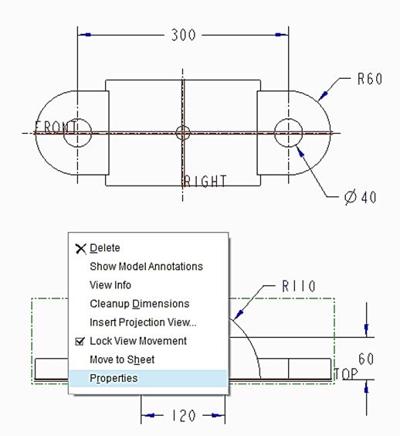

In the Drawing View window, select **Sections** and **2D cross-section.** Click the icon of **Add** (plus sign) to add cross-section. In the pop up window, accept Planarand **Single > Done**.

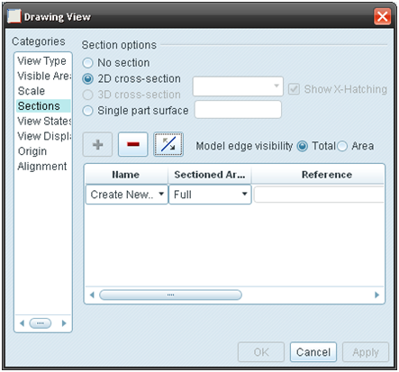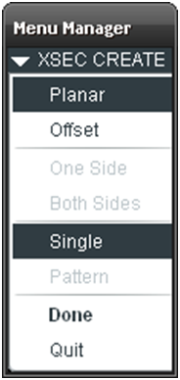

The software system is asking the user to enter a name for cross-section. Type *A* as the name for cross-section and press the **Enter** key. On the screen display, select the **FRONT** datum plane from the Top View > click the box of **Apply**, a cross-section is added to the Front view.

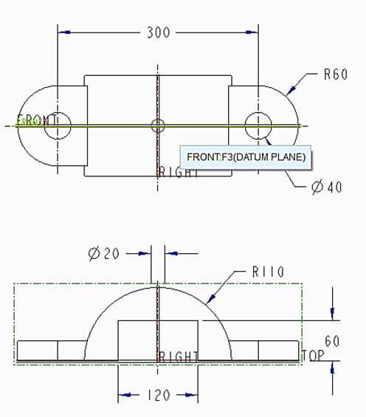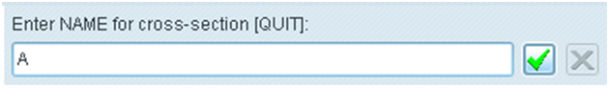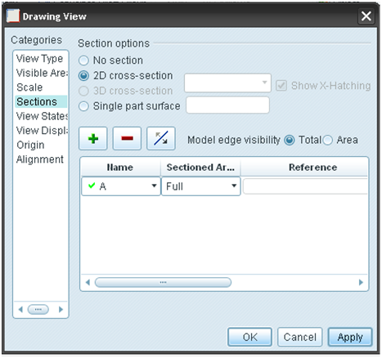

Pick FRONT DATUM PLANE

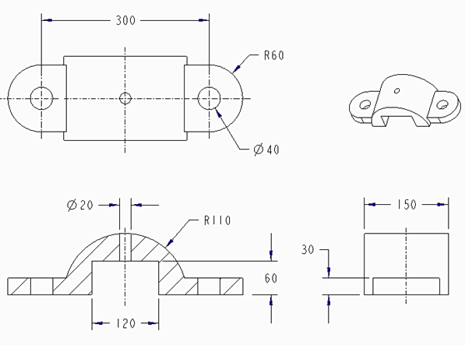

To add an arrow indicating the direction of the cross-section view, activate **Arrow Display** from the **Drawing View** window > click the Top view > **Apply** and two arrows marked as A appear together with SECTION A-A > **Close**.

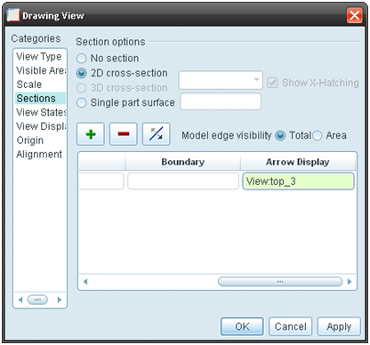

At this time, the user has successfully added a section view to the front view of the designed U_bracket part. Select **Save** from the main toolbar > **OK**.

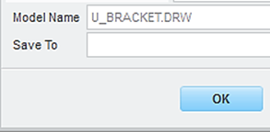

**EXERCISE AND ACTIVITIES**